CROPSIGHT: SMART CROP DELIVERY WITH AI-BASED PRICE AND QUALITY INTELLIGENCE
(CropSight)
A project report submitted in partial fulfilment of the requirements for the award of the degree of
BACHELOR OF TECHNOLOGY
in
COMPUTER SCIENCE AND ENGINEERING (DATA SCIENCE)
Submitted by
G.PRANAVI | 23K91A6765
G.SIRI CHANDANA | 23K91A6763
A.NIKHIL | 23K91A6715
G.VISHNU VARDHAN | 23K91A6754
Batch A17 (CSE - Data Science, Section A)
Under the esteemed guidance of
K. Mounika
[DESIGNATION]
[COLLEGE LOGO]
DEPARTMENT OF COMPUTER SCIENCE AND ENGINEERING (DATA SCIENCE)
[COLLEGE NAME]
[COLLEGE ADDRESS / AFFILIATING UNIVERSITY]
[ACADEMIC YEAR]

[COLLEGE LOGO]
[COLLEGE NAME]
DEPARTMENT OF COMPUTER SCIENCE AND ENGINEERING (DATA SCIENCE)
CERTIFICATE
This is to certify that the project report entitled "CropSight: Smart Crop Delivery with AI-Based Price and Quality Intelligence (CropSight)" is a bonafide record of the work carried out by G.PRANAVI (23K91A6765), G.SIRI CHANDANA (23K91A6763), A.NIKHIL (23K91A6715), G.VISHNU VARDHAN (23K91A6754), in partial fulfilment of the requirements for the award of the degree of Bachelor of Technology in Computer Science and Engineering (Data Science), during the academic year [ACADEMIC YEAR], under my supervision.

Project Guide  K. Mounika  [DESIGNATION] | Head of the Department  [HOD NAME]  Department of Computer Science and Engineering (Data Science) | External Examiner  [NAME AND SIGNATURE]
DECLARATION
We hereby declare that the project report entitled "CropSight: Smart Crop Delivery with AI-Based Price and Quality Intelligence (CropSight)", submitted to the Department of Computer Science and Engineering (Data Science), [COLLEGE NAME], in partial fulfilment of the requirements for the award of the degree of Bachelor of Technology in Computer Science and Engineering (Data Science), is a record of original work carried out by us under the guidance of K. Mounika, [DESIGNATION]. The results embodied in this report have not been submitted to any other university or institution for the award of any degree or diploma.

G.PRANAVI | 23K91A6765
G.SIRI CHANDANA | 23K91A6763
A.NIKHIL | 23K91A6715
G.VISHNU VARDHAN | 23K91A6754
Place: [PLACE]
Date: [DATE]
ACKNOWLEDGEMENT
We express our sincere gratitude to our project guide, K. Mounika, [DESIGNATION], for valuable guidance, encouragement and constructive suggestions throughout this project.
We thank [HOD NAME], Head of the Department of Computer Science and Engineering (Data Science), for providing the facilities and support needed to complete this work, and [PRINCIPAL NAME], Principal, [COLLEGE NAME], for the encouragement given to us.
We thank the project coordinators and all faculty and staff members of the department for their help, and our families and friends for their constant support.
We also acknowledge the authors of the base paper, Ayesha Khaliq, Atif Khan, Salman Jan and their co-authors, the creators of the public photograph datasets used for the real-image checks (Sultana, Jahan and Uddin for the fresh and rotten fruit set, and the Project-AgML collection for the vegetable set), and the authors and maintainers of the open-source software on which CropSight is built, in particular FastAPI, SQLAlchemy, scikit-learn, SHAP, OpenCV, scikit-image, React and Vite.

G.PRANAVI
G.SIRI CHANDANA
A.NIKHIL
G.VISHNU VARDHAN
ABSTRACT
Farmers lose income to unpredictable prices, inconsistent manual quality grading, long chains of middlemen and unmonitored storage and transport. Smart-agriculture research has concentrated on decisions before the harvest, such as soil analysis, irrigation and crop selection; the base paper by Khaliq et al. (IEEE Access, 2025) combines IoT sensors, deep tabular models and explainable AI for exactly those tasks. Few systems support the decisions after the harvest: how good is this produce, what is it worth and when should it be sold, who should buy it, and is it travelling safely.
This project builds CropSight, a full-stack platform that applies the sensing, learning and explanation idea of the base paper after the harvest. A farmer uploads a crop photograph; real computer-vision code extracts eleven colour, texture, edge, blemish and size features, and a Random Forest assigns grade A, B, C or Reject with probabilities and SHAP explanations. A gradient-boosted model with two quantile models gives the current price, a confidence band and a 31-day curve, and the best day to sell within a 14-day window. A transparent weighted score ranks buyers by price, distance, quality fit, reliability and spoilage risk and proposes a route. A role-gated marketplace takes the order through placement, confirmation, transit and delivery, and a WebSocket stream shows temperature, humidity and shock readings of a shipment with alerts. The backend is FastAPI with SQLite and JWT authentication; the web app is React with TypeScript.
No real crop-image set and no real market-price series were available, so both models are trained on synthetic data generated in the same feature space, and the sensor source is a simulator; the application states this itself. On their own synthetic test sets the grader reaches 92.3 % accuracy (92.9 % +- 0.3 over five seeds) and the price model a mean absolute error of 164.6 INR per quintal with R2 0.992 and a mean absolute percentage error of 5.1 %, against a noise floor of 2.8 %. A check on 3,200 real fruit photographs shows that the synthetic-trained grader does not transfer (50.4 % fresh-versus-rotten accuracy, AUC 0.57), while the same eleven features retrained on real labels reach 90.6 %. Thirty-six automated tests pass, three more document defects found in the code, and median API response times range from 2 ms to 174 ms, except bcrypt login at 325 ms. The report states these limits and defects plainly and lists the work needed to move from a validated prototype to field use.
Keywords: post-harvest, crop quality grading, price forecasting, explainable AI, SHAP, IoT monitoring, agri marketplace.
TABLE OF CONTENTS
CHAPTER 1 INTRODUCTION 1
1.1 Introduction to the Project Domain 1
1.2 Background and Motivation 2
1.3 Problem Statement 3
1.4 Need for the Proposed System 3
1.5 Objectives 3
1.6 Scope of the Project 4
1.7 Key Contributions 5
1.8 Limitations and Assumptions 6
1.9 Organisation of the Report 7
CHAPTER 2 LITERATURE SURVEY 8
2.1 Overview of the Literature Survey 8
2.2 Base Paper Analysis 8
2.3 Related Work 10
2.4 Datasets and Algorithms Used in the Literature and in CropSight 12
2.5 Strengths and Limitations of Existing Work 13
2.6 Research Gap 13
CHAPTER 3 FEASIBILITY STUDY 15
3.1 Technical Feasibility 15
3.2 Economic Feasibility 16
3.3 Operational Feasibility 16
3.4 Data, Legal and Ethical Feasibility 17
3.5 Schedule Feasibility 17
3.6 Advantages and Constraints 18
CHAPTER 4 SYSTEM REQUIREMENTS AND ANALYSIS 19
4.1 Existing System and its Limitations 19
4.2 Proposed System and its Advantages 19
4.3 Functional Requirements 20
4.4 Order Lifecycle Requirements 21
4.5 Non-Functional Requirements 22
4.6 Hardware and Software Requirements 22
4.7 User Roles and Constraints 23
CHAPTER 5 SYSTEM DESIGN 24
5.1 System Architecture 24
5.2 High-Level Workflow 25
5.3 Data-Flow Diagrams 26
5.4 UML Diagrams 28
5.5 Database Design 31
5.6 Module Design 33
5.7 User Interface Design 34
CHAPTER 6 METHODOLOGY AND SOFTWARE IMPLEMENTATION 36
6.1 Overall Methodology 36
6.2 Dataset 37
6.3 Preprocessing: Image Features and Market Features 38
6.4 Algorithm Choice and Justification 39
6.5 Mathematical Formulation 40
6.6 Models, Training Configuration and Measured Results 42
6.7 Application Architecture 42
6.8 Key Code Walkthroughs 43
6.9 Implementation Decisions and Reasoning 45
6.10 API Design 46
6.11 Security and Error Handling 47
6.12 Installation and Execution 48
CHAPTER 7 SYSTEM TESTING 49
7.1 Testing Strategy 49
7.2 Unit Testing 49
7.3 Integration Testing 50
7.4 Functional Testing 50
7.5 Security Testing 51
7.6 Validation and Edge Cases 52
7.7 Performance Testing 52
7.8 User Acceptance Testing 53
7.9 Limits of the Testing Done 53
CHAPTER 8 RESULTS AND OUTPUT SCREENS 54
8.1 Output Screens 54
8.2 Model Performance 59
8.3 Software Verification Results 66
8.4 Comparison with the Base Paper 67
8.5 Sample Inputs and Outputs 68
8.6 Success and Failure Analysis 69
8.7 Limits of the Results 70
8.8 Objectives Against Outcomes 70
CHAPTER 9 CONCLUSION 71
9.1 Summary of the Work 71
9.2 Objectives Achieved 71
9.3 Key Findings 71
9.4 Practical Applications 72
9.5 Known Limitations 72
CHAPTER 10 FUTURE SCOPE 74
10.1 Improvements 74
10.2 Additional Features 74
10.3 Scalability and Deployment 74
10.4 Further Research 75
REFERENCES 76
APPENDIX A IMPORTANT CODE 78
A.1 Foreground Mask and Blemish Features 78
A.2 Random Forest Training 78
APPENDIX B INSTALLATION AND USER GUIDE 79
B.1 Installation Guide 79
B.2 User Guide 79
APPENDIX C ADDITIONAL SCREENS 81

LIST OF FIGURES
Fig. 5.1: System architecture of CropSight 24
Fig. 5.2: High-level workflow 25
Fig. 5.3: Data-flow diagram, level 0 (context) 26
Fig. 5.4: Data-flow diagram, level 1 27
Fig. 5.5: Data-flow diagram, level 2: Grade crop (process 2.0) 28
Fig. 5.6: Use-case diagram 29
Fig. 5.7: UML class diagram 30
Fig. 5.8: Sequence diagram: from photo upload to delivery 31
Fig. 5.9: Entity-relationship diagram (9 tables) 32
Fig. 5.10: Log-in page with demo-account shortcuts 34
Fig. 5.11: Farmer dashboard: upload form and own listings 34
Fig. 5.12: Listing workspace: grade, confidence, quality radar and SHAP bars 35
Fig. 5.13: Buyer marketplace with grade badges and asking prices 35
Fig. 5.14: Distributor: confirmed orders ready to ship 35
Fig. 5.15: Live monitoring with the out-of-range banner 35
Fig. 5.16: Admin overview: counts and gross volume 35
Fig. 5.17: Admin model insights with training-data disclosure 35
Fig. 8.1: Landing page 54
Fig. 8.2: Failure case: wrong password 54
Fig. 8.3: Farmer dashboard with a real photograph selected 54
Fig. 8.4: Grading result 55
Fig. 8.5: Price forecast 55
Fig. 8.6: Delivery planner 56
Fig. 8.7: Listings after publishing 56
Fig. 8.8: Buyer marketplace 56
Fig. 8.9: Listing detail 56
Fig. 8.10: Place-order dialog 56
Fig. 8.11: Buyer orders 57
Fig. 8.12: Farmer confirms an order 57
Fig. 8.13: Distributor: orders ready to ship 57
Fig. 8.14: Distributor: shipments in transit 57
Fig. 8.15: Live shipment monitoring 58
Fig. 8.16: Cold-chain alert toast 58
Fig. 8.17: Alert banner after drift 58
Fig. 8.18: Admin overview 58
Fig. 8.19: Model insights: quality model 58
Fig. 8.20: Confusion matrix of the quality grader on the synthetic test set 60
Fig. 8.21: Impurity and permutation importance of the 11 features 61
Fig. 8.22: Feature-group ablation: one group alone against all but one group 61
Fig. 8.23: Predicted grade share for fresh and rotten photographs 61
Fig. 8.24: Fresh-versus-rotten AUC of the shipped model for each fruit 62
Fig. 8.25: Mean feature values of the synthetic grade profiles and of the real photographs 62
Fig. 8.26: Fresh-versus-rotten accuracy: shipped model, retrained on real labels, and retrained on unseen fruits 63
Fig. 8.27: Price baselines and grouped feature importance 64
Fig. 8.28: Observed against predicted price on the synthetic test set 64
Fig. 8.29: Distribution of the recommended best sell day over 256 combinations 65
Fig. 8.30: Share of simulated shipments in alarm (left) and one simulated trajectory, the demo shipment of order 3, seed 304 (right) 66
Fig. 8.31: tomato_1.jpg, graded B (0.701) 68
Fig. 8.32: potato_2.jpg, graded A (0.834) 68
Fig. C.1: Log-in page 81
Fig. C.2: Sign-up page 81
Fig. C.3: Farmer dashboard before an upload 81
Fig. C.4: Farmer orders before confirming 81
Fig. C.5: Live monitoring right after opening 81
Fig. C.6: Model insights: price model 81

LIST OF TABLES
Table 1.1: Organisation of the report 7
Table 2.1: Papers in the batch literature survey and the two papers added 8
Table 2.2: Base paper and CropSight compared 10
Table 2.3: Datasets in the survey and in the project 12
Table 2.4: Techniques and the references behind them 12
Table 2.5: Strengths and limitations of the surveyed work 13
Table 2.6: Research gap and the project response 13
Table 3.1: Technical risks and their handling 15
Table 3.2: Cost elements of the project 16
Table 3.3: Project schedule (indicative) 17
Table 3.4: Advantages and constraints of the project 18
Table 4.1: Limitations of the existing system 19
Table 4.2: Features of CropSight 19
Table 4.3: How the proposed system answers the limitations 20
Table 4.4: Functional requirements 20
Table 4.5: Order state transitions 21
Table 4.6: Non-functional requirements 22
Table 4.7: Hardware and software requirements 22
Table 4.8: User roles and permissions 23
Table 5.1: Database tables 32
Table 5.2: Modules of CropSight 33
Table 6.1: Pipeline of CropSight 36
Table 6.2: Datasets used 37
Table 6.3: Mean of selected features per grade in the synthetic generator 37
Table 6.4: Algorithm choices 39
Table 6.5: Training configuration 42
Table 6.6: Technology stack of the implementation 43
Listing: Foreground mask in ml/quality/feature_extraction.py 43
Listing: Grade and probabilities in ml/quality/infer.py 44
Listing: Forecast loop in ml/price/infer.py 44
Listing: Weighted match score in ml/delivery/recommend.py 44
Listing: ShipmentSensorState.step() in ml/iot/simulate.py 45
Listing: Role dependency in core/security.py 45
Table 6.7: Implementation decisions 45
Table 6.8: API endpoints 46
Listing: Price request and response (shape) 47
Table 6.9: Installation and execution 48
Table 7.1: Unit tests (7) 49
Table 7.2: Integration tests (32 including the 3 expected failures) 50
Table 7.3: Backend test inventory (pytest, 26 October 2026) 50
Table 7.4: Functional test cases (live walk-through) 51
Table 7.5: Validation and edge cases 52
Table 7.6: API response times (live server) 52
Table 8.1: Headline results 59
Table 8.2: Per-grade results of the Random Forest (1,200 synthetic test rows) 59
Table 8.3: Baselines on the same synthetic split 60
Table 8.4: Grades predicted by the shipped model for 3,200 real fruit photographs 61
Table 8.5: Price model results on the synthetic series 63
Table 8.6: Price baselines on the same split 63
Table 8.7: API response times (live server on 127.0.0.1, same machine, other jobs running) 66
Table 8.8: Automated test results 66
Table 8.9: CropSight and the base paper 67
Table 8.10: Real sample photographs and the grades the shipped model gave them 68
Table 8.11: Sample inputs and outputs (live run, 26 October 2026) 68
Table 8.12: Failure and weakness analysis 69
Table 8.13: Objectives against outcomes 70
Listing: _foreground_mask() and the edge and blemish features in ml/quality/feature_extraction.py 78
Listing: Training of the quality grader in ml/quality/train_model.py 78
Table B.1: Demo accounts created by the seed script 79
Table B.2: User guide 79

LIST OF ABBREVIATIONS
Abbreviation | Expansion
AI | Artificial Intelligence
API | Application Programming Interface
AUC | Area Under the ROC Curve
CPU | Central Processing Unit
CSS | Cascading Style Sheets
CV | Computer Vision
DFD | Data-Flow Diagram
ER | Entity-Relationship
FK | Foreign Key
FR | Functional Requirement
GBR | Gradient Boosting Regressor
GLCM | Gray-Level Co-occurrence Matrix
HSV | Hue, Saturation, Value
HTTP | Hypertext Transfer Protocol
INR | Indian Rupee
IoT | Internet of Things
JSON | JavaScript Object Notation
JWT | JSON Web Token
MAE | Mean Absolute Error
MAPE | Mean Absolute Percentage Error
ML | Machine Learning
NFR | Non-Functional Requirement
ORM | Object-Relational Mapping
R2 | Coefficient of Determination
REST | Representational State Transfer
RF | Random Forest
RMSE | Root Mean Square Error
SHAP | SHapley Additive exPlanations
SQL | Structured Query Language
UI | User Interface
UML | Unified Modeling Language
URL | Uniform Resource Locator
WS | WebSocket
XAI | Explainable Artificial Intelligence

CHAPTER 1
INTRODUCTION

1.1 Introduction to the Project Domain
Agriculture supports millions of farmers, but a farmer's income depends on events that begin only after the crop has been harvested: how the produce is judged, what price the market offers on the day, who buys it, and whether it reaches the buyer in good condition. Most research in smart agriculture addresses the period before harvest. The base paper of this project, by Khaliq et al. [1], is a typical and recent example: it combines Internet-of-Things (IoT) soil sensors, deep learning and explainable artificial intelligence (XAI) to advise on soil health, irrigation, crop choice and fertiliser. The period after harvest, in which quality is graded, a price is agreed and the produce is stored and transported, receives much less attention in the same integrated, explainable form.
The domain of this project is therefore post-harvest decision support for farmers: the grading of crop quality from photographs, the prediction of market prices, the planning of delivery, the monitoring of storage and transport conditions, and the marketplace that connects farmers, distributors and buyers. It sits between several established areas of computer science. Image analysis supplies colour, texture, edge and blemish measures from a photograph [15], [16], [17], [19], [20]. Supervised learning supplies classifiers and regressors such as random forests [10] and gradient boosting [11], and quantile regression [12] supplies prediction bands. Explainable AI supplies methods such as SHAP [13], [14] that attribute a prediction to its input features. IoT sensing supplies the stream of storage and transport conditions that the base paper [1] uses on the farm.
CropSight, the system built in this project, combines these ideas into one web application with four roles. A farmer uploads a photograph of the harvested crop and receives a quality grade (A, B, C or Reject) with a probability for each class and the features that drove the decision; asks for a 30-day price forecast with a confidence band and a best day to sell; and obtains a ranked list of buyers with a suggested route before publishing the lot to a marketplace. Buyers browse and order, distributors carry the order and watch a live sensor stream, and an administrator sees platform figures and the transparency card of each model. The title of the project, CropSight: Smart Crop Delivery with AI-Based Price and Quality Intelligence, is read in this sense: the intelligence is limited to grading, pricing and delivery decisions after harvest, and each decision is explained.
One point of wording must be made at the outset. The batch abstract speaks of deep learning for image grading. What was built and measured is classical machine learning on hand-crafted computer-vision features: eleven colour, texture, edge, blemish and size measures computed from the pixels of the uploaded photograph and classified by a random forest. This choice, and its consequences, are explained in Chapters 6 and 8.

1.2 Background and Motivation
Four observations motivated the project, and they follow the batch introduction. First, a farmer's income depends on unpredictable market prices, and a farmer who sells on the first available day has little information about whether the price is likely to rise or fall. Price-prediction systems that use machine learning on market, weather and demand data have been proposed [4], [5], and recent work shows that modern forecasting models can improve markedly on conventional benchmarks for agricultural commodity prices [6], but these systems seldom reach the farmer at the point of sale.
Second, crop quality is usually judged by eye by a trader at the market. Such judgement is quick but subjective, and the same lot can receive different grades from different people, which in turn affects the price. Image-based grading and inspection systems have been proposed for agricultural products [3], computer vision has been applied to leaf-disease diagnosis and severity grading [2], and a recent crop-image recognition model reports an accuracy of 0.982 on its own benchmark [7]; but a farmer needs the grade together with a price and a buyer, not as an isolated classification.
Third, produce is lost after harvest when storage and transport conditions are not monitored. A cold-chain breach, a humidity excursion or rough handling can spoil a lot, and without readings nobody can tell where or when it happened. Fourth, farmers have limited access to buyers and to real-time decision support, and the existing channel passes through middlemen who keep a share of the final price. Government portals publish prices without forecasts, and decisions about grade and price are rarely explained to the seller.
Taken together, these observations show a gap between what pre-harvest smart-agriculture systems provide and what a farmer needs once the crop is in the shed. The base paper [1] demonstrates that IoT, learning models and XAI can be combined into an end-to-end advisory system with a farmer-friendly interface. This project asks whether the same combination can be carried over to the post-harvest stage, and how honestly it can be built and evaluated by a student team without access to a labelled crop-image set, a real market feed or sensor hardware.

1.3 Problem Statement
Crop quality is graded manually and inconsistently. Farmers cannot predict prices or choose the best time to sell. Storage and transport conditions cause unmonitored post-harvest losses. Middlemen and limited market access reduce farmer income.
Formal statement. Given a photograph of a harvested crop lot, its type, quantity and region, produce (i) a quality grade in {A, B, C, Reject} with class probabilities and a ranked list of the image features that drove the decision; (ii) a current price, a confidence band and a 30-day forecast for that crop, region and grade, with the drivers of the price and the best day to sell within a spoilage window; (iii) a ranked list of buyers with a match score and a suggested route; and then (iv) carry the lot through a marketplace order whose stages are enforced for each role, and (v) monitor temperature, humidity and shock while the lot is in transit and raise an alert when a reading leaves its safe range.
The problem is a systems problem as much as a modelling problem: five decisions have to be made consistently, explained to different users, and linked to the same record of the lot.

1.4 Need for the Proposed System
An integrated platform is needed that grades quality, forecasts prices, monitors the supply chain and connects farmers to buyers. Separate tools for each task leave the farmer to combine their outputs, and a tool that gives a grade or a price without a reason is difficult to trust or to dispute. The need can be stated as four requirements.
- Consistency. The same photograph should receive the same grade each time, and the grade should be stored with the lot so that buyer and seller see one value.
- Foresight. A price with an uncertainty band and a recommended selling day lets the farmer weigh waiting against spoilage.
- Transparency. Grading and pricing decisions must be accompanied by the features that produced them, in plain language, so that they can be questioned.
- Traceability. An order must move through defined stages, each permitted to one role, and a shipment must leave a record of its conditions.
CropSight is proposed to meet these four requirements in one application, and the evaluation in Chapter 8 states how far each is met.

1.5 Objectives
The project has six objectives, taken from the batch objectives document:
1. Grade crop quality automatically from images (the batch text says "using deep learning"; the delivered grader uses a random forest on eleven image features).
2. Forecast crop prices from market, weather and demand data.
3. Monitor storage and transport conditions using IoT sensors (delivered as a simulated sensor stream, because no hardware was available).
4. Explain grading and pricing decisions with XAI (delivered with SHAP).
5. Recommend buyers, delivery routes and the best time to sell.
6. Connect farmers, distributors and buyers through a digital marketplace.
Chapter 8 measures each of these objectives against the results, and states where an objective was met only in part.

1.6 Scope of the Project

1.6.1 In scope
- Photographs of harvested produce (JPEG, PNG or WEBP, up to 8 MB) and eight crops: tomato, onion, potato, wheat, rice, mango, cotton and maize.
- Computer-vision feature extraction (eleven features) and a four-class grade with probabilities and a SHAP explanation of the top six features.
- A price model with a point estimate, a 15%-85% quantile band, a 30-day forecast, a best day to sell within a 14-day window and a grouped SHAP explanation.
- A transparent delivery-scoring engine that ranks buyers by price, distance, quality fit, reliability and spoilage risk and proposes a route.
- A role-gated marketplace (farmer, buyer, distributor, administrator) with a placed, confirmed, in-transit, delivered order lifecycle.
- A live sensor stream over WebSocket with threshold alerts, stored in a history table (the source is a simulator).
- A web application with sign-up and log-in, role dashboards, charts and an administrator page that discloses how each model was trained.
- An evaluation of both models, of the delivery scoring and of the simulator, a real-photograph transfer check, and an automated test suite.

1.6.2 Out of scope
- Pre-harvest tasks: soil analysis, irrigation, crop and fertiliser recommendation, which are the subject of the base paper [1].
- Training on a real labelled crop-image set or a real market-price feed; none was available, so both models are trained on synthetic data.
- Real sensor hardware, cold-chain devices and GPS tracking; the stream is simulated.
- Payments, invoicing, contracts and integration with government market portals.
- A language-model assistant or chatbot; the base paper includes a chatbot, this project does not.
- Grading of crops that are not in the list of eight, and of photographs with several lots or a cluttered background.
- Production hardening such as HTTPS termination, rate limiting, a hosted database and load testing.

1.6.3 Assumptions
- A photograph shows one lot of one crop, against a plain, bright background, in reasonable light.
- Quantities and asking prices are entered honestly by the user; they are not validated against market norms.
- Prices are in rupees per quintal (100 kg) and regions are the eight named regions of the demonstration data.
- The application runs on one machine with a single SQLite database for one demonstration deployment.

1.7 Key Contributions
1. An integrated post-harvest platform. One application that links image-based quality grading, price forecasting, delivery planning, a role-gated marketplace and a live sensor stream, with 21 API endpoints (20 REST and one WebSocket) and nine database tables, applying the IoT, learning and XAI idea of the base paper [1] after harvest instead of before it.
2. Real computer-vision feature extraction with an explained grade. Eleven features are computed from the pixels of the uploaded photograph (foreground mask, colour statistics, grey-level co-occurrence texture, edge density, blemish ratio, size score); a random forest grades the lot and SHAP lists the six features that drove the grade. On its own synthetic test set the grader scored 92.3% accuracy (five seeds: 92.9% ± 0.3%), and every error was between neighbouring grades.
3. A price estimate with an uncertainty band and a selling-day rule. A gradient-boosted model gives the point price (test MAE 164.6 INR per quintal, R² 0.992, MAPE 5.1% against a noise floor of 2.8%), two quantile models give a 15%-85% band (empirical coverage 69.3% against 70% nominal), and the best day to sell is the maximum of the forecast over a 14-day spoilage window.
4. Transparent delivery scoring with measured stability. A five-term weighted score ranks buyers and suggests a route; perturbing every weight by a factor between 0.5 and 1.5 left the top buyer unchanged in 97.7% of 25,600 trials.
5. A role-gated order lifecycle. Order stages are enforced by a state machine in which each transition is open to one role, and a shipment record and sensor history are created when transit starts.
6. An honest, reproducible evaluation that includes a negative result. Both models are evaluated against baselines and over several seeds; a check on 3,200 real fruit photographs shows that the synthetic-trained grader does not transfer (accuracy 50.4%, AUC 0.571, chance level), while the same eleven features retrained on real freshness labels reach 90.6% in five-fold cross-validation. The result locates the weakness in the training data, not in the feature extractor.
7. A tested and documented code base. A suite of 39 automated tests (36 pass, 3 expected failures that document real gaps), measured API latencies, and defects found by testing are reported instead of hidden.
Contributions 1, 4 and 5 are engineering contributions; contributions 2, 3 and 6 are those whose quality was measured. Compared with the base paper [1], which works on tabular soil, weather and crop data from the farm and reports accuracies of 98.75% to 99.3% on its own datasets, this project works on photographs, prices and shipments after harvest, uses classical models rather than transformer models, and is trained on synthetic data. The datasets and tasks differ, so no numeric head-to-head is claimed.

1.8 Limitations and Assumptions
- Synthetic training data. No real labelled crop-image set and no real market series were available. The grader is trained on feature vectors drawn from per-grade normal distributions, and the price model on a series produced by a formula with 3.5% noise. The high scores measure how well each model recovers its generator, not performance on farms or markets, and the administrator page says so.
- The grader does not transfer to real photographs. On 3,200 real fruit photographs it assigned grade B to about 99% of both fresh and rotten fruit; 99.8% of the real photographs lie outside the three-standard-deviation envelope of every synthetic grade profile.
- Classical machine learning, not deep learning. The grader is a random forest on eleven hand-crafted features. A convolutional network would need a real labelled image set that the project did not have.
- The price forecast is not a time-series forecast. The 30-day curve is the point model evaluated on 31 successive hash-generated market contexts; rainfall and temperature carry almost no importance (0.00009 and 0.00005), and the apparent gain from waiting to the best day (mean 14.6%) is an artefact of that context.
- Simulated sensors. The stream is a seeded random walk with injected events, without mean reversion: in 50 simulated shipments 91.6% of steps were in alarm, and a reconnection replays the same trajectory.
- Simulated buyer offers. The offered price of a buyer is the model price times a hash-derived factor between 0.90 and 1.18, so differences between buyers are not market information.
- Defects found by testing. The administrator volume figure multiplies a price per quintal by kilograms and overstates volume 100 times; a corrupt image with an image content type returns a server error and leaves a draft listing without a grade; crop, region, quantity and price are not validated; the WebSocket endpoint is not authenticated; and a default signing key ships in the configuration.
- Single machine, single database, no load, concurrency or penetration testing, and no user study with real farmers.
- No numeric comparison with the base paper. The base paper reports accuracies on tabular farm data; CropSight works on different data and tasks.

1.9 Organisation of the Report
Table 1.1: Organisation of the report
Chapter | Title | Content
1 | Introduction | Domain, motivation, problem statement, objectives, scope, contributions, limitations
2 | Literature Survey | Base paper, related work by theme, datasets and algorithms, strengths and limitations, research gap
3 | Feasibility Study | Technical, economic, operational and schedule feasibility
4 | System Requirements and Analysis | Existing and proposed system, requirements, platform, user roles
5 | System Design | Architecture, workflow, DFDs, UML, database, modules, user interface
6 | Methodology and Software Implementation | Pipeline, datasets, preprocessing, algorithms, mathematics, application, API, security, installation
7 | System Testing | Strategy, unit, integration, functional, security, validation, performance, acceptance, limits
8 | Results and Output Screens | Output screens, measured results, real-photograph check, comparison, failure analysis, objectives against outcomes
9 | Conclusion | Summary, objectives achieved, findings, applications, limitations
10 | Future Scope | Improvements, features, deployment, research

CHAPTER 2
LITERATURE SURVEY

2.1 Overview of the Literature Survey
The survey covers five groups of work. The first is the base paper [1], an integrated smart-agriculture system for the pre-harvest stage. The second is work on image-based assessment of crops and agricultural products [2], [3], [7]. The third is work on crop-price prediction [4], [5] and on forecasting agricultural commodity prices with modern models [6]. The fourth is the learning, image-analysis and explanation techniques from which CropSight is built [10]-[22]. The fifth is the data on which grading can be checked against real photographs [8], [9].
The batch literature survey lists five papers [1]-[5]. The base paper [1] was read in full from its PDF. Papers [2]-[5] could not be retrieved independently during this work: searches by title and venue did not find them, so they are described here by title, year and venue as listed in the batch survey, and no result is attributed to them. To avoid resting the review on titles alone, two further papers whose full text is in the project's archive of candidate base papers were read and are reported: a study of time-series foundation models for commodity prices [6] and a study of large-scale crop image recognition [7].
Table 2.1: Papers in the batch literature survey and the two papers added
No. | Paper (as listed) | Year | Venue | Status in this survey
1 | AI-driven smart agriculture: an integrated approach for soil analysis, irrigation, and crop-fertilizer recommendations [1] (base paper) | 2025 | IEEE Access | Read in full
2 | Cross-task consistent multi-task learning for fine-grained crop leaf disease diagnosis and severity grading [2] | 2026 | CVIDL 2026 | Listed; not retrieved
3 | Design of agricultural product quality inspection and e-commerce grading system based on image recognition [3] | 2026 | AIDLNN 2025 | Listed; not retrieved
4 | Crop and market price prediction system using machine learning [4] | 2023 | IRJMETS | Listed; not retrieved
5 | Crop price prediction using machine learning [5] | 2024 | Journal of Electrical Systems | Listed; not retrieved
6 | Time-series foundation models for agricultural forecasting [6] | 2026 | arXiv:2601.06371 | Added; read
7 | Large-scale crop image recognition, ConvLSTM and LCMST-Net [7] | 2026 | IEEE Access | Added; read

2.2 Base Paper Analysis
Base paper. A. Khaliq, A. Khan, S. Jan, M. Umair, A. Gulshair, A. Ali, and U. A. Shah, "AI-driven smart agriculture: An integrated approach for soil analysis, irrigation, and crop-fertilizer recommendations," IEEE Access, vol. 13, pp. 141124-141138, 2025, doi: 10.1109/ACCESS.2025.3594162.
Problem and scope. Khaliq et al. address water shortage, inefficient resource use and declining soil health, and argue that traditional farming based on observation and generalised practice lacks the precision these problems need. They propose an AI-powered smart-agriculture system that integrates deep learning, IoT sensing and explainable AI for four tasks: soil analysis, irrigation advice, crop recommendation and fertiliser recommendation. All four tasks concern the period before and during cultivation.
Data and preprocessing. The framework draws on soil nutrient profiles, real-time environmental sensor readings, historical weather data and crop records, arranged as tabular datasets for each task. Preprocessing consists of missing-value imputation by mean or median, normalisation of numeric features to the range 0 to 1, outlier removal by standard-deviation thresholds, and label or one-hot encoding of categorical fields such as crop names. As we read the text, the number of records of each dataset is not stated.
Method. Four models are used. A Transformer-based Tabular Learning (TTL) model gives irrigation advice; a TabNet regressor analyses soil health; a Sparse Weighted Fusion Transformer (SwiFT) recommends crops; and a TabNet classifier recommends fertiliser [22]. The data are split 80% to 20% for training and testing, and the transformer models are trained with the Adam optimiser at a learning rate of 0.001, a batch size of 32 and 30 epochs. Explanations of the TabNet predictions are produced with LIME [21]. A weather API supplies forecasts for the irrigation decision, and a chatbot interface is added for farmers. The models were developed in Python on a Windows 10 computer with an Intel Core i5 processor and 8 GB of memory.
Reported results. TTL reaches 99.13% accuracy for irrigation advice; the TabNet regressor reaches a root mean square error of 1.51 and an R² of 98.7% for soil analysis; SwiFT reaches 98.75% for crop recommendation; and the TabNet classifier reaches 99.3% for fertiliser recommendation. A feature study on crop recommendation shows the value of combining soil and climate inputs: accuracy falls to 97% and 82% when soil nutrients or climate features are removed, and to 67% and 51% when only nutrients, or only pH and rainfall, are used.
Strengths. The paper covers four decisions in one framework, adds explanations and a farmer-facing interface, reports an ablation, and uses a modest computer, which supports the claim that such systems are affordable.
Limitations, as we read them. The framework works on tabular data only and does not use images; it stops at the farm gate and does not address grading, price, storage or delivery; the numbers of records are not stated in the text; and the authors themselves list real-time adaptive control and generalisation across geographical regions as future work.
What CropSight adopts. The architectural idea of the base paper: IoT sensing, learning models and explanation combined in one system with a farmer-facing interface. CropSight applies it after harvest, to quality grading, price prediction and delivery, and keeps the explanation component, using SHAP [13], [14] where the base paper uses LIME [21].
What differs. The input (photographs, prices and shipments instead of soil and weather tables); the models (a random forest [10] and gradient boosting [11] instead of transformers and TabNet); the explanation method (SHAP instead of LIME); the sensing (a simulated stream instead of soil sensors); the addition of a delivery planner and a role-gated marketplace; and the absence of a chatbot. The training data also differ: CropSight is trained on synthetic data, and this is stated wherever results are given. Because tasks and datasets differ, the accuracies of the base paper and of CropSight are not comparable.
Table 2.2: Base paper and CropSight compared
Aspect | Base paper [1] | CropSight
Stage of the farming cycle | Before and during cultivation | After harvest
Decisions | Soil health, irrigation, crop, fertiliser | Quality grade, price and best day, buyer and route, shipment alerts
Input data | Tabular soil, weather, fertiliser and crop records | Crop photograph, market context features, order and sensor records
Models | TTL, TabNet, SwiFT (deep, transformer-based) | Random forest, gradient boosting with quantile bands (classical)
Explanation | LIME | SHAP (TreeExplainer)
Sensing | IoT soil and environment sensors | Simulated storage and transport stream
User interface | Chatbot and weather API | Role-based web application and marketplace
Reported evidence | Accuracy 98.75% to 99.3%; RMSE 1.51; R² 98.7% | Accuracy 92.3% and R² 0.992 on synthetic test sets; chance-level transfer to real photographs

2.3 Related Work

2.3.1 Image-based assessment of crops and agricultural products
The batch survey lists two image-based papers. One is on cross-task consistent multi-task learning for fine-grained crop leaf disease diagnosis and severity grading [2], published at the 2026 International Conference on Computer Vision, Image and Deep Learning; the other is on the design of an agricultural-product quality-inspection and e-commerce grading system based on image recognition [3], published in the proceedings of AIDLNN 2025. Their titles show the two ideas that CropSight combines, severity grading from images and image-based grading tied to e-commerce, but their results could not be read and none is quoted.
Feng and Zong [7] study large-scale crop image recognition. They improve a ConvLSTM network with a coordinate-attention mechanism and an atrous spatial pyramid pooling (ASPP) module, and classify the extracted spatiotemporal features with a model they call LCMST-Net. The improved ConvLSTM reaches an accuracy of 0.979 and a recall of 0.926, and the average classification accuracy of LCMST-Net is 0.982. The work shows what deep networks achieve on large labelled crop-image sets; it is also a reminder that CropSight did not have such a set.

2.3.2 Crop-price prediction and agricultural forecasting
The batch survey lists two machine-learning papers on crop and market price prediction [4], [5], from 2023 and 2024. Their text could not be retrieved, so only their topic is stated: predicting crop prices with machine learning from market data.
Wang and Zhang [6] evaluate 17 forecasting approaches from four classes (traditional time series, machine learning, deep learning and five time-series foundation models) on monthly commodity-price data of the United States Department of Agriculture Economic Research Service from 1997 to 2025. They report that zero-shot foundation models outperform the traditional, machine-learning and deep-learning models trained from scratch, and that on three of four major commodities they also beat the department's futures-based forecasts; Time-MoE improves on the benchmark by 54.9% for wheat and 18.5% for corn on 2017-2024 data excluding the COVID period. The paper is the strongest evidence that price forecasting from real history is a feasible and improving field; it also shows what CropSight does not do, since CropSight's price model is not a time-series model and was not trained on a real price history.

2.3.3 IoT sensing and cold-chain monitoring
The base paper [1] uses IoT sensors for soil and environmental monitoring and treats the sensor stream as an input to learning models. CropSight transfers the sensing idea to storage and transport, with temperature, humidity and shock readings and a threshold alert. No physical sensors were available, so the stream is generated by a simulator whose behaviour is measured in Chapter 8.

2.3.4 Explainable AI for tabular and image-feature models
Tree ensembles are accurate but not transparent. SHAP [13] assigns each feature a contribution to a prediction on the basis of Shapley values, and the TreeExplainer algorithm computes them exactly and quickly for tree models [14]. The base paper uses LIME [21], which fits a local linear model around a prediction. CropSight uses SHAP on both of its tree models because the computation is exact for trees and the contributions add up to the prediction.

2.3.5 Classical and deep models for grading and pricing
Deep networks dominate recent image work [2], [7] and the base paper [1] uses transformer models for tabular data, and both report high accuracy on their own datasets. They need large labelled datasets and, usually, a graphics processor. Tree ensembles remain strong on small and medium tabular problems [10], [11], train in seconds on a central processor, and can be explained exactly [14]. For a project with no labelled crop images and no graphics processor, the second family was the practical choice; the cost of that choice, a feature extractor that must be designed by hand and a grader that depends entirely on how well the training distribution matches real photographs, is measured in Chapter 8.

2.3.6 Marketplaces and delivery planning
The batch survey notes that farmers sell through middlemen at market prices and that government portals publish prices without forecasts. The reviewed papers do not combine grading, price and buyer matching with a delivery plan; CropSight does so with a transparent weighted score rather than a trained model, so that every ranking can be explained.

2.4 Datasets and Algorithms Used in the Literature and in CropSight

2.4.1 Datasets
Table 2.3: Datasets in the survey and in the project
Dataset | Content | Use in CropSight
Fresh and Rotten Fruits [8] | 3,200 raw photographs of 8 fruits (apple, banana, grape, guava, jujube, orange, pomegranate, strawberry), 200 fresh and 200 rotten each; CC BY 4.0 | Real-photograph check of the grader and of the feature extractor
Vegetable Classification, Bangladesh [9] | 4,319 photographs of 12 vegetables including tomato, onion and potato; CC BY 4.0 | Real tomato, onion and potato photographs for the demonstration and sample inputs
Synthetic quality features | 6,000 rows, 11 features, 4 grades, 6% label noise (generated by the project) | Training and test set of the shipped grader
Synthetic market series | 23,360 rows, 8 crops, 8 regions, 2022-2024 (generated by the project) | Training and test set of the shipped price model

2.4.2 Algorithms and software
Table 2.4: Techniques and the references behind them
Technique | Reference | Role in CropSight
Otsu thresholding | [17] | Foreground mask on the saturation channel
Grey-level co-occurrence texture | [15] | Texture contrast, homogeneity and energy
Canny edge detector | [16] | Edge density inside the mask
OpenCV, scikit-image | [20], [19] | Colour conversion, morphology, edges, texture
Random forest | [10] | Four-class quality grader (250 trees)
Gradient boosting | [11] | Point price model (300 trees)
Quantile regression | [12] | 15% and 85% price quantiles
SHAP, TreeExplainer | [13], [14] | Feature contributions for grade and price
scikit-learn | [18] | Training, evaluation, baselines
LIME, TabNet (base paper) | [21], [22] | Explanation and tabular learning in the base paper, not used here
JSON Web Token | [23] | Stateless authentication of API calls

The choice between a deep network and a random forest on hand-crafted features is discussed in Chapter 6. In short, the forest needs no large labelled image set, trains in seconds on a computer without a graphics processor, and gives exact SHAP explanations, which suits a project with no labelled crop images [10], [13], [14].

2.5 Strengths and Limitations of Existing Work
Table 2.5: Strengths and limitations of the surveyed work
Work | Strengths | Limitations for this project
Base paper [1] | Four decisions in one framework; XAI; weather API; chatbot; ablation; high reported accuracy | Tabular, pre-harvest only; no images, grading, price or delivery; record counts not stated in the text read
Leaf-disease multi-task learning [2] | Joint diagnosis and severity grading (from the title) | Not retrieved; leaves, not harvested produce; no result quoted
Quality inspection and e-commerce grading [3] | Image-based grading linked to e-commerce (from the title) | Not retrieved; no result quoted
Crop and market price prediction [4], [5] | Machine-learning price prediction (from the titles) | Not retrieved; no result quoted
Foundation models for commodity prices [6] | 17 approaches, 28 years of real data, comparison with USDA forecasts | Monthly national series; not a farm-gate, grade-specific price
Crop image recognition [7] | Accuracy 0.982 with ConvLSTM and LCMST-Net | Needs large labelled data and a deep network; no price or delivery
Fruit and vegetable photograph sets [8], [9] | Real photographs, open licence | Freshness labels, not A/B/C/Reject grades; fruit and vegetable types differ from the crop list

Two general lessons follow. High reported accuracies on one dataset do not show that a model works elsewhere, and the transfer check in Chapter 8 is a direct example of this for CropSight itself. Systems that explain their decisions are rare in the post-harvest literature reviewed, which is why explanation was kept as a design requirement.

2.6 Research Gap
Smart-agriculture systems focus on pre-harvest decisions; few support post-harvest quality grading, price forecasting and delivery planning for farmers. The reviewed work leaves four gaps, summarised below.
Table 2.6: Research gap and the project response
Gap | Evidence in the surveyed work | How CropSight responds
Post-harvest decisions are not covered together | The base paper [1] stops at soil, irrigation, crop and fertiliser; [2]-[7] each treat one task | One platform for grading, price, delivery, monitoring and marketplace
Grading is not linked to price and buyer | Image work [2], [3], [7] ends at a class label | The grade feeds the price model and the buyer ranking
Decisions are not always explained to the seller | Many models are opaque; the base paper explains soil and fertiliser only | SHAP explanation shown with every grade and price
Claims rest on a single dataset | Reported accuracies are on the papers' own data | A real-photograph transfer check, baselines and several seeds, with a negative result reported

The project therefore asks a practical question: can grading, price intelligence, delivery planning and monitoring be joined in one explainable application for the post-harvest stage, and how far can such an application be trusted when it must be trained without real labelled data? Chapters 6 to 8 answer both parts.

CHAPTER 3
FEASIBILITY STUDY

3.1 Technical Feasibility
CropSight needs six technical capabilities: reading a crop photograph, grading it, estimating a price, ranking buyers, streaming sensor readings, and serving everything to four kinds of user through a web application. Each was available as a mature, open-source component that runs on an ordinary computer without a GPU or a paid service.
Image analysis. OpenCV [20] converts the photograph to HSV colour space, Otsu thresholding [17] separates the crop from the background, and Canny edge detection [16] measures surface detail. scikit-image [19] computes grey-level co-occurrence (GLCM) texture statistics [15]. Together they produce an 11-value feature vector in tens of milliseconds.
Learning. The grading model is a Random Forest [10] and the price model is a gradient-boosted regressor [11] with two quantile models for the price band [12], all from scikit-learn [18]. SHAP [13], [14] explains both. Training both models takes about twenty seconds on the development machine, and the saved artefacts are small (6.4 MB for the grader and 1.9 MB for the price model).
Serving. FastAPI, SQLAlchemy with SQLite, JSON Web Tokens [23] and bcrypt hashing are well-established. The React front end is built with Vite and runs on a laptop. The measured response times on the development machine (12-thread Intel Core i5-12500, 15.7 GB of memory, no discrete GPU) are 174 ms median for upload and grading, 55 ms for a price forecast, 100 ms for a delivery recommendation and 18 ms for the marketplace list.
Streaming. FastAPI supports WebSockets natively, so one reading every 1.4 seconds can be pushed to the browser and stored in the database.
Verified by construction. The system was built and run end to end: 36 automated backend tests pass (three more are marked as expected failures because they document known gaps), and every output screen in Chapter 8 was captured from the running application.
Table 3.1: Technical risks and their handling
Risk | Likelihood and effect | Mitigation in the prototype
No real labelled training data | Certain; accuracy on real produce is unknown | Disclosed in the admin screen; a 3,200-photo real check measures the gap (Chapter 8)
No real market feed | Certain; the forecast follows a generated market context | Context generation isolated in one function (market_context) that can be replaced by a feed
No sensor hardware | Certain; readings are simulated | Simulator isolated in ShipmentSensorState; same WebSocket path a real device would use
Single-process SQLite | Limits concurrent users | Acceptable for a prototype; a server database is listed as future work
Library version drift | Pickled models depend on the scikit-learn version | Versions pinned in requirements.txt; models retrained by two commands

Two technical risks are stated openly. First, no real labelled crop-image set and no real market-price series were available, so both models are trained on synthetic data; the technology is feasible, but the accuracy on real produce is not established. Second, no sensor hardware was used, so the IoT stream is a simulator. Both limits are discussed in Chapters 6 to 9.

3.2 Economic Feasibility
Table 3.2: Cost elements of the project
Item | Choice | Cost
Machine learning | scikit-learn Random Forest and gradient boosting, SHAP (open source) | INR 0 licence
Image processing | OpenCV, scikit-image, Pillow (open source) | INR 0 licence
Back end | Python 3.11, FastAPI, SQLAlchemy, SQLite, Uvicorn (open source) | INR 0 licence
Front end | React, TypeScript, Vite, Tailwind CSS, Recharts, Three.js (open source) | INR 0 licence
Paid APIs | None: no language-model, map, weather or payment service is called | INR 0
Hardware | An ordinary desktop or laptop (development machine: Core i5-12500, 15.7 GB), no GPU | Existing machine
Data | Synthetic training sets generated by the project; two public photo sets (CC BY 4.0) used only for checking | INR 0; staff time only
Sensors, hosting, mobile data, payments | Not used or not costed | Not estimated

Because every component is open source and no external service is billed, the cost of building and running the prototype is limited to the development machine and the team's time. A monetary estimate of a real deployment was not made: real cameras or phones, IoT sensors, cellular connectivity, cloud hosting, a database server and the collection and labelling of real crop images and price data would all add cost that this project did not measure. The economic benefit to farmers (for example a better selling price) is likewise not measured, because the price model has not been tested on real markets.

3.3 Operational Feasibility
- Users. All four roles need only a web browser. Farmers, buyers and distributors register themselves with an e-mail address and a password; the administrator account is seeded and cannot be created through the sign-up form.
- Setup. The back end is installed from requirements.txt, the two models are trained with two commands, scripts/seed_db.py creates the demo accounts, eight towns and one sample listing, and npm run dev starts the web app. The README documents each step.
- Everyday use. A farmer uploads a photo, presses one button to grade it, one to forecast the price and one to plan delivery, then publishes. A buyer filters the marketplace and orders; the order then moves through confirmation, transit and delivery with one button per step.
- Trust and explanation. Every grade and every forecast is shown with its main drivers (SHAP), and the admin screen states in plain words that both models were trained on synthetic data.
- Maintenance. The models are retrained by re-running the two training scripts; the synthetic datasets are regenerated if the CSV files are deleted. Role checks are centralised in one dependency (require_roles), so a new role or permission is a small change.
- Limits of operation. The prototype is a single-process application with a SQLite file. It has not been load-tested and has no hosted deployment, so operation by many simultaneous users is not demonstrated.

3.4 Data, Legal and Ethical Feasibility
The project handles two kinds of data. User data are limited to a name, e-mail address, region, optional phone number and a bcrypt password hash; photographs of crops contain no personal information. No data were scraped: the two photograph collections used for checking are published under the Creative Commons Attribution 4.0 licence [8], [9] and are credited in the references. The reasoning behind a grade or a price is shown to the user, which supports fair and contestable decisions. A production system would still need a privacy notice, consent for storing contact details, and a process for disputing a grade.

3.5 Schedule Feasibility
The project followed the phases below. The durations are indicative relative weeks for a four-member team; no calendar dates are claimed because the build history of the repository does not record them reliably.
Table 3.3: Project schedule (indicative)
Phase | Indicative duration | Outcome
Problem study and survey | Weeks 1-2 | Problem statement, objectives, base paper and literature survey
Design | Weeks 3-4 | Architecture, data model of 9 tables, 21 endpoints, order state machine
Data and models | Weeks 5-7 | Synthetic datasets, 11-feature image pipeline, grading model, price model, SHAP, delivery scoring
Back end | Weeks 6-9 | FastAPI routers, JWT security, marketplace, order state machine, WebSocket sensor stream
Front end | Weeks 8-11 | Landing page, role dashboards, workspace with charts, marketplace, live monitoring, admin pages
Testing and measurement | Weeks 12-13 | 36 automated tests, experiments on both models, real-photo check, latency measurement
Documentation | Weeks 13-14 | Review decks, chapter documents, final report and conference-style paper

The schedule was feasible because each heavy component was an existing library. The synthetic data generators let the team build and test every screen before any real data existed, which is also the reason the evidence for real-world accuracy is weak: the work that remains is to replace the synthetic data with real data.

3.6 Advantages and Constraints
Table 3.4: Advantages and constraints of the project
Advantages | Constraints
Runs on one laptop with no GPU, no paid service and no licence fee | Both models are trained on synthetic data; accuracy on real produce is not established
One platform joins grading, price forecast, delivery planning, marketplace and monitoring | The grader is classical machine learning on 11 hand-crafted features, not a deep network
Every grade and forecast is explained with SHAP drivers | Sensor readings are simulated; no hardware was integrated
Role-based security: JWT, bcrypt, role guards on every protected route | Buyer offers and market context are hash-derived, not live market data
Order lifecycle enforced as a state machine with role checks | Some inputs are not validated (quantity, price, unknown crop names)
Measured latencies are low (18 ms to 325 ms median) | Single-process SQLite; no load test, no hosted deployment

CHAPTER 4
SYSTEM REQUIREMENTS AND ANALYSIS

4.1 Existing System and its Limitations
Today a farmer who has harvested a crop depends on a chain of manual steps. Quality is judged by eye by a trader at the market. The crop is usually sold through middlemen at the prevailing mandi price. Government portals such as e-NAM publish prices but give no forecast, so the farmer cannot decide when to sell. Storage and transport conditions are rarely monitored, so heat and humidity damage is discovered only on arrival. Even the smart-agriculture work that does use AI, such as the base paper [1], concentrates on decisions before harvest: soil analysis, irrigation and crop-fertiliser advice.
Table 4.1: Limitations of the existing system
Limitation of the existing system | Consequence
Quality is graded manually by traders | Grading is subjective and inconsistent, so the same crop can fetch different prices
No price forecast reaches the farmer | The farmer cannot choose the best time to sell
Middlemen sit between farmer and buyer | The farmer's share of the final price is reduced; market access is limited
Storage and transport are not monitored | Post-harvest losses are unnoticed until delivery
Grading and pricing decisions are not explained | Neither side can see why a grade or a price was given
Smart-agriculture systems focus on pre-harvest decisions [1] | Few systems support post-harvest grading, price forecasting and delivery planning

4.2 Proposed System and its Advantages
CropSight joins the post-harvest steps in one web platform. A farmer uploads a photograph of the crop; the system extracts eleven colour, texture, edge, blemish and size features and grades the crop A, B, C or Reject with a confidence and an explanation. It forecasts the price for today and for the next thirty days with a confidence band, and recommends the best day to sell within a fourteen-day spoilage window. It ranks buyers by a transparent weighted score and suggests a route. The listing is published to a marketplace where buyers place orders; the order moves through confirmation, transit and delivery, and while it is in transit a live temperature, humidity and shock stream is shown to the distributor.
Table 4.2: Features of CropSight
Feature | What it does | Advantage over the existing system
F1 Image grading | Photo to 11 features to A / B / C / Reject with class probabilities | Consistent, repeatable grade in 174 ms (median, including storage)
F2 Explainable grade | SHAP contributions of the six strongest features | The farmer sees why a grade was given
F3 Price intelligence | Point price, 15-85 % band, 31-day curve, best day to sell | A forecast to decide when to sell (synthetic-trained)
F4 Explainable price | SHAP drivers grouped into readable labels | Shows what moves the price
F5 Delivery planner | Five-term score ranks the top five buyers and the best route | Buyer and route chosen by stated rules, not by a middleman
F6 Marketplace | Listings, filters, orders and an order state machine | Direct farmer-to-buyer trade with role-checked steps
F7 Cold-chain monitoring | WebSocket stream of temperature, humidity and shock with alerts (simulated source) | Demonstrates monitoring of transit conditions
F8 Model transparency | Admin screen: algorithm, accuracy, importances, training-data disclosure | States what each model is and what it was trained on

The advantages listed are those the built system actually demonstrates. They do not include a measured gain in farmers' income, which was not tested.
The table below maps each limitation of the existing system to the feature that answers it and states how far the prototype actually goes. 'Demonstrated' means it works in the running application; 'Simulated' means the behaviour is shown with generated data; 'Partial' means only part of the need is met.
Table 4.3: How the proposed system answers the limitations
Limitation of the existing system | Answering feature | Status in the prototype
Subjective manual grading | F1, F2 image grading with explanation | Demonstrated on photographs; trained on synthetic data, so accuracy on real produce is not established
No price forecast | F3, F4 price intelligence | Demonstrated; trained on a synthetic market series with a generated market context
Middlemen reduce the farmer's share | F5, F6 delivery planner and marketplace | Demonstrated as a direct order flow; buyer offers are simulated
Unmonitored storage and transport | F7 cold-chain monitoring | Simulated: no sensor hardware
Opaque grading and pricing | F2, F4, F8 SHAP and model transparency | Demonstrated
Pre-harvest focus of smart-agriculture work [1] | Whole platform is post-harvest | Demonstrated as software; no field trial

Data requirements. The grader needs a photograph and the crop type; the price model needs crop, region and grade, and reads a market context (rainfall, temperature, demand index, supply index, fuel index) that the prototype generates deterministically from the crop, region and date; the delivery scorer needs the buyers, their regions and reliability scores, and the town coordinates; the monitor needs one temperature, humidity and shock reading per step. In a real deployment each generated input would be replaced by a feed or a device; the prototype shows where each would plug in.

4.3 Functional Requirements
Table 4.4: Functional requirements
ID | Requirement | Satisfied by
FR1 | A visitor shall register as a farmer, buyer or distributor and log in; the system shall issue a signed token; admin accounts shall not be self-registered | POST /api/auth/signup, /login, GET /me; Login and Sign-up pages
FR2 | A farmer shall upload a JPEG, PNG or WEBP photo of at most 8 MB with crop, region and quantity; other files shall be refused | POST /api/crops/upload; Farmer dashboard
FR3 | The system shall extract 11 image features and grade the crop A, B, C or Reject with confidence and probabilities | feature_extraction.py, quality/infer.py
FR4 | The system shall explain each grade with its six strongest SHAP contributions | SHAP TreeExplainer; workspace charts
FR5 | A farmer shall obtain a current price, a 15-85 % band, a 31-day forecast and a best day to sell for a listing | POST /api/prices/predict; Price forecast panel
FR6 | A farmer shall obtain the five best buyers and a route for a listing; the result shall be stored | GET /api/delivery/{id}/recommend; Delivery planner
FR7 | A farmer shall publish a draft listing with an asking price | POST /api/crops/{id}/list
FR8 | A buyer shall browse listed crops filtered by crop, region and grade and place an order | GET /api/marketplace/listings, POST /orders
FR9 | Orders shall move only placed to confirmed or cancelled, confirmed to in transit or cancelled, in transit to delivered, with role checks | PATCH /api/marketplace/orders/{id}/status
FR10 | Starting transit shall create a shipment; a distributor shall watch live readings and receive an alert when a reading is out of range | GET /api/iot/shipments, WebSocket /api/iot/ws/iot/{id}; Live monitoring page
FR11 | Each role shall see only its own screens and the data it is allowed to see | require_roles dependency, RequireRole route guard
FR12 | An administrator shall see platform counts and each model's algorithm, accuracy and training-data disclosure | GET /api/admin/overview, /model-insights; Admin pages

4.4 Order Lifecycle Requirements
The marketplace is governed by the following transition rules, enforced in update_status(). A request that breaks them is refused with HTTP 400 (illegal transition) or 403 (wrong role).
Table 4.5: Order state transitions
From | To | Who may do it | Side effect
(listing listed) | placed | Buyer | Order created; listing becomes sold
placed | confirmed or cancelled | Owning farmer or admin | -
confirmed | in transit | A distributor | Distributor assigned; shipment created with stage in transit
confirmed | cancelled | Owning farmer or admin | -
in transit | delivered | Assigned distributor or admin | Shipment stage becomes delivered

A delivered or cancelled order cannot move again, and a listing that is sold cannot be ordered a second time. The quantity and price of an order are not constrained by the listing, which is one of the known gaps.

4.5 Non-Functional Requirements
Table 4.6: Non-functional requirements
ID | Requirement | How it is met / measured
NFR1 Performance | Interactive operations shall respond within a fraction of a second on a laptop | Median 1.6 ms health, 17.7 ms marketplace, 22.8 ms admin overview, 54.9 ms price forecast, 99.8 ms delivery plan, 173.9 ms upload and grade, 112.9 ms model insights, 325.3 ms login (bcrypt)
NFR2 Model quality | The models shall be measured and the result stated | Grader 92.3 % and price R2 0.992 on synthetic test sets; real-photo transfer measured at chance (Chapter 8)
NFR3 Security | Passwords hashed, tokens signed, routes role-guarded | bcrypt, HS256 JWT [23], require_roles on protected routes, tested in test_api.py
NFR4 Explainability | Each prediction shall carry its drivers | SHAP top-six features on every grade and every forecast
NFR5 Reliability | Invalid input shall not corrupt state | Type, size and role checks; three known gaps recorded as expected-failure tests
NFR6 Usability | Plain labels, role-specific navigation, responsive layout | One sidebar per role, charts and badges, toast messages
NFR7 Portability | Runs on Windows with Python 3.11 and Node.js | Run and measured on Windows 11, Python 3.11.9, Node 24.19.0
NFR8 Maintainability | Configuration outside the code; automated tests | Settings class (environment-overridable), 39 pytest tests, strict TypeScript
NFR9 Honesty | Limits of the data shall be visible to the user | Admin 'Model insights' discloses synthetic training data

Assumptions. The system assumes that a photograph shows one crop on a plain, light background, that region names come from the fixed list of eight regions, that prices are quoted in rupees per quintal, and that the buyers and distributors who register are genuine. Constraints. The prototype runs as one process with a SQLite file, the models are loaded once per process, and the synthetic datasets define the prices and grades the models can produce.

4.6 Hardware and Software Requirements
Table 4.7: Hardware and software requirements
Item | Requirement
Machine used for development and measurement | 12th Gen Intel Core i5-12500 (6 cores, 12 threads), 15.7 GB RAM, Windows 11 Pro, Intel UHD 770 graphics (no discrete GPU)
Disk | A few tens of MB for data and models (datasets 5.5 MB and 1.3 MB, model files 1.9 MB and 6.4 MB); the Python environment and node_modules need additional space
Minimum machine | Not measured; the system was run only on the machine above
Operating system | Windows 10 or 11 was used; the Python and Node code is portable
Python and Node | Python 3.11.9; Node.js 24.19.0
Back-end libraries | FastAPI 0.115.6, Uvicorn 0.32.1, SQLAlchemy 2.0.36, Pydantic 2.10.3, python-jose 3.3.0 (HS256 JWT), passlib 1.7.4 with bcrypt 4.0.1, python-multipart, NumPy 1.26.4, pandas 2.2.3, scikit-learn 1.5.2, scikit-image 0.24.0, OpenCV (headless) 4.10.0.84, SHAP 0.46.0, joblib 1.4.2, Pillow 11.0.0, websockets 13.1
Front-end libraries | React 19, TypeScript, Vite 8, Tailwind CSS 4, React Router 7, Zustand, Axios, Recharts, Framer Motion, GSAP, Lenis, Three.js with React Three Fiber
Database | SQLite (file cropsight.db) through SQLAlchemy
External services | None required
Browser | A current Chrome was used for all captures; other browsers were not tested

4.7 User Roles and Constraints
CropSight has four roles. The role is stored on the user record, placed in the signed token, and checked by the require_roles dependency on every protected route and by the RequireRole guard in the web app.
Table 4.8: User roles and permissions
Role | Can do | Cannot do
Farmer | Upload and grade crop photos; view own listings; forecast price and plan delivery for own listings; publish a listing; confirm or cancel orders on own listings | Place orders; start transit; open the admin pages; publish or plan another farmer's listing (404)
Buyer | Browse and filter listed crops; open a listing; place an order; view own orders | Upload crops; confirm orders; start transit
Distributor | See confirmed orders and own shipments; start transit; open the live sensor stream; mark own shipments delivered | Upload crops; place orders; confirm or cancel orders
Admin | View platform KPIs and the model-insight cards; may also confirm, cancel or deliver any order | Cannot be created through sign-up; seeded only

Constraints. Photographs must be JPEG, PNG or WEBP and at most 8 MB. A listing must be graded before it is priced from its own grade; the forecast, delivery plan and publication are available only to the owning farmer. An order can be placed only on a listing whose status is listed, and placing it marks the listing sold. Transit can be started only from the confirmed state, and any distributor may start it; the shipment then belongs to that distributor.
Known gaps. The prototype does not validate order quantity or price, does not check crop and region names against the catalogue, lets any signed-in user read any listing, and does not authenticate the WebSocket. These gaps are recorded as expected-failure tests and discussed in Chapter 7.

CHAPTER 5
SYSTEM DESIGN

5.1 System Architecture
CropSight is a single-machine web application: a React front end, a FastAPI back end, a SQLite database, two trained scikit-learn models and a sensor simulator. No external service is called. The figure below shows the layers.
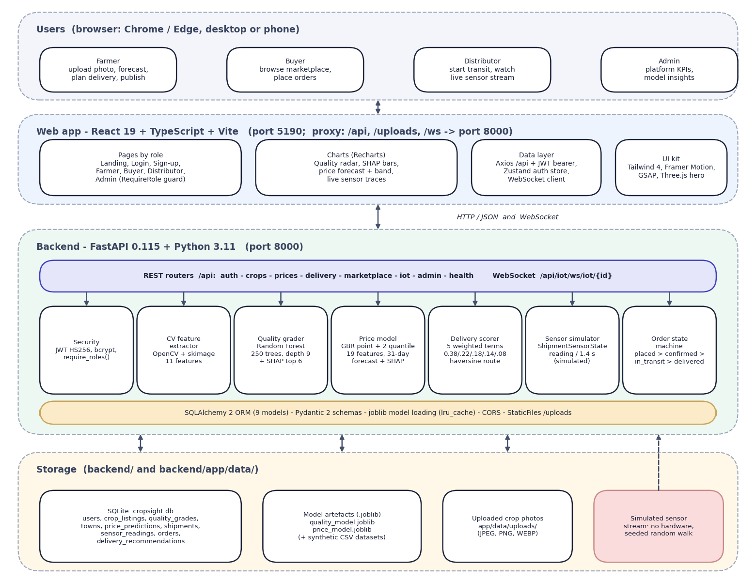
Fig. 5.1: System architecture of CropSight
The diagram shows five layers. At the top are the four kinds of user, each working in a browser: the farmer uploads a photo, forecasts the price, plans delivery and publishes; the buyer browses the marketplace and places orders; the distributor starts transit and watches the live sensor stream; the admin sees platform figures and model insights. Below them is the React 19 web application served by Vite on port 5190, which proxies /api, /uploads and /ws to the backend. It has role-based pages, Recharts charts (quality radar, SHAP bars, price forecast with its band, live sensor traces), a data layer (Axios with the bearer token, a Zustand authentication store and the WebSocket client) and the user-interface kit.
The backend is a FastAPI application on port 8000. Its REST routers (auth, crops, prices, delivery, marketplace, iot, admin and health) and one WebSocket route call seven building blocks: security (JWT and bcrypt, require_roles), the image feature extractor, the quality grader (Random Forest with SHAP), the price model (gradient boosting with two quantile models, a 31-day forecast and SHAP), the delivery scorer, the sensor simulator and the order state machine. SQLAlchemy maps nine models to SQLite; the joblib model files are loaded once and cached. Storage is local: the cropsight.db file, the two model artefacts with their synthetic CSV datasets, and the uploaded photos. The shaded box marks the sensor source as simulated: no hardware is connected.
The design follows five principles. Explain every prediction: the grade and the forecast each return the SHAP contributions that produced them, so the farmer sees the drivers and not only the result. Keep scoring transparent: the buyer ranking is a stated weighted sum, not a second black-box model. Enforce roles on the server: the web app hides screens a role should not see, but the decision is made by require_roles in the API and by the order state machine. Keep the heavy work local: image analysis, the models and the SHAP explanations run on the CPU in the same process. Isolate what is simulated: the market context for the price forecast (market_context()) and the sensor stream (ShipmentSensorState) are the only two places where data is generated instead of read, so a real weather and price feed or real sensors could replace them without changing the routes.

5.2 High-Level Workflow
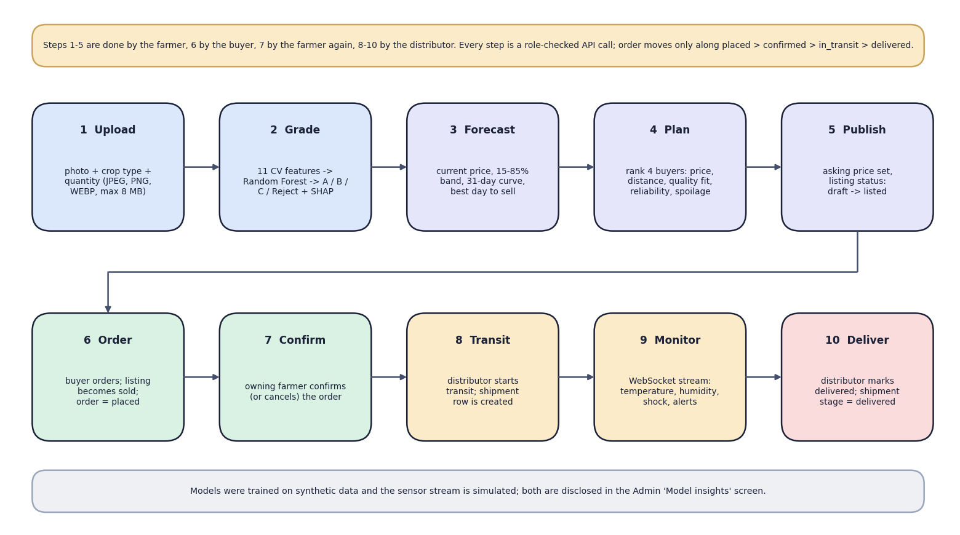
Fig. 5.2: High-level workflow
The ten steps follow one crop from the field to delivery. Steps 1 to 5 belong to the farmer: upload the photo with crop type and quantity, grade it (11 features, Random Forest, SHAP), forecast the price, plan delivery and publish the listing. Step 6 is the buyer's order, which marks the listing sold. Step 7 is the owning farmer's confirmation. Steps 8 to 10 belong to the distributor: start transit, which creates a shipment; watch the live sensor stream; and mark the order delivered. Every step is a role-checked API call and the order moves only along placed, confirmed, in transit and delivered. The note at the bottom states that the models were trained on synthetic data and the sensor stream is simulated.

5.3 Data-Flow Diagrams
The data-flow diagrams show how data moves through CropSight at three levels of detail: the context (level 0), the seven main processes with their data stores (level 1) and the expansion of the grading process (level 2).
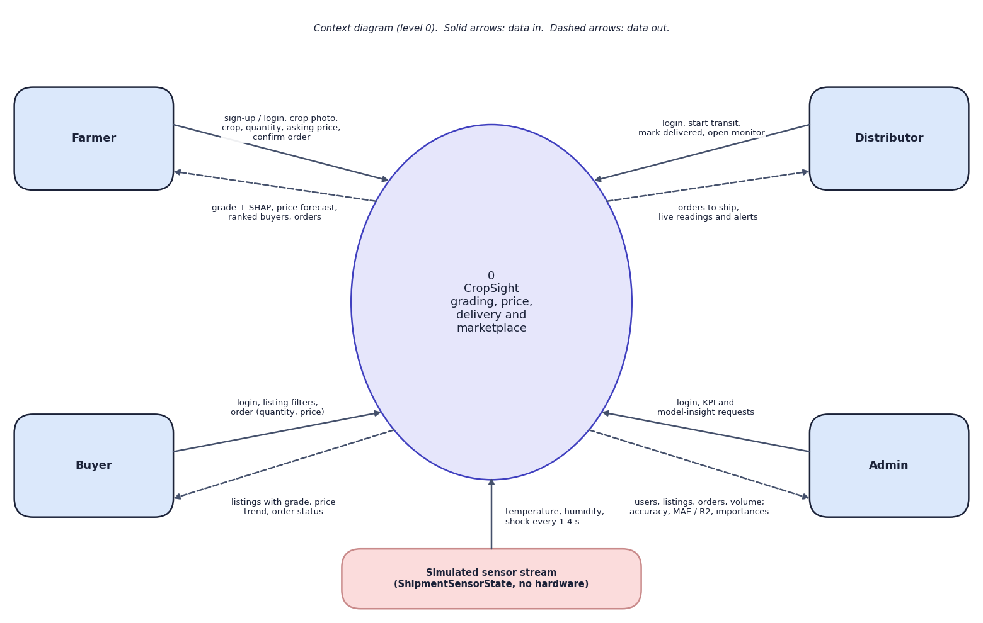
Fig. 5.3: Data-flow diagram, level 0 (context)
At the highest level CropSight is one process with five external entities. The farmer sends sign-up or login details, the crop photo, crop type, quantity, asking price and order confirmations, and receives the grade with its SHAP explanation, the price forecast, the ranked buyers and the orders. The buyer sends filters and orders and receives listings with grade, price trend and order status. The distributor sends login, start-transit and delivered actions and receives orders to ship and the live readings and alerts. The admin sends login and KPI or model-insight requests and receives user, listing and order totals, gross volume, and each model's accuracy or R2 and feature importances. The simulated sensor stream (ShipmentSensorState) supplies a temperature, humidity and shock reading every 1.4 seconds.
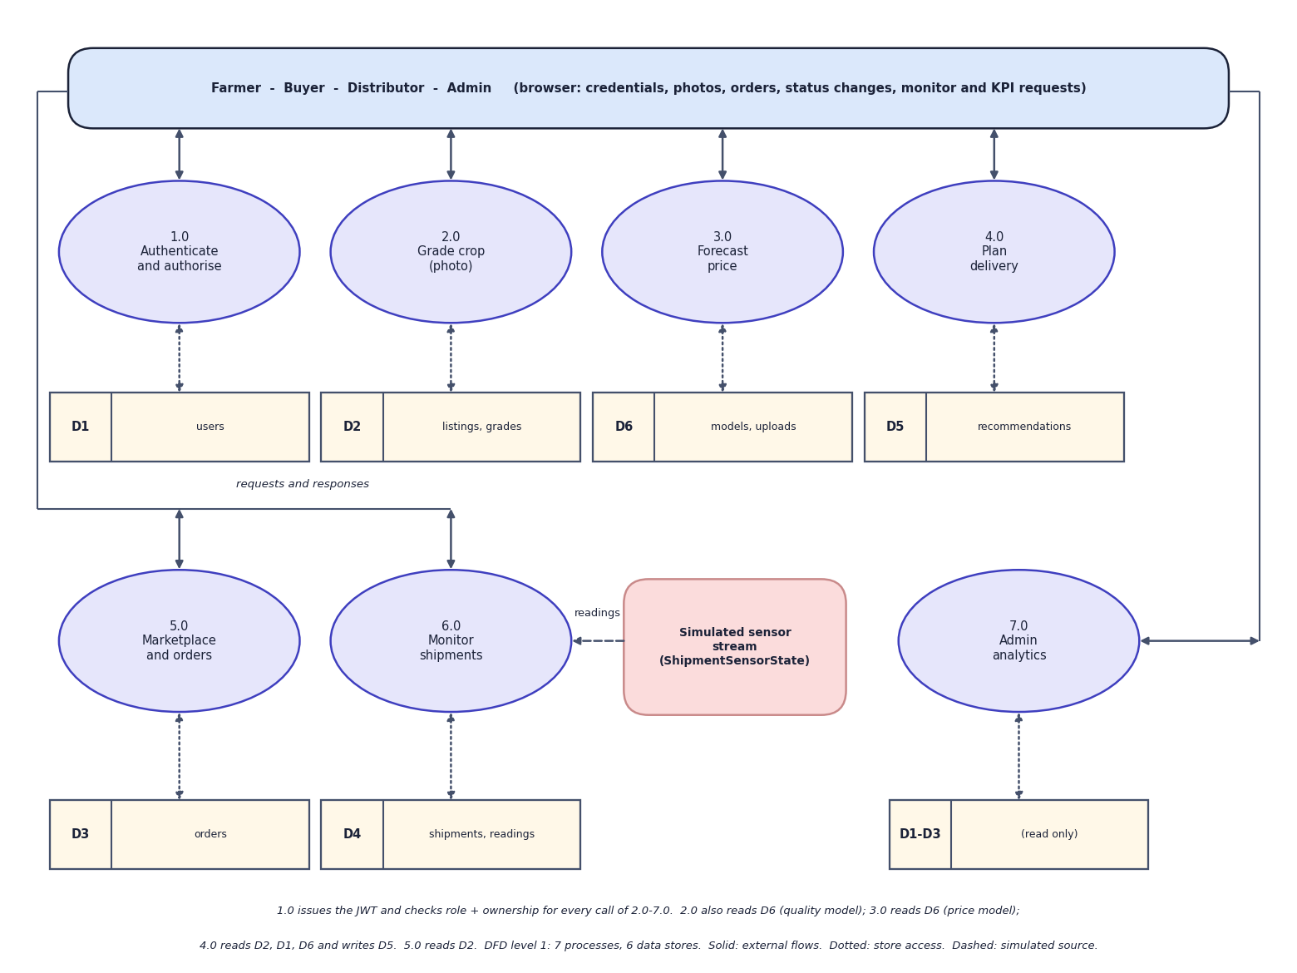
Fig. 5.4: Data-flow diagram, level 1
Level 1 splits CropSight into seven processes: authenticate and authorise (1.0), grade crop from a photo (2.0), forecast price (3.0), plan delivery (4.0), marketplace and orders (5.0), monitor shipments (6.0) and admin analytics (7.0). Six data stores hold the users (D1), the listings and grades (D2), the orders (D3), the shipments and sensor readings (D4), the stored delivery recommendations (D5) and the model files with the uploaded photos (D6). Process 1.0 issues the token and checks role and ownership for every call to processes 2.0 to 7.0. Process 2.0 reads the quality model from D6 and writes D2; 3.0 reads the price model from D6; 4.0 reads D2, the buyers in D1 and the towns, and writes D5; 5.0 reads D2 and writes D3 and the listing status; 6.0 receives readings from the simulated source and writes D4; 7.0 reads D1 to D3 and the two model files. Admin analytics is read-only.
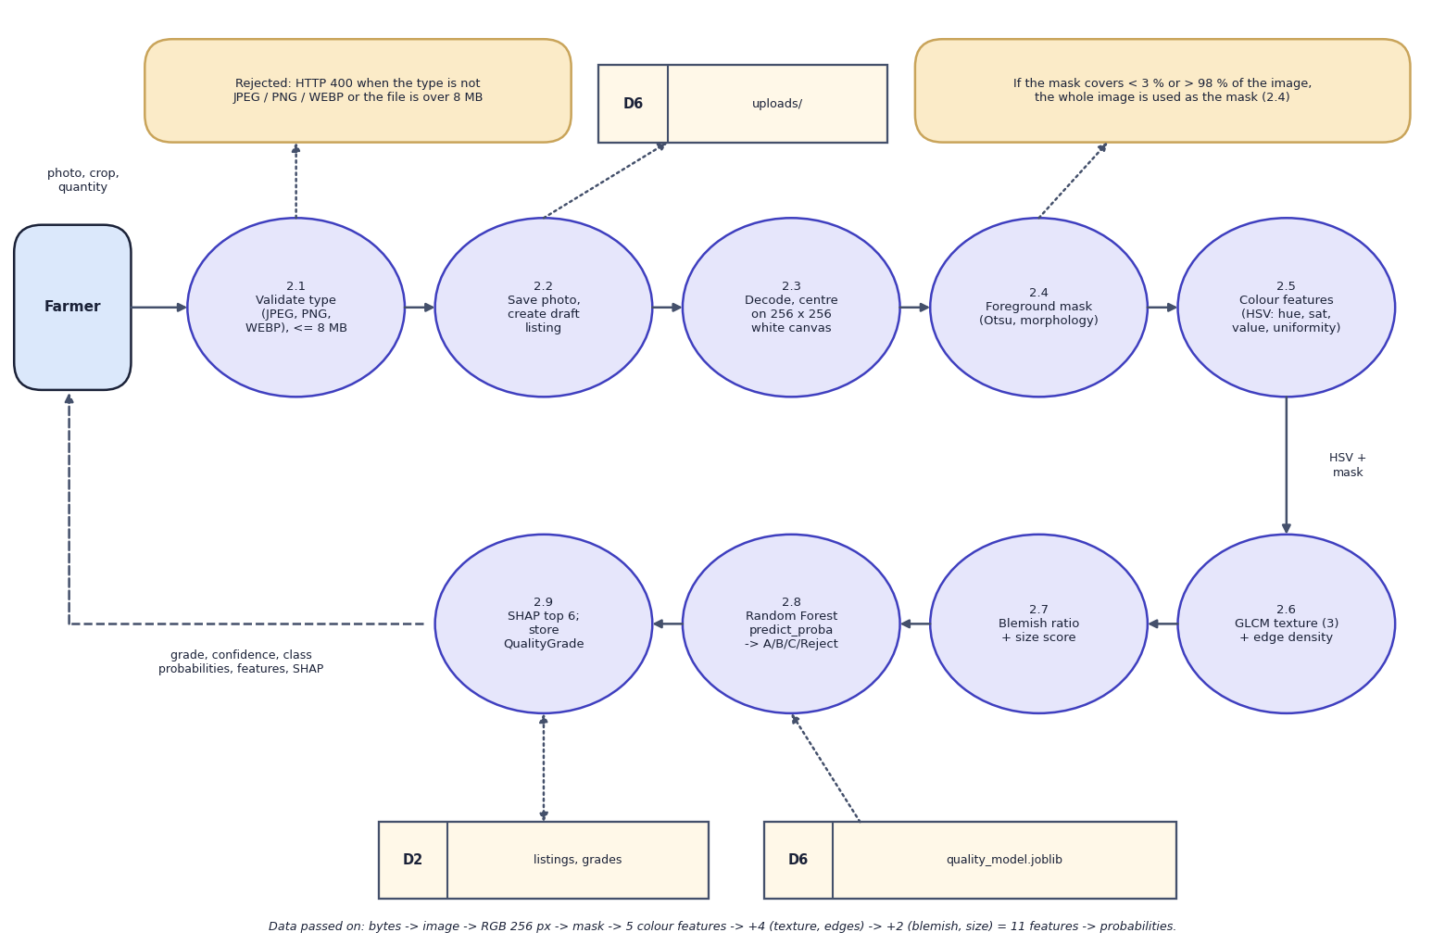
Fig. 5.5: Data-flow diagram, level 2: Grade crop (process 2.0)
Process 2.0 is expanded into nine steps that follow the code of upload_crop() and grade_image(). The type (JPEG, PNG or WEBP) and the size (8 MB at most) are validated first (2.1); a failure returns HTTP 400. The photo is saved under a random file name and a draft listing is created (2.2). The image is decoded and centred on a 256 x 256 white canvas (2.3). A foreground mask is made by Otsu thresholding on saturation, removal of bright low-saturation background and morphological opening and closing; if the mask covers less than 3 % or more than 98 % of the image, the whole image is used instead (2.4). Colour features are computed in HSV space: circular mean hue, mean saturation, mean value, saturation spread and colour uniformity (2.5). Three GLCM texture statistics and the edge density follow (2.6), then the blemish ratio and the size score (2.7). The 11 features go to the Random Forest, which returns class probabilities; the grade is the most probable class (2.8). SHAP gives the six strongest contributions and the result is stored as a QualityGrade row and returned (2.9).

5.4 UML Diagrams
Three UML views describe the design: the use-case diagram (who does what), the class diagram (what the code contains) and the sequence diagram (how the main flow runs). The two core algorithms are shown as flowcharts in Chapter 6.
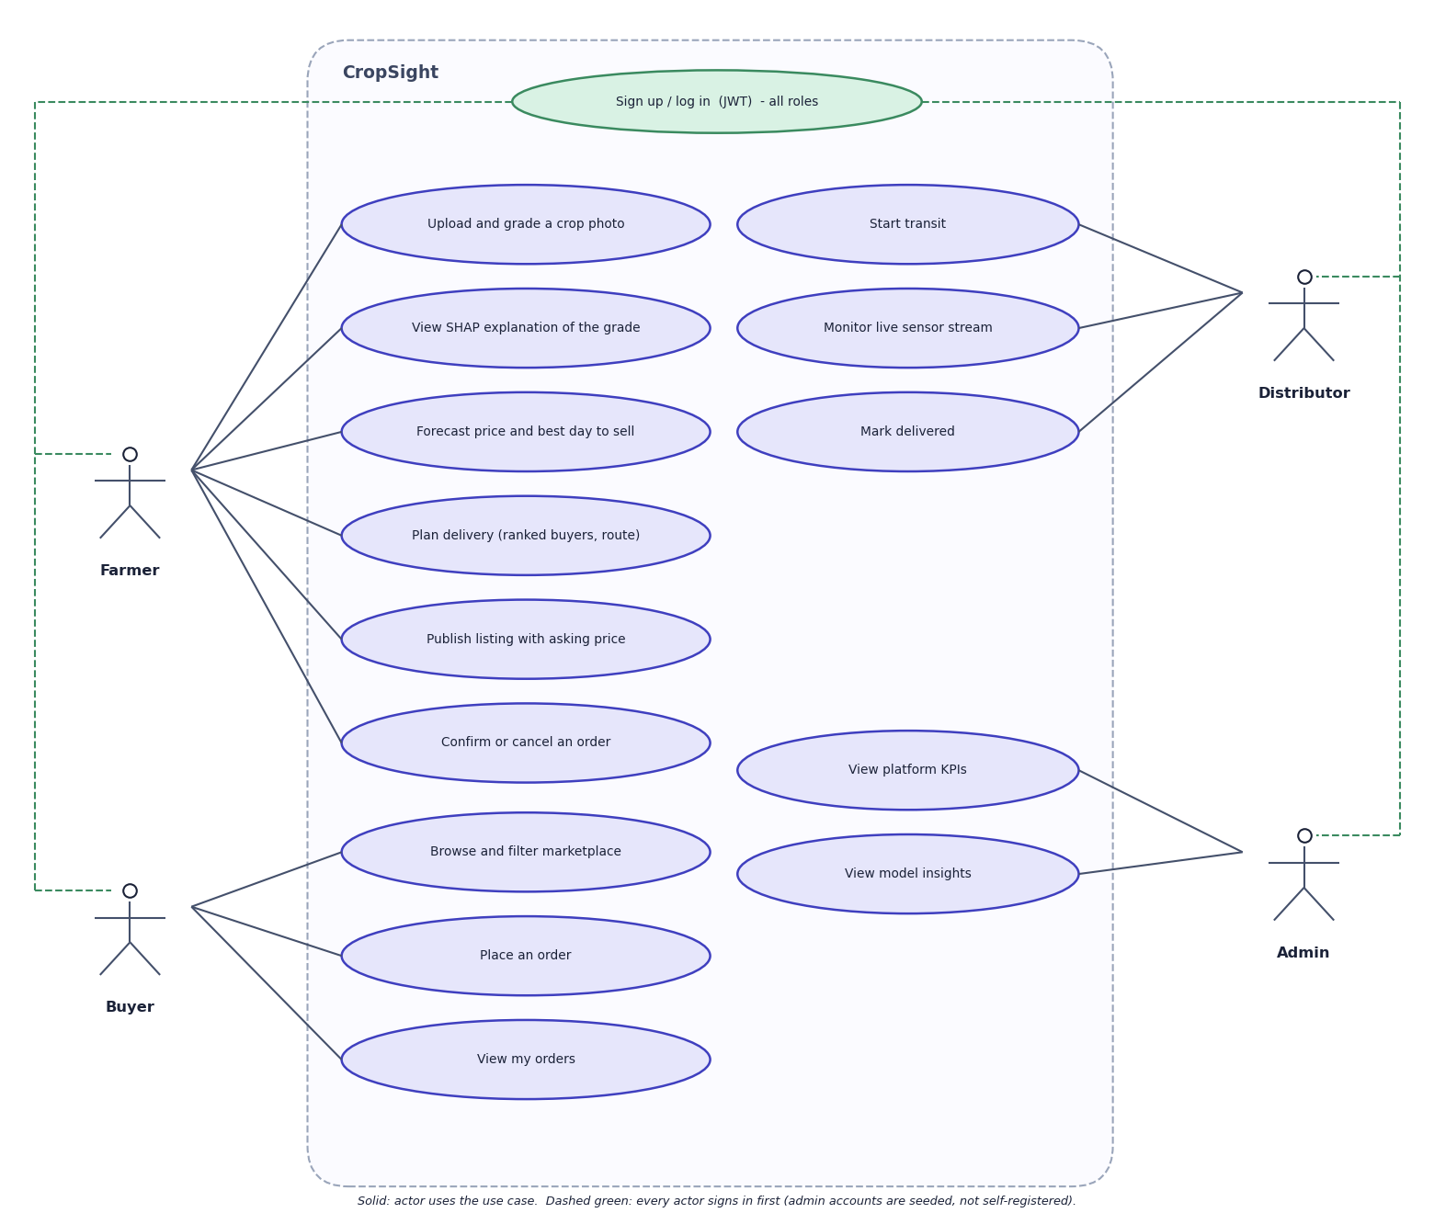
Fig. 5.6: Use-case diagram
Every actor first signs up or logs in. The farmer can upload and grade a crop photo, view the SHAP explanation of the grade, forecast the price and best day to sell, plan delivery, publish a listing with an asking price, and confirm or cancel an order. The buyer can browse and filter the marketplace, place an order and view their orders. The distributor can start transit, monitor the live sensor stream and mark an order delivered. The admin can view platform KPIs and the model insights. In the code the admin may also confirm, cancel or deliver any order; the diagram shows the use cases each role performs in normal operation. Admin accounts are seeded, not self-registered.
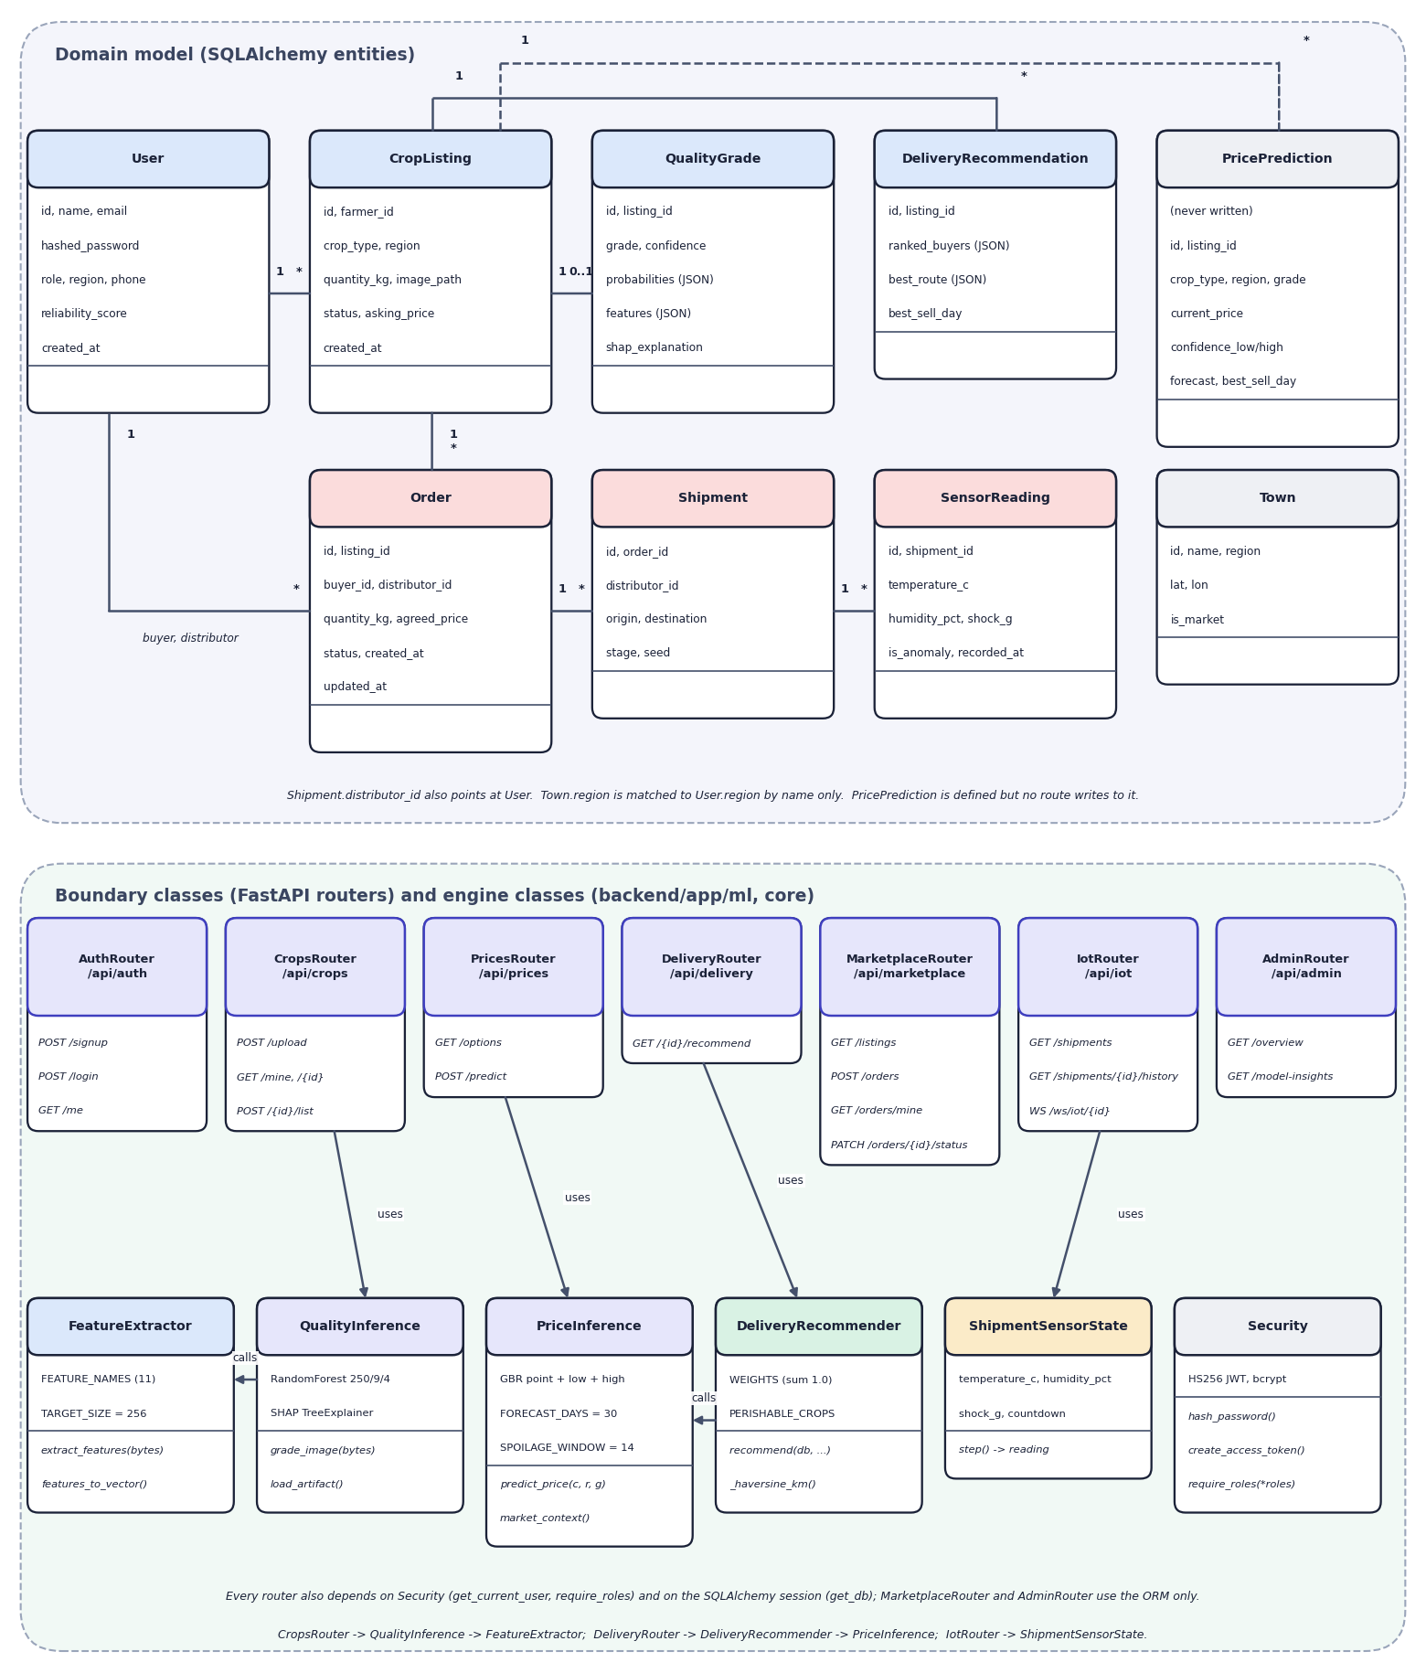
Fig. 5.7: UML class diagram
The upper part shows the domain model, the nine SQLAlchemy entities with their main attributes and associations (a user has many listings; a listing has one quality grade, many orders and many recommendations; an order has one shipment; a shipment has many sensor readings; Order points to users twice, as buyer and as distributor). PricePrediction is marked as never written and Town is matched to users by region name only. The lower part shows the boundary classes, the seven FastAPI routers with their routes, and the engine classes behind them: FeatureExtractor with the 11 feature names and the 256-pixel target size; QualityInference with the Random Forest (250 trees, depth 9) and the SHAP explainer; PriceInference with the point and two quantile models, the 30-day horizon and the 14-day spoilage window; DeliveryRecommender with the five weights and the perishable-crop set; ShipmentSensorState; and Security. Arrows show which router uses which engine.
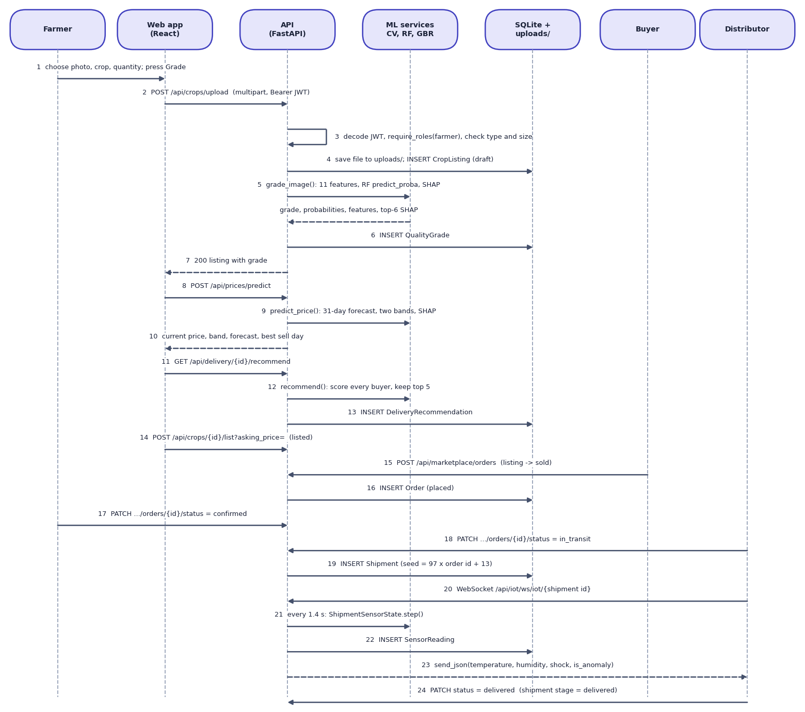
Fig. 5.8: Sequence diagram: from photo upload to delivery
The sequence shows the main flow in 24 steps across seven participants. The farmer chooses a photo and presses Grade; the web app posts the multipart request with the bearer token to /api/crops/upload. The API decodes the token, applies require_roles("farmer") and checks type and size (3), saves the file and inserts a draft CropListing (4), calls grade_image() on the machine-learning services (5), inserts the QualityGrade (6) and returns the listing (7). The web app then calls /api/prices/predict (8 to 10) and /api/delivery/{id}/recommend (11 to 13), after which the farmer publishes the listing (14). The buyer posts an order, which inserts an Order in the placed state and marks the listing sold (15, 16). The farmer confirms (17); the distributor starts transit, which inserts a Shipment whose seed is 97 times the order id plus 13 (18, 19) and opens the WebSocket (20); every 1.4 seconds the simulator produces a reading that is stored and pushed to the browser (21 to 23). Finally the distributor marks the order delivered and the shipment stage becomes delivered (24).

5.5 Database Design
The database is SQLite, created by SQLAlchemy 2 at start-up with create_all; there are no migrations. Results that are read and written whole (class probabilities, features, SHAP explanations, forecasts, ranked buyers) are stored as JSON columns. Uploaded photographs are stored as files under app/data/uploads with random names, and the table keeps only the path.
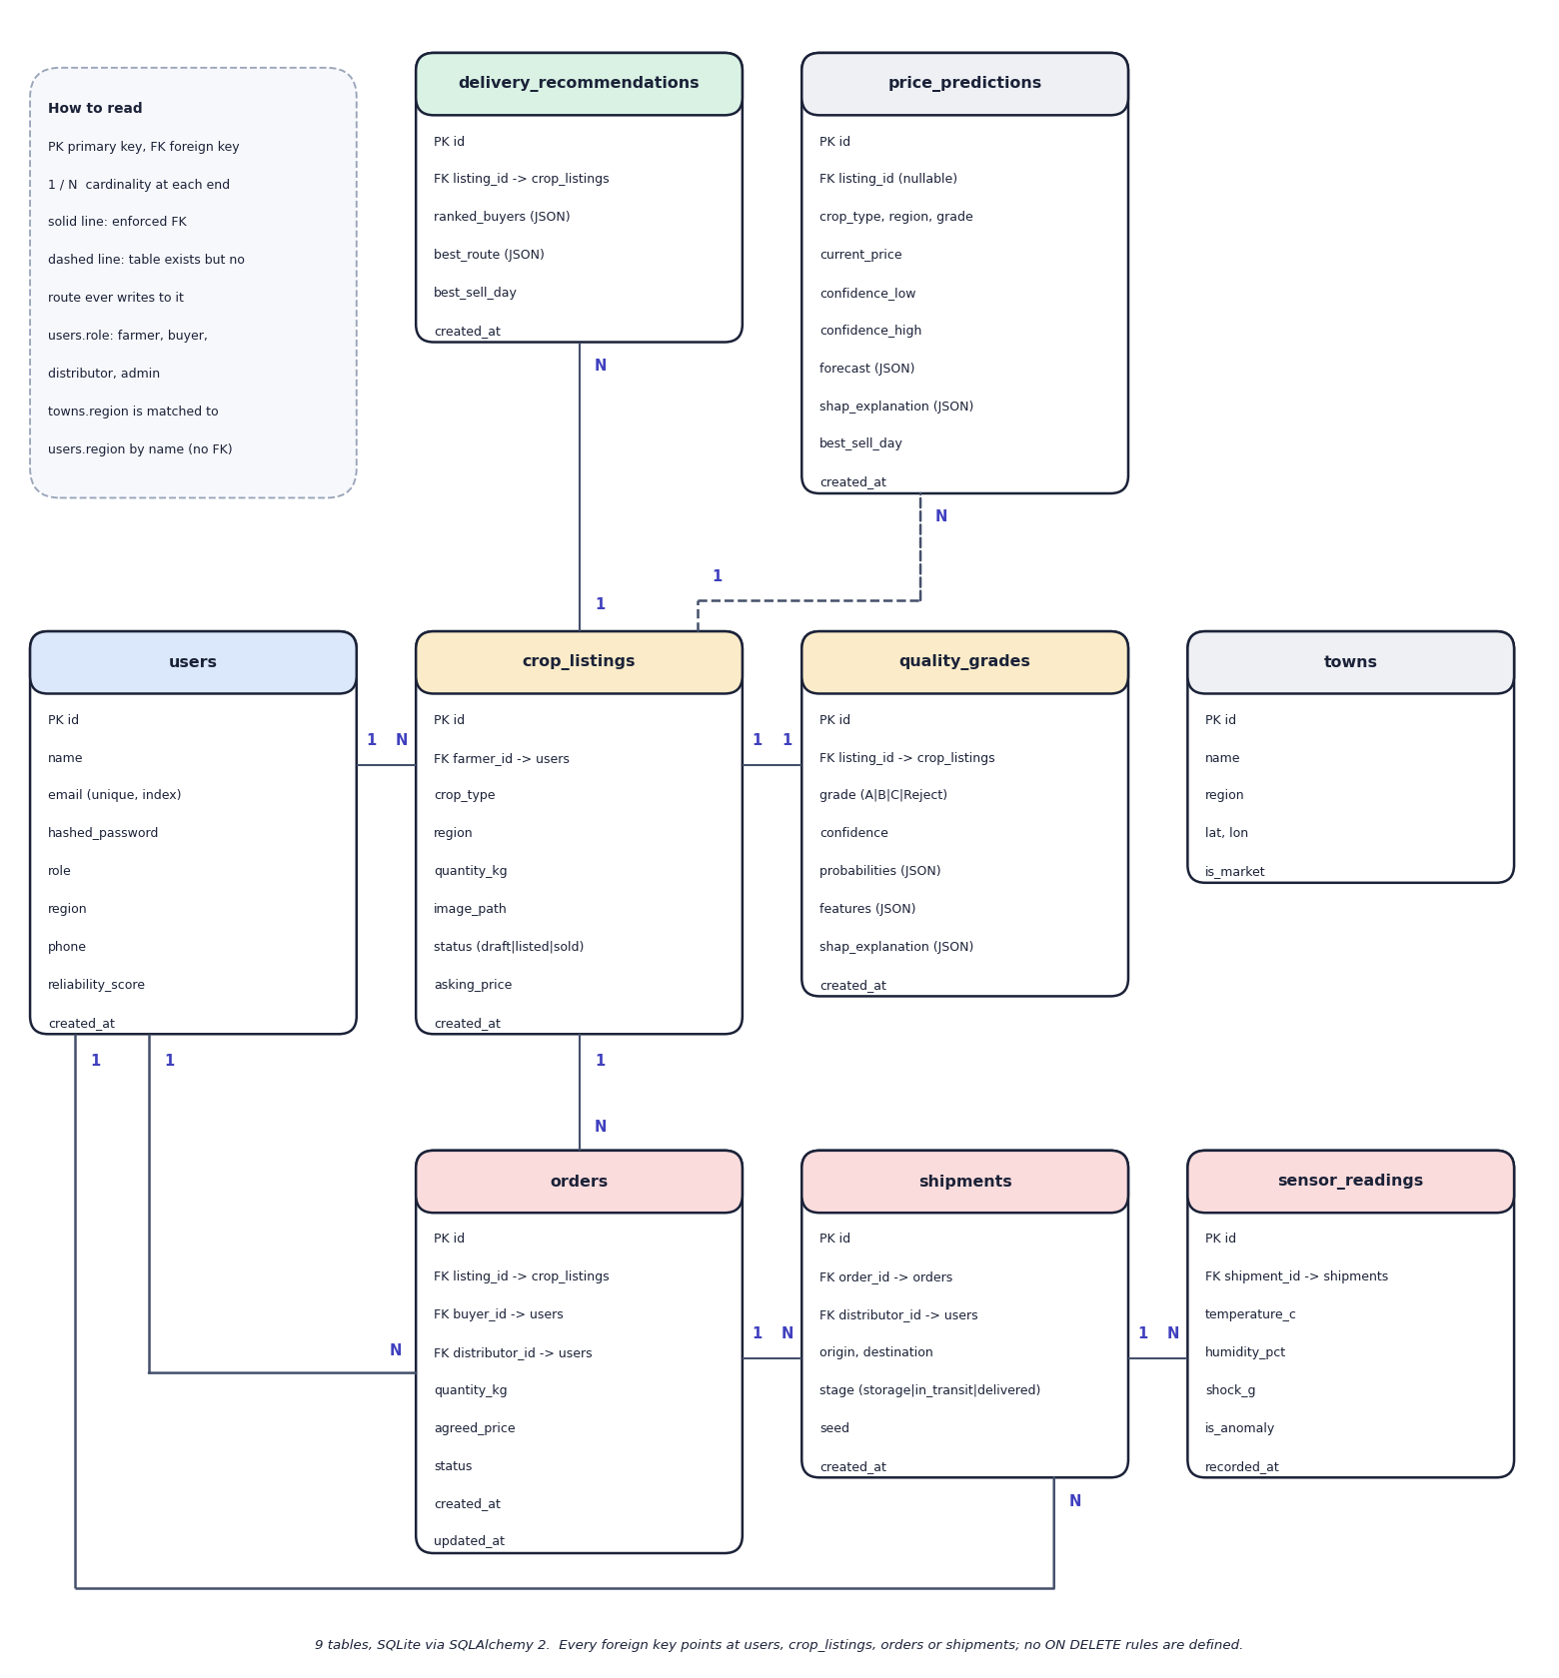
Fig. 5.9: Entity-relationship diagram (9 tables)
Nine tables are created by SQLAlchemy in SQLite. A user (farmer) owns many crop listings; each listing has at most one quality grade, many delivery recommendations and, once sold, orders. An order refers to a listing and to a buyer, and optionally to the distributor who took it; a shipment refers to an order and a distributor, and a shipment has many sensor readings. The towns table holds the eight market towns with coordinates and is joined to users and listings by region name only, not by a foreign key. The price_predictions table is drawn dashed: the model and table exist, but no route writes to it. No foreign key has an ON DELETE rule.
Table 5.1: Database tables
Table | Purpose | Key columns
users | Accounts of all four roles | id, name, email (unique, indexed), hashed_password (bcrypt), role (farmer, buyer, distributor, admin), region, phone, reliability_score (default 4.5), created_at
crop_listings | A graded crop lot | id, farmer_id (FK users), crop_type, region, quantity_kg, image_path, status (draft, listed, sold), asking_price, created_at
quality_grades | Grade of a listing | id, listing_id (FK), grade (A, B, C, Reject), confidence, probabilities (JSON), features (JSON, 11 values), shap_explanation (JSON), created_at
towns | Eight market towns | id, name, region, lat, lon, is_market
price_predictions | Defined for stored forecasts; never written by any route | id, listing_id (FK, nullable), crop_type, region, grade, current_price, confidence_low/high, forecast (JSON), shap_explanation (JSON), best_sell_day, created_at
delivery_recommendations | Stored delivery plan | id, listing_id (FK), ranked_buyers (JSON), best_route (JSON), best_sell_day, created_at
orders | A buyer's order | id, listing_id (FK), buyer_id (FK users), distributor_id (FK users, nullable), quantity_kg, agreed_price, status (placed, confirmed, in_transit, delivered, cancelled), created_at, updated_at
shipments | A transit of one order | id, order_id (FK, nullable), distributor_id (FK, nullable), origin, destination, stage (storage, in_transit, delivered), seed, created_at
sensor_readings | One simulated reading | id, shipment_id (FK), temperature_c, humidity_pct, shock_g, is_anomaly, recorded_at

Two design points should be noted. First, the schema keeps the quality grade in its own table with a one-to-one relationship to the listing, so a listing can exist as a draft before it is graded; if grading fails after the draft is saved, the draft remains without a grade, which is one of the known gaps. Second, no foreign key declares an ON DELETE rule and passwords are never stored in clear text: hashed_password holds a bcrypt hash.

5.6 Module Design
Table 5.2: Modules of CropSight
Module | Code | Responsibility
Application | backend/app/main.py | Creates the FastAPI app, CORS, the /uploads static mount, the start-up table creation and the /api/health route; includes the seven routers
Configuration and database | app/core/config.py, database.py | Settings (secret, algorithm, token lifetime, database URL), engine, session dependency
Security | app/core/security.py | bcrypt hashing, HS256 JWT creation and decoding, get_current_user, require_roles
Auth API | app/api/auth.py | Sign-up for farmer, buyer or distributor, login, current user
Crops API | app/api/crops.py | Upload with validation, grading, own listings, listing detail, publish
Prices API | app/api/prices.py | Catalogue options and price prediction (uses the listing's grade when a listing is given)
Delivery API | app/api/delivery.py | Owner-only recommendation, stored as a row
Marketplace API | app/api/marketplace.py | Listings with filters, orders, role-scoped order list, status transitions that create shipments
IoT API | app/api/iot.py | Shipments in transit, last 60 readings, WebSocket stream that stores each reading
Admin API | app/api/admin.py | Platform counts and gross volume; model cards with importances and training-data disclosure
Quality pipeline | app/ml/quality/ | feature_extraction.py (11 features), generate_dataset.py (synthetic profiles), train_model.py (Random Forest), infer.py (grade, probabilities, SHAP)
Price pipeline | app/ml/price/ | features.py (catalogue, 19 features, market context, price formula), generate_dataset.py, train_model.py (point and two quantile models), infer.py (forecast, best day, SHAP)
Delivery engine | app/ml/delivery/recommend.py | Weighted score, haversine distance, transit time, spoilage risk, top five buyers and best route
Sensor simulator | app/ml/iot/simulate.py | Seeded random walk with injected anomalies and the alert rule
Models and schemas | app/models/, app/schemas/ | Nine SQLAlchemy models and the Pydantic request and response types
Seed script and tests | scripts/seed_db.py, tests/ | Demo accounts, towns and one sample listing; 39 pytest tests
Web application | frontend/src/ | 17 page and layout components in six groups (marketing, auth, farmer, buyer, distributor, admin), 23 shared components, the API client, the authentication store and the types

The package app/ml/explain/ exists but is empty: SHAP is called directly inside the two inference modules.

5.7 User Interface Design
The web application has one landing page, a log-in page and a sign-up page, and a sidebar layout for each role. The farmer has a dashboard (upload form and own listings), a listing workspace (grade, price forecast, delivery planner, publication) and an orders page. The buyer has the marketplace, a listing detail page with an order dialog, and an orders page. The distributor has an active-deliveries page and a live monitoring page. The admin has an overview and a model-insights page. A route guard sends a user who opens another role's address back to their own home page.
Design decisions follow from the users. Every grade is shown with a badge, the confidence and a six-axis quality radar next to the SHAP bars that explain it. The forecast chart shows the confidence band and marks the best day to sell. The live monitoring page draws three sensor traces, shows a banner while the latest reading is out of range, and raises a toast when an alert begins. The admin model-insights page prints the algorithm, the measured accuracy, the feature importances and a sentence stating that the training data were synthetic. Colour is paired with text labels and the layout adapts to narrow screens.
One limitation of the interface should be stated: the statistics on the landing page (crops graded, price uplift, grading accuracy, farmers onboarded) and its price ticker are fixed marketing text in the page source, not measurements, and the figures in this report are the measured ones. The sign-in page also offers one-click demo accounts for the four roles. The screens below were captured from the running application with real crop photographs; the complete set is in Chapter 8 and Appendix C.
  Fig. 5.10: Log-in page with demo-account shortcuts | 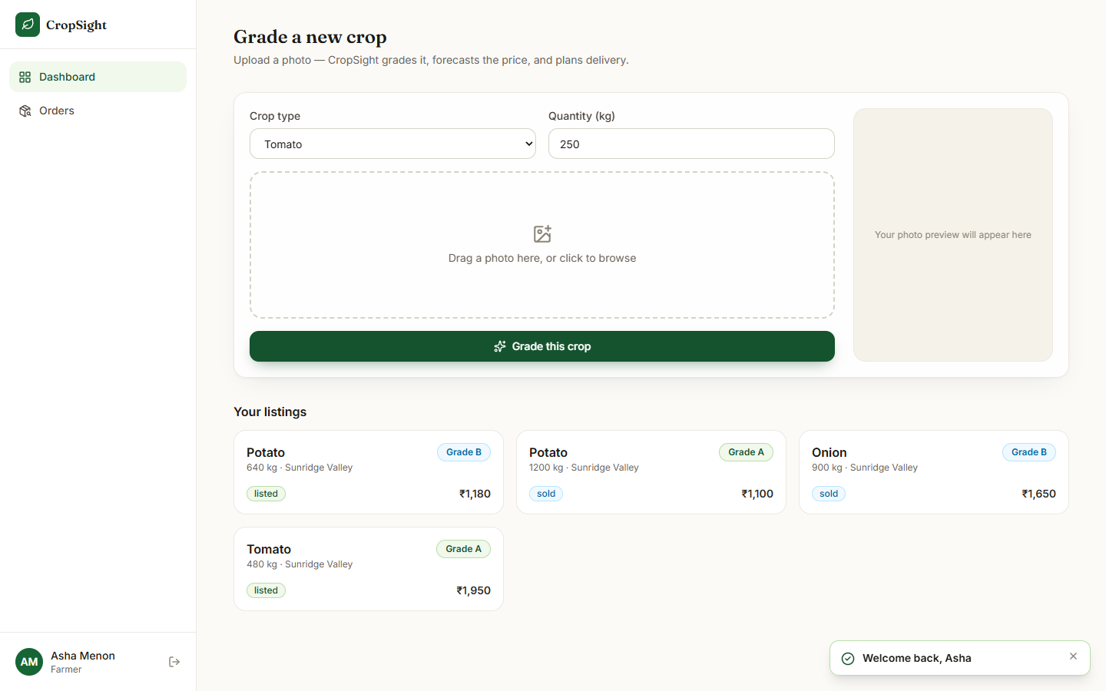  Fig. 5.11: Farmer dashboard: upload form and own listings

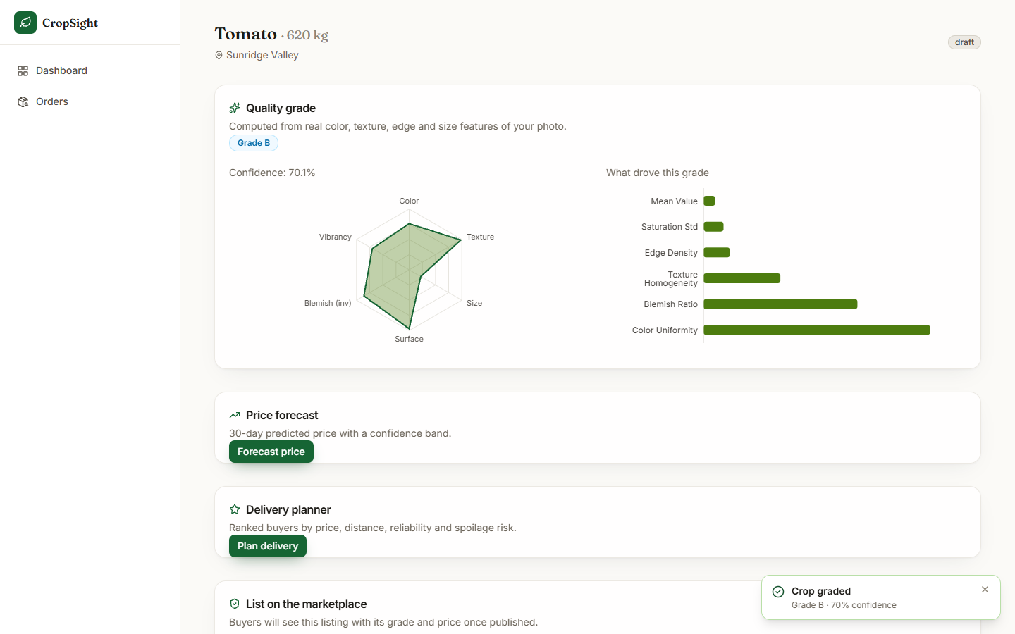  Fig. 5.12: Listing workspace: grade, confidence, quality radar and SHAP bars | 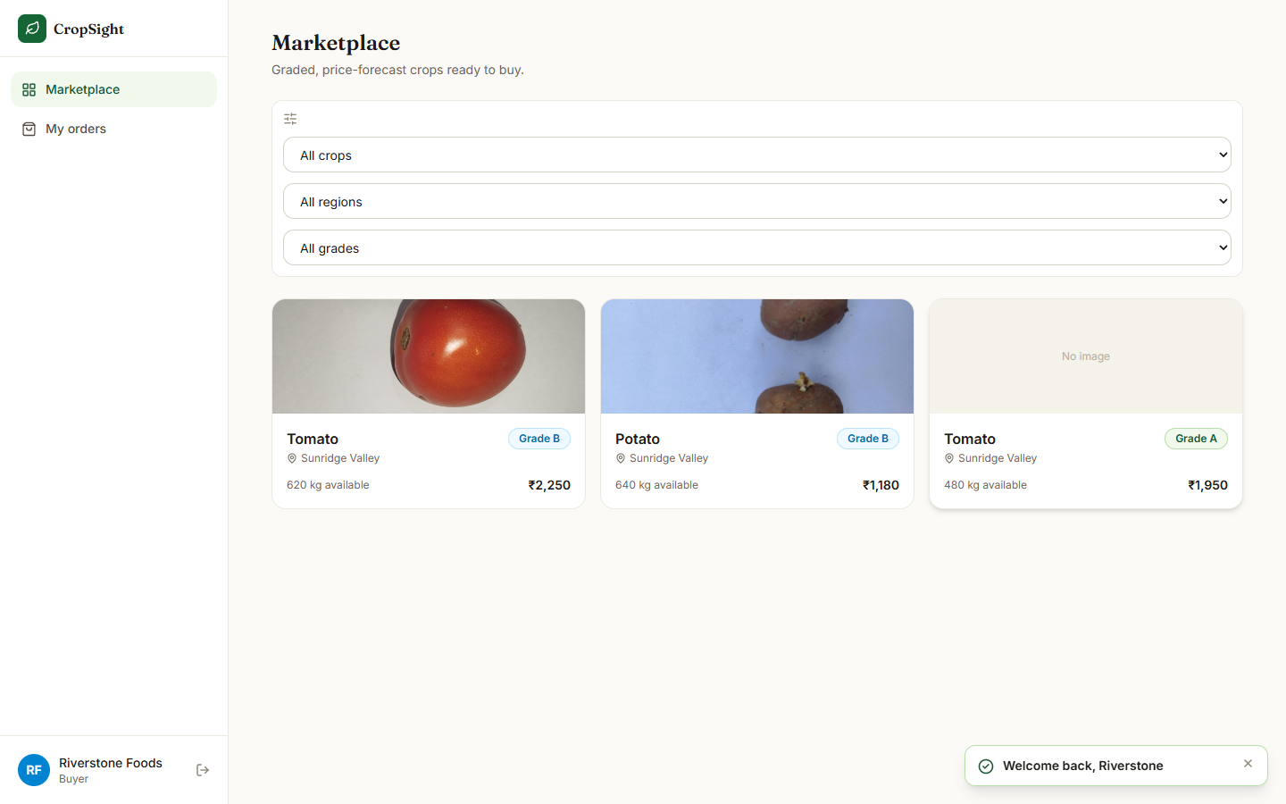  Fig. 5.13: Buyer marketplace with grade badges and asking prices

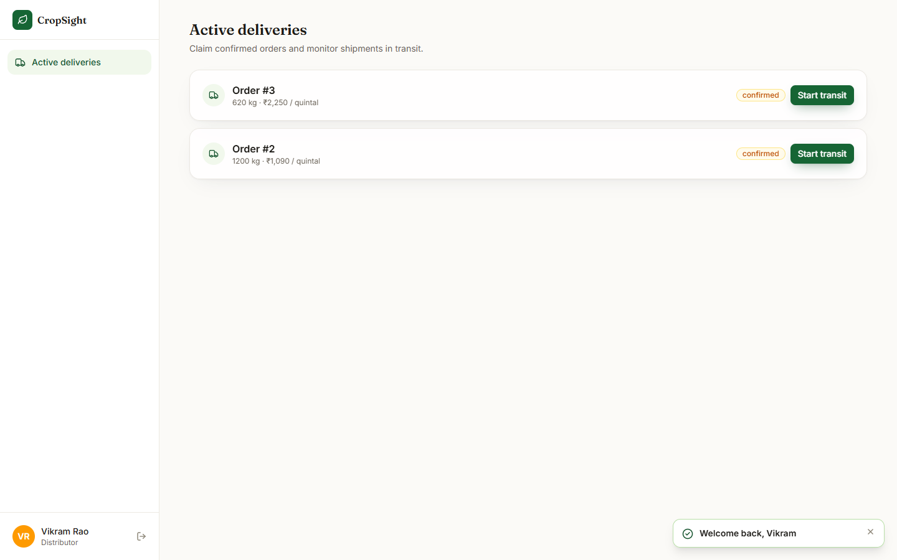  Fig. 5.14: Distributor: confirmed orders ready to ship | 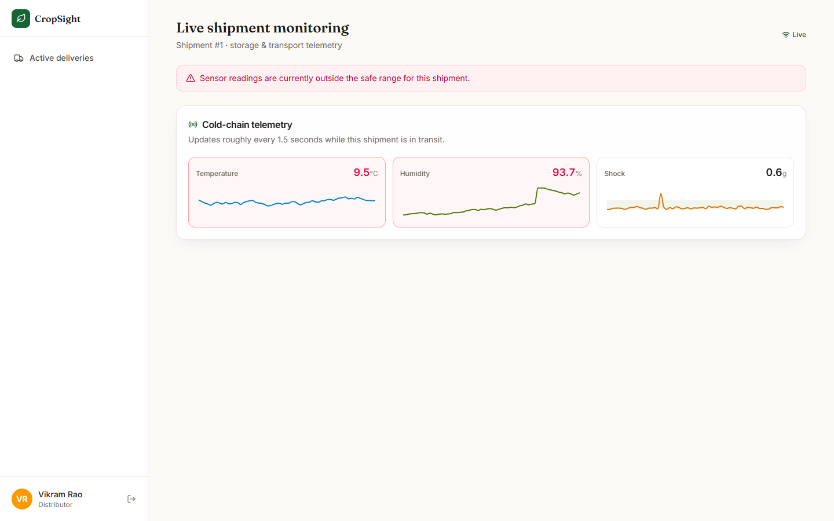  Fig. 5.15: Live monitoring with the out-of-range banner

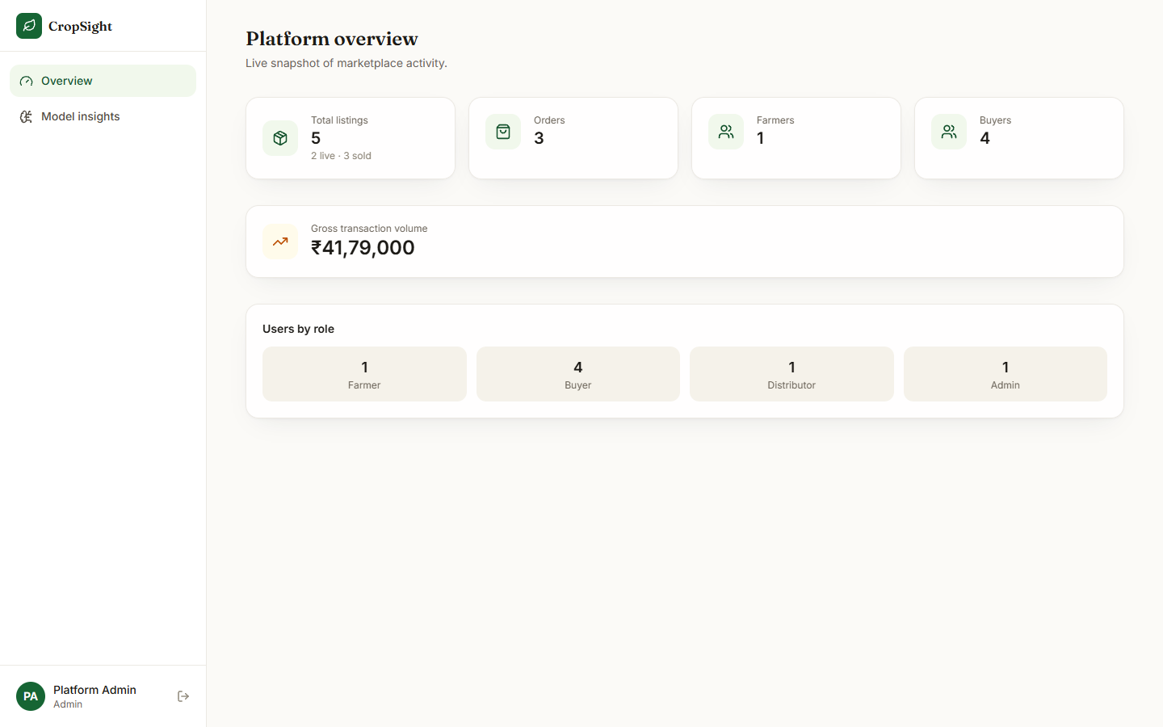  Fig. 5.16: Admin overview: counts and gross volume | 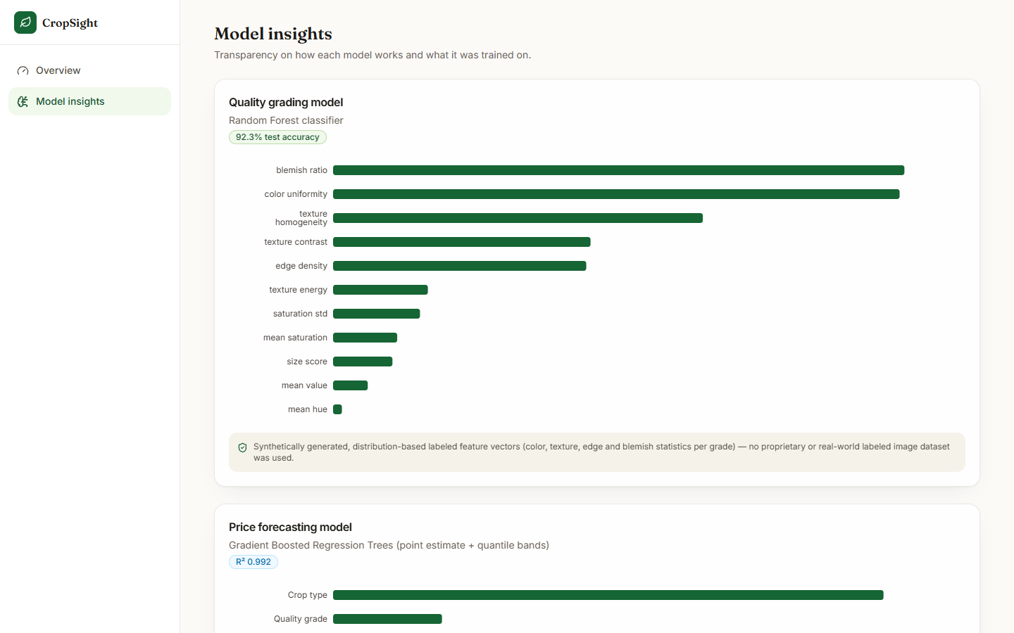  Fig. 5.17: Admin model insights with training-data disclosure

CHAPTER 6
METHODOLOGY AND SOFTWARE IMPLEMENTATION

6.1 Overall Methodology
CropSight follows a post-harvest decision chain: a farmer photographs a harvested crop, the system turns the photograph into numbers, grades it, estimates the price it should fetch and the best day to sell, ranks the buyers who would pay most for the least spoilage, publishes the lot to a marketplace, and then tracks the shipment until delivery. The base paper [1] combines IoT sensing, deep learning and explainable AI for pre-harvest advice (soil analysis, irrigation, crop and fertiliser recommendation). CropSight keeps that three-part idea (sensing, learning, explanation) and moves it after the harvest: image features replace soil readings, a price model replaces the irrigation advisor, SHAP [13], [14] provides the explanations, and a sensor stream monitors storage and transport.
Two differences from the base paper must be stated at the outset. First, the learning components are classical machine learning, a Random Forest classifier [10] on eleven hand-crafted image features and a gradient-boosted regressor [11] on nineteen market features, not the transformer-based models of the base paper. Second, both models are trained on synthetic data (section 6.2), because no labelled crop-image set and no market-price series were available to the project. The method is therefore a working, explainable end-to-end pipeline whose learned parts have been validated on their own generators and checked once against real photographs (Chapter 8), not a model validated in the field.
Table 6.1: Pipeline of CropSight
Step | Method | Output
1 Capture | Farmer uploads a JPEG, PNG or WEBP photo (at most 8 MB) with crop, quantity and region | Draft listing and stored image
2 Extract | OpenCV and scikit-image: foreground mask, HSV colour statistics, GLCM texture, Canny edges, blemishes, relative size | Vector of 11 features in [0, 1]
3 Grade | Random Forest (250 trees) and SHAP TreeExplainer | Grade A / B / C / Reject, class probabilities, top-6 feature contributions
4 Forecast | Gradient-boosted point model plus two quantile models on a 19-feature market row; context walked forward 30 days | Current price, 15-85 % band, 31-day curve, best sell day, SHAP drivers
5 Plan delivery | Weighted score of price, distance, quality fit, reliability and spoilage risk over the buyers | Top-5 buyers, best route, best sell day
6 Trade | Publish, order and four-state order machine, role-gated at every transition | Orders: placed, confirmed, in transit, delivered (or cancelled)
7 Monitor | Seeded sensor simulator streamed over WebSocket every 1.4 s; alarm rule on temperature, humidity and shock | Live traces, cold-chain alert, stored readings
8 Review | Admin KPIs and model cards (accuracy, MAE, R2, importances, training-data disclosure) | Overview and Model insights screens

6.2 Dataset
No labelled crop-image dataset and no historical market-price feed were available to the project, so the two learned models are trained on datasets generated by code in the repository. Two public photograph sets were used afterwards, not for training: to test whether the synthetic-trained grader transfers to real images and to supply real photographs for the demonstration. All four are summarised below.
Table 6.2: Datasets used
Dataset | Role | Source and licence | Size and split
Synthetic quality features | Trains and tests the Random Forest | generate_dataset.py, seed 42; project code | 6,000 rows, 1,500 per grade, 11 features; 6 % of labels (360) moved to a neighbouring grade; 80/20 stratified split (4,800 / 1,200)
Synthetic market series | Trains and tests the price models | generate_dataset.py, seed 7; project code | 23,360 rows = 8 crops x 8 regions x every 3rd day, 2022-01-01 to 2024-12-28; price 402 to 19,176 INR per quintal (mean 3,796); 85/15 random split (19,856 / 3,504)
Fresh and Rotten Fruits [8] | Real-photo check of the grader | Sultana, Jahan and Uddin, Data in Brief 2022; Hugging Face copy of Project-AgML; CC BY 4.0 | 3,200 photographs: 8 fruits (apple, banana, grape, guava, jujube, orange, pomegranate, strawberry) x 200 fresh and 200 rotten
Vegetable Classification, Bangladesh [9] | Real tomato, onion and potato photos for the demonstration | Project-AgML, Hugging Face; CC BY 4.0 | First 40 tomato, 40 onion and 40 potato images scanned; four photographs used on the screens

6.2.1 How the synthetic quality set is generated
Each grade is a set of independent normal distributions, one per feature, clipped to [0, 1]. The distributions overlap, so the classifier has a boundary to learn rather than separate clusters to memorise; then 6 % of the labels are moved to a neighbouring grade (A to B, B to C, C to B, Reject to C) to imitate grader disagreement. Table 6.2 lists the means used; the standard deviations range from 0.015 to 0.15.
Table 6.3: Mean of selected features per grade in the synthetic generator
Feature | A | B | C | Reject
mean_saturation | 0.62 | 0.52 | 0.40 | 0.28
color_uniformity | 0.90 | 0.74 | 0.55 | 0.35
texture_contrast | 0.18 | 0.30 | 0.46 | 0.64
texture_homogeneity | 0.86 | 0.72 | 0.56 | 0.38
edge_density | 0.09 | 0.15 | 0.23 | 0.33
blemish_ratio | 0.02 | 0.07 | 0.15 | 0.30
size_score | 0.82 | 0.68 | 0.52 | 0.35

6.2.2 How the synthetic price series is generated
Each row is one crop, region, grade and date. Base prices per quintal are Tomato 1,800, Onion 1,600, Potato 1,200, Wheat 2,400, Rice 2,800, Mango 4,200, Cotton 6,800 and Maize 2,000; the grade premium is 1.22 (A), 1.05 (B), 0.85 (C) and 0.45 (Reject); the region factor ranges from 0.93 to 1.08. Daily weather, demand, supply and fuel indices are drawn from a generator seeded by a hash of crop, region and date, so the same inputs always give the same context. The price is the closed formula of section 6.5 times (1 + noise) with noise drawn from N(0, 0.035). The model therefore learns a known formula; the measured noise floor (MAPE 2.80 %) is the best any model can score on this data.

6.2.3 Real photographs and how they were used
The 3,200 fruit photographs were passed through the real feature extractor and the shipped grader without any training, and the same features were then used to train a separate Random Forest on the real fresh/rotten labels, to separate the quality of the extractor from the quality of the synthetic-trained classifier (section 6.6). Fresh versus rotten is a binary freshness label, not an A/B/C/Reject grade; mapping fresh to {A, B} and rotten to {C, Reject} is an assumption of this check, and the fruits are not the crops of the application. The four photographs on the output screens are real tomato, onion and potato images chosen from the first 40 of each crop so that more than one grade appears; every scanned onion and tomato was graded B, and 39 of 40 potatoes were graded B, which is itself a finding.

6.3 Preprocessing: Image Features and Market Features

6.3.1 Computer-vision pipeline
Every feature of the grader is computed from the pixels of the uploaded photograph; nothing in feature_extraction.py is simulated. The steps are:
1. Decode and normalise. The image is converted to RGB, shrunk to fit 256 x 256 pixels, centred on a white 256 x 256 canvas and converted to BGR.
2. Foreground mask. The saturation channel is thresholded with Otsu's method [17]; pixels that are bright and nearly unsaturated (value above 235, saturation below 25) are removed as table or paper; a 5 x 5 opening and closing remove specks and holes. If the mask covers less than 3 % or more than 98 % of the canvas the whole image is used instead.
3. Colour. Mean hue (circular mean), mean saturation, mean value, the standard deviation of saturation and a uniformity score derived from it, all inside the mask.
4. Texture. The grey image is quantised to 16 levels and a grey-level co-occurrence matrix is built at distance 2 over four angles [15]; contrast, homogeneity and energy are averaged over the angles.
5. Edges. Canny edges (thresholds 60 and 150) [16]; edge density is the fraction of mask pixels that are edge pixels.
6. Blemishes. The share of mask pixels whose value is more than 1.15 standard deviations darker than the mask mean.
7. Size. The mask area as a share of the canvas, divided by 0.55 and clipped to 1.
The result is the vector (mean_hue, mean_saturation, mean_value, saturation_std, color_uniformity, texture_contrast, texture_homogeneity, texture_energy, edge_density, blemish_ratio, size_score), every component in [0, 1]. The extractor uses OpenCV [20] and scikit-image [19]. Two properties matter for the results: the size score measures how much of the frame the object fills, not its physical size, and the blemish score depends on the lighting of the photograph, so both are properties of the photograph as much as of the crop.

6.3.2 Market features
The price model uses nineteen features: sine and cosine of the month, rainfall (mm), average temperature (C), demand index, supply index, fuel-price index, days to harvest, a year-trend term, the grade premium, a regional factor, and eight one-hot crop columns. For a request the context (rainfall, temperature, demand, supply and fuel) for a given crop, region and date comes from a generator seeded with SHA-256 of those three values: the same request on the same day always gives the same numbers, and no external weather or market feed is involved. This is stated on the admin Model insights screen and repeated here because it determines what the forecast means.

6.3.3 Cleaning and validation
Uploads are checked for content type (JPEG, PNG or WEBP) and size (8 MB) before decoding. All features are clipped to [0, 1], so a degenerate photograph (blank, tiny, or a single colour) still yields a valid vector: a 64 x 64 image is graded without error in the tests. Missing-value handling and outlier removal as in the base paper [1] are not needed because the synthetic generators produce complete rows.

6.4 Algorithm Choice and Justification
Table 6.4: Algorithm choices
Decision | Chosen | Alternatives measured or considered | Why
Grader | Random Forest, 250 trees, depth 9 [10] | Logistic regression, k-NN, decision tree, histogram gradient boosting (all measured) | Handles mixed-scale features without scaling, gives probabilities and impurity importances, and TreeExplainer gives exact SHAP values [14]
Explanation | SHAP TreeExplainer [13], [14] | LIME [21] | Exact and fast for tree ensembles; the base paper [1] also uses XAI, here attached to the post-harvest models
Price model | Gradient boosting regressor, 300 trees, depth 4 [11] | Crop mean, crop x grade mean, linear regression, random forest (all measured) | Lowest error of those measured; additive structure suits a price built from multiplicative effects
Uncertainty | Two quantile gradient-boosting models, alpha 0.15 and 0.85 [12] | Residual-based intervals | Gives a band without distribution assumptions; measured coverage 69.3 % against 70 % nominal
Delivery | Transparent weighted score, not trained | A learned ranker | No real buyer-choice data exists; every ranking can be explained in plain terms
Sensing | Seeded random-walk simulator over WebSocket | Physical sensors | No hardware in the project; exercises the real streaming and storage path
Deep learning | Not used | CNN or transformer grader and TabNet / SwiFT price models as in [1], [7] | No labelled images or real price history to train them on; features are hand-crafted so the extractor can be inspected

The classifier was compared with simpler models on the same split of the synthetic data. The result is an honest one: a linear model and a nearest-neighbour model match the forest, because the synthetic classes are close to linearly separable. The forest was kept because it provides probabilities, importances and exact SHAP values from a single model, not because it is more accurate on this data.

6.5 Mathematical Formulation
The formulas below are those implemented in the code; symbols are defined where they are used.

6.5.1 Image features
Hue. OpenCV stores hue H in 0 to 179. With θ = H x π / 90 over the foreground pixels, mean_hue = ( atan2( mean(sin θ), mean(cos θ) ) mod 2π ) / 2π, a circular mean so that reds on either side of the hue wheel do not cancel. Saturation and value: mean_saturation = mean(S) / 255, mean_value = mean(V) / 255, σ_S = std(S) / 255 and color_uniformity = clip(1 - 2.2 σ_S, 0, 1).
Texture. With the grey image quantised to 16 levels, P(i, j) is the symmetric, normalised co-occurrence matrix at distance 2 for the angles 0, 45, 90 and 135 degrees [15]. contrast = Σ P(i, j) (i - j)², homogeneity = Σ P(i, j) / (1 + (i - j)²), energy = √( Σ P(i, j)² ), each averaged over the four angles; the stored contrast feature is clip(contrast / 40, 0, 1).
Edges, blemishes, size. edge_density = (number of Canny edge pixels in the mask) / |mask|. With μ_V and σ_V the mean and standard deviation of value in the mask, τ = μ_V - 1.15 σ_V and blemish_ratio = |{ p in mask : V(p) < τ }| / |mask|. size_score = clip( |mask| / (0.55 x 256²), 0, 1 ).

6.5.2 Random Forest and SHAP
The forest averages the class probabilities of T = 250 trees: P(c | x) = (1 / T) Σ_t P_t(c | x), and the grade is argmax_c P(c | x); the confidence shown to the farmer is the largest probability. For a tree ensemble f the SHAP value of feature i is φ_i = Σ over S ⊆ F \ {i} of [ |S|! (|F| - |S| - 1)! / |F|! ] ( f(S ∪ {i}) - f(S) ), the Shapley value of the feature over all subsets S of the feature set F [13]; TreeExplainer computes it exactly in polynomial time [14], and the six largest |φ_i| for the predicted class are returned with the feature values.

6.5.3 Gradient boosting, quantile bands and the price formula
The point model is F_m(x) = F_(m-1)(x) + ν h_m(x), with ν = 0.06 and m = 1 ... 300 regression trees h_m of depth 4 fitted to the residuals under squared error [11]. The two band models minimise the pinball loss ρ_α(u) = u ( α - 1[u < 0] ) with α = 0.15 and 0.85 [12]. The served band is [ min(q_0.15, p), max(q_0.85, p) ] around the point estimate p, so the displayed range always contains the estimate.
The synthetic generator prices a lot as P = B_c x g x r x D x (1 + 0.12 sin(2π m / 12)) x (1 - 0.001 max(0, rain - 150)) x (1 - 0.004 d) x fuel^0.15 x (1 + trend) x (1 + ε), where B_c is the crop's base price, g the grade premium, r the region factor, m the month, d the days since harvest, ε ~ N(0, 0.035) and the demand-supply term is D = clip( 0.65 + 0.7 demand / max(supply, 0.15), 0.55, 1.9 ). The model never sees this formula, only the rows it produces.

6.5.4 Forecast and best day to sell
Starting from today's context c_0, the context for day k is c_k = 0.8 c_(k-1) + 0.2 t_k, where t_k is the hash-generated context of that day (an exponentially weighted walk, so the curve is continuous rather than a new random jump each day). The forecast is p_k = f(row(c_k, max(0, d - k))) for k = 0 ... 30, and the recommended day is argmax over k in 0 ... 14 of p_k, the 14-day window being the assumed spoilage horizon.

6.5.5 Delivery score
For a buyer with offer o (the reference price times a hash factor between 0.90 and 1.18), reliability ρ out of 5, and distance δ km from the origin town computed with the haversine formula δ = 2R asin( √( sin²(Δφ / 2) + cos φ1 cos φ2 sin²(Δλ / 2) ) ), R = 6371 km: transit time τ = δ / 380 + 0.5 days; spoilage risk s = min(τ / span, 1) with span 5 days for Tomato, Mango, Onion and Potato and 21 days otherwise. The five normalised terms are price = min(o / (1.2 p), 1), distance = max(0, 1 - min(δ, 500) / 500), quality fit = 1.0, 0.85, 0.6, 0.1 for grades A, B, C, Reject, reliability = min(ρ / 5, 1) and 1 - s. The match score is S = 100 x (0.38 price + 0.22 distance + 0.18 fit + 0.14 reliability + 0.08 (1 - s)); the weights sum to 1.00.

6.5.6 Sensor simulator and alarm rule
For each shipment, seeded by 97 x order_id + 13, temperature and humidity follow random walks T_(t+1) = T_t + u1, u1 ~ U(-0.35, 0.35) and H_(t+1) = H_t + u2, u2 ~ U(-1.2, 1.2); shock g_t = max(0, N(0.3, 0.25)). Every 18 to 55 steps an event is injected: temperature +4 to +8 C, humidity +12 to +20 %, or shock +2.2 to +4 g. A reading is flagged if an event was injected at that step, or temperature lies outside [0.5, 9.5] C, or humidity outside [47, 83] %, or shock is at least 2.4 g. There is no pull back towards a set point, which determines the behaviour measured in section 6.6.

6.5.7 Evaluation measures
Accuracy, per-class precision, recall and F1 and the confusion matrix for the grader; MAE, RMSE, R² and MAPE for the price model; empirical coverage of the 15-85 % band; for the real-photo check the accuracy of the mapped binary decision and the area under the ROC curve (AUC) of P(A) + P(B) as a fresh-versus-rotten score.

6.6 Models, Training Configuration and Measured Results
Both models are trained in seconds on the CPU of the development machine. The tables give the real configuration and what was measured; every value is from experiments/*/metrics.json.
Table 6.5: Training configuration
Item | Quality grader | Price model
Algorithm | RandomForestClassifier | GradientBoostingRegressor (point) + 2 quantile GradientBoostingRegressor
Hyper-parameters | 250 trees, max depth 9, min leaf 4, random_state 42 | 300 trees, depth 4, learning rate 0.06; bands 250 trees, depth 3, alpha 0.15 / 0.85
Inputs | 11 image features | 19 market features
Data | 6,000 synthetic rows | 23,360 synthetic rows
Split | 80/20 stratified (4,800 / 1,200), random_state 42 | 85/15 random (19,856 / 3,504), random_state 42
Artefact | quality_model.joblib (model, feature names, test accuracy, report) | price_model.joblib (three models, feature columns, MAE, R2)
Training time | seconds on CPU | seconds on CPU

The measured results of both models (per-class scores, confusion matrix, seed study, baselines, ablation, noise floor, band coverage, time hold-out), the behaviour of the served forecast, the delivery score and the sensor stream, and the real-photograph check are reported in Chapter 8 (section 8.2), where they are set beside the output screens. In short: on its own synthetic test set the grader reaches 92.3 % accuracy and the price model R2 0.992 with MAPE 5.1 % (noise floor 2.8 %), but the grader does not transfer to real photographs (50.4 % accuracy, AUC 0.571), while the same eleven features retrained on real labels reach 90.6 %.

6.7 Application Architecture
The backend is a FastAPI application organised in layers. Routers in api/ (auth, crops, prices, delivery, iot, marketplace, admin) validate input and enforce roles; the machine-learning services live in ml/quality, ml/price, ml/delivery and ml/iot; SQLAlchemy models in models/ map to nine tables; Pydantic schemas in schemas/ define request and response types; core/ holds configuration, the database session and the JWT and password helpers. The models are loaded lazily on first use and cached; if an artefact is missing it is trained on demand. Uploaded images are written to app/data/uploads and served at /uploads.
The frontend is a single-page React 19 application in TypeScript built with Vite. React Router defines the routes for four roles (farmer, buyer, distributor, admin), each wrapped in a RequireRole guard that redirects a user to their own home; Zustand keeps the token and user in browser storage; an Axios instance attaches the bearer token and signs the user out on a 401 response; Recharts draws the radar, SHAP, forecast and sensor charts; Tailwind CSS 4, Framer Motion, GSAP, Lenis and a Three.js hero scene give the presentation. The Vite development server proxies /api, /uploads and /ws to the backend, so the browser sees a single origin.
Table 6.6: Technology stack of the implementation
Layer | Technology | Version
Language and runtime | Python; Node.js | 3.11.9; 24.19.0
Web framework | FastAPI with uvicorn; Pydantic | 0.115.6; 0.32.1; 2.10.3
Database | SQLAlchemy over SQLite | 2.0.36
Machine learning | scikit-learn; SHAP; NumPy; pandas | 1.5.2; 0.46.0; 1.26.4; 2.2.3
Computer vision | OpenCV (headless); scikit-image; Pillow | 4.10; 0.24; 11.0
Security | python-jose (HS256 JWT); passlib with bcrypt | 3.3.0; 1.7.4 with bcrypt 4.0.1
Frontend | React; Vite; Tailwind CSS; TypeScript | 19.x; 8.x; 4.x; 6.0
Size | Backend Python; frontend TypeScript | 1,980 lines; 3,302 lines (17 page and 23 other components)

The order of the pages follows the roles. Farmer: dashboard (upload and listings), listing workspace (grade, forecast, delivery plan, publish), orders. Buyer: marketplace with crop, region and grade filters, listing detail, orders. Distributor: active deliveries and live monitoring. Admin: overview and model insights. Public pages are the landing page, log-in and sign-up.

6.8 Key Code Walkthroughs

6.8.1 Foreground mask and texture features
The mask removes the bright, unsaturated table so that colour and texture statistics describe the crop; the co-occurrence matrix is built on the masked grey image.
Listing: Foreground mask in ml/quality/feature_extraction.py
_, mask = cv2.threshold(sat, 0, 255, cv2.THRESH_BINARY + cv2.THRESH_OTSU)
bright_bg = (val > 235) & (sat < 25)
mask[bright_bg] = 0
kernel = np.ones((5, 5), np.uint8)
mask = cv2.morphologyEx(mask, cv2.MORPH_OPEN, kernel)
mask = cv2.morphologyEx(mask, cv2.MORPH_CLOSE, kernel)
coverage = mask.mean() / 255.0
if coverage < 0.03 or coverage > 0.98:
mask = np.full(bgr.shape[:2], 255, dtype=np.uint8)

6.8.2 Grading with an explanation
grade_image() extracts the features, takes the class probabilities of the forest and attaches the six largest SHAP contributions for the predicted class.
Listing: Grade and probabilities in ml/quality/infer.py
proba = model.predict_proba(vector)[0]
classes = list(model.classes_)
grade = classes[int(np.argmax(proba))]
confidence = float(np.max(proba))
probabilities = {cls: float(p) for cls, p in zip(classes, proba)}

explainer = _explainer()
shap_values = explainer.shap_values(vector)
class_idx = classes.index(grade)
if isinstance(shap_values, list):
contribs = shap_values[class_idx][0]
else:
contribs = shap_values[0, :, class_idx]

6.8.3 Price forecast and best sell day
The context is walked forward one day at a time with an exponential blend, the point model is evaluated for each day, and the best day is the maximum over the first fourteen.
Listing: Forecast loop in ml/price/infer.py
forecast: dict[int, float] = {}
running_ctx = market_context(crop, region, today)
for offset in range(0, FORECAST_DAYS + 1):
d = today + timedelta(days=offset)
target_ctx = market_context(crop, region, d)
running_ctx = {k: 0.8 * running_ctx[k] + 0.2 * target_ctx[k] for k in running_ctx}
dth = max(0, days_to_harvest - offset)
row = build_row_from_context(crop, region, grade, d, running_ctx, dth, year_trend=row0["year_trend"])
vec = row_to_vector(row)
forecast[offset] = float(point_model.predict(vec)[0])

window = {k: v for k, v in forecast.items() if k <= SPOILAGE_WINDOW_DAYS}
best_sell_day = max(window, key=window.get)

6.8.4 Delivery score
Each buyer is scored on five normalised terms; the weights are constants that sum to one, so every ranking can be explained term by term.
Listing: Weighted match score in ml/delivery/recommend.py
price_norm = min(offered_price / (base_price * 1.2), 1.0)
distance_norm = max(0.0, 1.0 - min(distance_km, 500) / 500)
quality_fit = {"A": 1.0, "B": 0.85, "C": 0.6, "Reject": 0.1}.get(grade, 0.5)
reliability_norm = min(buyer.reliability_score / 5.0, 1.0)
transit_days = distance_km / 380 + 0.5
spoilage_risk = min(transit_days / spoilage_span, 1.0)

score = (
WEIGHTS["price"] * price_norm
+ WEIGHTS["distance"] * distance_norm
+ WEIGHTS["quality_fit"] * quality_fit
+ WEIGHTS["reliability"] * reliability_norm
+ WEIGHTS["spoilage_risk"] * (1 - spoilage_risk)
)

scored.append(
{

6.8.5 Order state machine
Transitions are declared in one table and checked before any role rule is applied; a distributor who starts transit also creates the shipment whose seed drives the simulator.

6.8.6 Sensor simulator step
The simulator moves each quantity by a small random step, injects an event when the countdown reaches zero and decides whether the reading is an anomaly.
Listing: ShipmentSensorState.step() in ml/iot/simulate.py
def step(self) -> dict:
self.temperature_c += self._rng.uniform(-0.35, 0.35)
self.humidity_pct += self._rng.uniform(-1.2, 1.2)
self.shock_g = max(0.0, self._rng.gauss(0.3, 0.25))

self._anomaly_countdown -= 1
is_anomaly = False
if self._anomaly_countdown <= 0:
kind = self._rng.choice(["temp_spike", "humidity_spike", "shock"])
if kind == "temp_spike":
self.temperature_c += self._rng.uniform(4.0, 8.0)
elif kind == "humidity_spike":
self.humidity_pct += self._rng.uniform(12.0, 20.0)
else:
self.shock_g += self._rng.uniform(2.2, 4.0)
is_anomaly = True
self._anomaly_countdown = self._rng.randint(25, 55)

self.temperature_c = max(-5.0, min(35.0, self.temperature_c))
self.humidity_pct = max(20.0, min(98.0, self.humidity_pct))

6.8.7 Token creation and role guard
Listing: Role dependency in core/security.py
def require_roles(*roles: str):
def dependency(user: User = Depends(get_current_user)) -> User:
if roles and user.role not in roles:
raise HTTPException(status_code=status.HTTP_403_FORBIDDEN, detail="Not authorized for this action")
return user

return dependency

6.9 Implementation Decisions and Reasoning
The table lists the main implementation decisions and the reason for each. Several of them are consequences of two constraints: the project had no real labelled data, and it had to run on one ordinary computer without a graphics card.
Table 6.7: Implementation decisions
Decision | Why
Classical machine learning (Random Forest [10], Gradient Boosting [11]) instead of a deep network | No labelled image set existed, the machine has no GPU, and the 11 features are computed from real pixels, so the model stays small, trains in seconds and can be explained with SHAP. The batch abstract speaks of deep learning; the shipped grader is not one
Hand-crafted computer-vision features (HSV colour with an Otsu threshold [17], GLCM texture [15], Canny edges [16], blemish and size) | Each feature has a meaning the farmer can read in the radar and SHAP charts; extraction is deterministic and needs no training data
Train on generated feature vectors with 6% label noise | A real labelled set was not available; the noise stops the forest from memorising separable clusters. The cost, shown in Chapter 8, is that real photographs fall outside the profiles
SHAP TreeExplainer for both models | Exact, fast attributions for tree ensembles [13], [14]; the top six contributions are returned with every grade and price
Quantile Gradient Boosting for the price band | Two extra models (alpha 0.15 and 0.85) give a 70% band without distributional assumptions [11], [12]; the displayed band is clamped to contain the point estimate
Forecast by walking a market context forward 30 days | A feed of weather, demand and supply did not exist, so the context is generated deterministically from crop, region and date; the same inputs give the same forecast on a day
Transparent weighted score for delivery, not a trained model | No delivery history exists; weights 0.38 / 0.22 / 0.18 / 0.14 / 0.08 can be read and defended, and the ranking was shown to be stable
Simulated sensor stream over a WebSocket | No hardware; a seeded random walk with injected events exercises the real path (WebSocket, history table, alert banner)
FastAPI and SQLAlchemy with SQLite; scikit-learn [18], scikit-image [19] and OpenCV [20] for the models and features | Typed request and response models, automatic documentation, no database server to install; sufficient for a single-machine demonstration
JWT bearer tokens and a role dependency on every route | Stateless authentication [23]; bcrypt password hashes; each role can reach only its own routes, and admins cannot be created by sign-up
Order state machine in one dictionary | placed to confirmed to in-transit to delivered is checked in one place, and each transition is bound to the role that may perform it
Vite proxy for /api, /uploads and /ws | The browser talks to one origin, so no cross-origin configuration is needed during development; ports 8000 and 5190 are fixed
Run the API without the auto-reload option | Observed in this setup: reload left orphaned worker processes holding the port with stale code; restart manually after backend edits
Models retrained at start-up if the artefact is missing | A fresh checkout works after the seed script; artefacts, datasets, the database and uploads are not committed
Admin page that states the training data | The synthetic origin of both models is shown in the application itself, not hidden

6.10 API Design
The API is REST over JSON under /api with one WebSocket, 21 endpoints in all. Interactive documentation (Swagger UI) is served by FastAPI at /docs. Every endpoint except health, sign-up, log-in and the option list needs Authorization: Bearer <token>; the WebSocket is not authenticated (see section 6.10). Errors have the form {"detail": "message"} with status 400, 401, 403, 404 or 422.
Table 6.8: API endpoints
Method | Path | Role | Purpose
GET | /api/health | any | Liveness
POST | /api/auth/signup | public | Create a farmer, buyer or distributor; returns a JWT
POST | /api/auth/login | public | Returns a JWT and the user
GET | /api/auth/me | signed in | Current user
POST | /api/crops/upload | farmer | Multipart photo and crop, region, quantity: draft listing, features, grade, SHAP
GET | /api/crops/mine | farmer | Own listings
GET | /api/crops/{id} | signed in | One listing
POST | /api/crops/{id}/list | owner farmer | Publish with an asking price
GET | /api/prices/options | public | Crops, regions, grades
POST | /api/prices/predict | signed in | Price, band, 31-day forecast, best day, SHAP
GET | /api/delivery/{id}/recommend | owner farmer | Top-5 buyers, route, best day; stored
GET | /api/marketplace/listings | signed in | Listed crops, filters crop, region, grade
GET | /api/marketplace/listings/{id} | signed in | Listing detail
POST | /api/marketplace/orders | buyer | Place an order; listing becomes sold
GET | /api/marketplace/orders/mine | signed in | Role-scoped orders
PATCH | /api/marketplace/orders/{id}/status | farmer, distributor, admin | Move an order along the state machine
GET | /api/iot/shipments | signed in | Shipments in transit
GET | /api/iot/shipments/{id}/history | signed in | Latest 60 sensor rows
WS | /api/iot/ws/iot/{id} | none | Sensor reading every 1.4 s, stored
GET | /api/admin/overview | admin | Users, listings, orders, volume
GET | /api/admin/model-insights | admin | Model cards and importances

Example: grade a crop. POST /api/crops/upload takes multipart/form-data with crop_type, region, quantity_kg and image, and returns the listing with its quality_grade object (grade, confidence, probabilities, features, shap_explanation.top_features). Example: price. The request and an abbreviated response:
Listing: Price request and response (shape)
POST /api/prices/predict
{"crop_type": "Tomato", "region": "Sunridge Valley", "grade": "B", "listing_id": 7}
-> {"current_price": 2272.0, "confidence_low": 2068.0, "confidence_high": 2272.0,
"forecast": {"0": ..., "1": ..., ... "30": ...}, "best_sell_day": 14, "shap_explanation": {"top_features": [...]}}

When listing_id refers to a graded listing, the grade of that listing replaces the grade in the request, so the farmer cannot price a lot at a better grade than it received.
The order status endpoint accepts {"status": "confirmed"}, "cancelled", "in_transit" or "delivered"; an illegal move returns 400 and an unauthorised actor 403.

6.11 Security and Error Handling
- Passwords are hashed with bcrypt through passlib; sign-up requires a password of at least six characters and a syntactically valid e-mail address (reserved domains such as .test are rejected by the validator).
- Tokens. A signed JWT [23] (HS256, python-jose) with a seven-day expiry carries the user id and role; every protected route decodes it and loads the user, and an invalid or tampered token returns 401.
- Role guards. require_roles() is a dependency that returns 403 for other roles; ownership of a listing is checked in the route (a foreign listing returns 404); the front end repeats the role check with RequireRole for navigation only.
- Registration. Only farmer, buyer and distributor can be created through the API; the admin account exists only in the seed script.
- Uploads. Only JPEG, PNG and WEBP content types are accepted, with a maximum of 8 MB; files are stored under a random UUID name.
- Order integrity. The state machine rejects skipped or repeated transitions, a listing can be ordered once, and delivery can only be recorded by the assigned distributor or the admin.
- CORS allows the origins in config.py (port 5173), which is not the port the app is served on (5190); the app works because the browser reaches the API through the Vite proxy on its own origin.
Known gaps, found by testing and review, and stated so that they are not mistaken for features. (1) A default signing secret is committed in config.py and must be replaced for any shared deployment. (2) The sensor WebSocket and the shipment history need no token, and any signed-in user can read any listing or shipment. (3) Any distributor can start transit on any confirmed order. (4) Order quantity and price are not validated: zero, negative or larger-than-listed values are accepted. (5) Crop and region names are not checked against the catalogue. (6) A corrupt image sent with an image content type makes the grader raise, the request fails with HTTP 500 and the draft listing created just before is left behind without a grade. (7) The admin 'gross volume' multiplies a price per quintal by kilograms and so overstates the figure by a factor of 100. (8) There is no rate limiting, HTTPS or audit log. Gaps 4, 5 and 6 are recorded as expected-failure tests (Chapter 7).

6.12 Installation and Execution
The application needs Python 3.11 and Node.js. All commands are run from the project folder 8.ProjectCode.
Table 6.9: Installation and execution
Step | Command | What it does
1 | cd backend; python -m venv venv; venv\Scripts\activate; pip install -r requirements.txt | Creates the environment and installs the pinned backend packages
2 | python -m app.ml.quality.train_model; python -m app.ml.price.train_model | Generates both synthetic datasets if absent and trains both models (written to app/data/)
3 | python scripts/seed_db.py | Creates the tables, eight towns, the demo accounts and one sample listing
4 | python -m uvicorn app.main:app --port 8000 | Starts the API at http://127.0.0.1:8000 (docs at /docs); do not use --reload on Windows
5 | cd frontend; npm install; npm run dev | Starts the web app at http://127.0.0.1:5190, proxying to the API
6 | python -m pytest tests -q (in backend) | Runs the 39 backend tests

The demo accounts created by the seed script are listed in Appendix B.

CHAPTER 7
SYSTEM TESTING

7.1 Testing Strategy
CropSight is checked at five levels: automated backend tests, measurement of the machine-learning components on their own data, a check of the grader against real photographs, measured API response times, and a scripted walk-through of the whole product in a real browser. The levels answer different questions. The automated tests ask whether the code behaves as designed, deterministically and without any external service. The measurements ask how accurate the models are on the data they were built from. The real-photo check asks whether the grader transfers beyond that data. The latency run asks whether the product is responsive, and the browser walk-through asks whether a person can use it from sign-up to delivery.
The backend suite is written with pytest and FastAPI's test client. Each run uses a throw-away SQLite file selected through the DATABASE_URL setting, seeds the demo accounts, and builds its own photographs with Pillow (a plain red ellipse on a white table, and the same ellipse covered with dark spots), so no external file is required. The real feature extractor, the real Random Forest, SHAP and the real price models run in every test; nothing is mocked. The suite contains 39 tests: 36 pass and 3 are expected failures (xfail) that assert the behaviour a hardened system should have and fail today, so that known gaps are reported rather than hidden. The full run takes about 30 seconds.

7.2 Unit Testing
Table 7.1: Unit tests (7)
Test | What it checks
test_feature_vector_contract | The extractor returns exactly the 11 named features, in order, each in [0, 1]
test_blemishes_raise_blemish_ratio_and_edges | A photograph with dark spots has a higher blemish ratio and edge density than a clean one
test_blank_image_does_not_crash | A 64 x 64 image is graded without error and gives one of the four grades
test_grading_is_deterministic | Grading the same photograph twice gives the same class probabilities
test_delivery_weights_sum_to_one | The five delivery-score weights sum to 1.00
test_simulator_is_deterministic_per_seed | The same shipment seed reproduces the same sensor sequence and a different seed does not
test_simulator_bounds_and_anomaly_flag | Over 800 steps temperature stays in [-5, 35] C, humidity in [20, 98] %, shock is non-negative, and at least one anomaly is flagged

These seven tests cover the pure logic that must be exact: the feature contract between the extractor and the classifier, the monotone effect of blemishes, robustness to degenerate images, repeatability, and the sensor simulator. Repeatability is checked to a tolerance of 1e-9 because the last binary digit of a floating-point probability can differ between calls.

7.3 Integration Testing
The remaining 32 tests call the running application through its HTTP interface, so that routing, authentication, validation, the database and the machine-learning services are exercised together.
Table 7.2: Integration tests (32 including the 3 expected failures)
Area | Tests | What is checked
Health and authentication | 8 | Health endpoint; sign-up then log-in then /auth/me; duplicate e-mail rejected; the admin role cannot be requested at sign-up; invalid e-mail and short password give 422; wrong password gives 401; protected routes need a token; a tampered token is refused
Role guards | 1 | A buyer cannot upload, a farmer cannot order, a non-admin cannot read the admin endpoints, a distributor cannot request delivery plans
Listings and grading | 8 | Upload returns a grade among A, B, C, Reject with probabilities summing to 1, 11 features and 1 to 6 SHAP entries; a blemished photo grades no higher than a clean one; wrong content type and oversize files rejected; own listings; publish; foreign or unknown listings give 404
Price | 5 | Option lists; response shape (31 forecast days, band contains the estimate, best day 0 to 14, SHAP list); A > B > C > Reject price; the listing's grade overrides the requested grade; unknown crop (xfail)
Delivery | 2 | At most five buyers, sorted by a score between 0 and 100, best route equals the top buyer; a farmer cannot plan another farmer's listing
Marketplace and orders | 5 | Filtered browsing; a complete order lifecycle (placed, confirmed, in transit, delivered) with every illegal or unauthorised move refused; an unpublished lot cannot be ordered; role-scoped order lists; non-positive quantity (xfail)
IoT | 2 | A shipment created through the order flow streams three valid readings over the WebSocket and stores history; an unknown shipment gives 404
Admin | 1 | Overview counts; model insights contain both models, 11 importances and the synthetic-data disclosure

Table 7.3: Backend test inventory (pytest, 26 October 2026)
Group | Tests | Passed | Expected failures
Unit | 7 | 7 | 0
Integration (HTTP) | 32 | 29 | 3
Total | 39 | 36 | 3

The web application is exercised by the browser walk-through described under functional testing; it is not covered by automated front-end tests.

7.4 Functional Testing
The functional tests follow the golden path of the product and were run against the live application on 26 October 2026 in Chrome at 1440 x 900, using real tomato, onion and potato photographs and the demo accounts. The farmer, buyer, distributor and admin steps were driven through the browser interface (Playwright); the extra listings and orders that populate the lists were created through the same API the interface calls. The screenshots in Chapter 8 are the captures made during this run.
Table 7.4: Functional test cases (live walk-through)
No. | Requirement | Test performed | Observed
F1 | Sign-in with a role-based home | Log in as farmer, buyer, distributor, admin | Pass: each role lands on its own dashboard
F2 | Reject bad credentials | Log in with a wrong password | Pass: the API returns 401 and the page reports it
F3 | Grade a crop from a photograph | Upload tomato_1.jpg, tomato, 620 kg | Pass: grade B, confidence 70.1 %, radar and SHAP bars shown
F4 | Forecast the price | Press Forecast price | Pass: INR 2,272 per quintal, range 2,068 to 2,272, curve, best day 9 Nov, SHAP drivers
F5 | Plan delivery | Press Plan delivery | Pass: four buyers ranked, best 67.7 % match (Harvest & Co.), route and transit time
F6 | Publish to the marketplace | Enter 2,250 and publish | Pass: listing visible to buyers with grade and price
F7 | Buyer places an order | Open listing, place order 620 kg at 2,250 | Pass: order placed, listing becomes sold
F8 | Farmer confirms | Confirm on the orders page | Pass: status confirmed
F9 | Distributor starts transit | Start transit, open Live monitor | Pass: shipment created, live traces appear
F10 | Cold-chain alert | Keep the monitor open | Pass: alert toast at 44.2 s (an injected humidity spike); red banner on at 215 s with temperature 9.5 C and humidity 93.7 %
F11 | Admin views | Open overview and model insights | Pass with a defect: gross volume is overstated 100 times (price per quintal multiplied by kilograms)
F12 | Model transparency | Open model insights | Pass: grader shown as 92.3 % accuracy and the synthetic-training disclosure is displayed

Every functional step passed except where a defect is noted, and one observation deserves emphasis: the photographs used in the walk-through were all graded B or A by the shipped grader (every scanned tomato and onion was B, 39 of 40 potatoes B), which is consistent with the real-photo check of Chapter 6 and means the C and Reject paths were exercised by the automated tests, not by real photographs.

7.5 Security Testing
Security testing is limited to the automated tests and a review of the validation paths. The tests confirm that a missing, malformed or tampered token is refused (401); that a buyer, farmer or distributor cannot reach another role's endpoints (403); that the admin role cannot be created through sign-up; that passwords shorter than six characters and invalid e-mail addresses are refused (422); that a wrong password fails with a generic message; that duplicate e-mail addresses are refused; that a farmer cannot publish or plan another farmer's listing (404); and that the order state machine refuses skipped, repeated and unauthorised transitions.
Findings from the review. The default signing secret is committed in the configuration file; the sensor WebSocket and the shipment history need no token; any signed-in user can read any listing; any distributor can start transit on any confirmed order; there is no rate limiting. Not tested: penetration testing, token expiry behaviour, HTTPS deployment, cross-site scripting in the front end, and malicious image files beyond the content-type and size checks.

7.6 Validation and Edge Cases
Table 7.5: Validation and edge cases
Case | Behaviour observed | Result
Upload with a text content type | HTTP 400 Upload a JPEG, PNG or WEBP image | Pass
Upload larger than 8 MB | HTTP 400 Image too large (max 8MB) | Pass
Corrupt file sent as image/jpeg | Grader raises, HTTP 500, and a gradeless draft listing remains in the database | Gap (xfail); later tests found the orphan listing
Blank or very small image (64 x 64) | Foreground mask falls back to the whole image; a valid grade is returned | Pass
Unknown crop or region in a price request | Priced from an all-zero crop encoding with no error | Gap (xfail)
Order with quantity -50 and price 0 | Accepted; the listing becomes sold | Gap (xfail)
Second order on a sold listing | HTTP 400 Listing is not available | Pass
Order on an unpublished (draft) listing | HTTP 400 | Pass
Skipping a stage (placed to delivered) | HTTP 400 with the current and requested status | Pass
Reopening a finished shipment | A new WebSocket restarts the simulator from its seed and writes duplicate history rows | Observed by design review
Unknown shipment history | HTTP 404 | Pass

The three expected failures are the same three gaps listed in Chapter 6: unvalidated catalogue values, unvalidated order quantity and price, and an unhandled corrupt image. They are kept in the suite as tests of the desired behaviour, so that fixing the code turns them into passes.

7.7 Performance Testing
Response times were measured against a live server on the same machine over 127.0.0.1 (an Intel Core i5-12500 with 6 cores and 12 threads, 15.7 GB of memory, no discrete GPU, Windows 11) while other jobs were running, so the figures are indicative rather than a benchmark. Each request type was repeated 20 to 30 times with real tomato photographs.
Table 7.6: API response times (live server)
Request | Runs | Median (ms) | 95th percentile (ms) | Max (ms)
Health check | 30 | 1.6 | 4.7 | 4.9
Marketplace listings | 30 | 17.7 | 36.5 | 49.1
Admin overview | 30 | 22.8 | 46.0 | 46.8
Price forecast (31 days, band, SHAP) | 30 | 54.9 | 119.4 | 123.4
Delivery recommendation | 30 | 99.8 | 147.9 | 148.8
Admin model insights | 30 | 112.9 | 149.5 | 447.7
Upload and grade (photo, features, forest, SHAP, database) | 20 | 173.9 | 207.3 | 208.1
Log in (bcrypt verification) | 30 | 325.3 | 349.0 | 356.8

Measured inside the process, the price model takes a median of 13.1 ms (95th percentile 29.9 ms, maximum 96.7 ms) over 256 crop, region and grade combinations, and the delivery recommendation a median of 64.7 ms (95th percentile 107.1 ms). Grading a photograph, the heaviest request, takes about 0.17 s at the median; log-in is the slowest request at about 0.33 s because bcrypt is deliberately slow. Extracting features from 3,200 full-size fruit photographs and classifying them took about ten minutes (about 0.19 s each, including decoding), measured while other jobs ran. Both models train in seconds, and the whole backend suite runs in about 30 seconds.
Not measured: concurrent users, memory use under load, behaviour with a large database, the front end's load time, and other hardware.

7.8 User Acceptance Testing
No user-acceptance test with farmers, buyers or distributors was carried out. The walk-through of the previous section was run by the project team and is a functional acceptance run, not a user study; it shows that the intended flow works, not that real users find it understandable or useful. A pilot in which farmers photograph their own produce and compare the grade with a trader's, and in which buyers judge the delivery ranking, is the most important piece of future work, and it needs real-labelled data first.

7.9 Limits of the Testing Done
- The machine-learning results (grader accuracy 92.3 %, price R2 0.992) measure agreement with the synthetic generators that produced the data; the only evidence about real images is the single check on 3,200 fruit photographs, which showed chance-level transfer (accuracy 50.4 %, AUC 0.571).
- The real-photo check uses fruits and a binary fresh/rotten label, not the application's crops and A/B/C/Reject grades, and the mapping between them is an assumption.
- The price 'forecast' and the buyer offers are generated from hashed values, not market data, and the sensor stream is a simulator; testing shows that the mechanisms work, not that their numbers match reality.
- The 39 backend tests use synthetic photographs and a temporary database; there are no automated front-end tests, no load or concurrency tests, no penetration tests and no browser compatibility matrix (Chrome only).
- All timing figures come from one machine that was running other jobs, so they vary between runs.
- No user study was carried out. Three gaps are known and recorded as expected failures; five further weaknesses (default secret, open WebSocket, broad read access, no rate limiting, the volume-unit error) were found by review rather than by tests.

CHAPTER 8
RESULTS AND OUTPUT SCREENS

8.1 Output Screens
Every screen below is a real capture of CropSight running with real data on 26 October 2026: real photographs of a tomato, onions and potatoes from a public vegetable dataset, the models trained from the project's code, and orders that moved through the full farmer, buyer and distributor flow. The farmer, buyer and distributor steps of the featured tomato lot were performed in the browser; the extra onion and potato listings and their orders were created through the same API the browser uses. The captures are 1440 by 900 pixels.
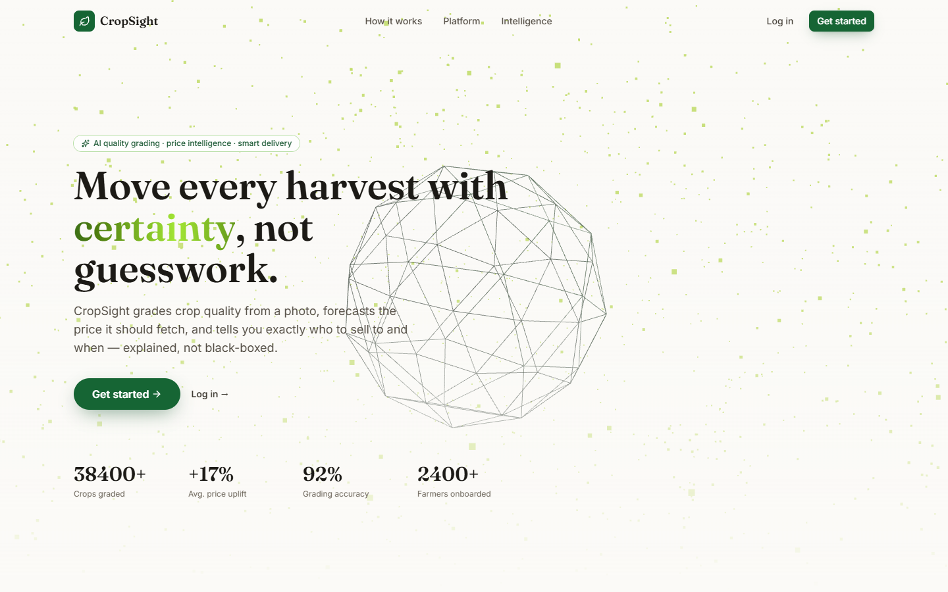  Fig. 8.1: Landing page | 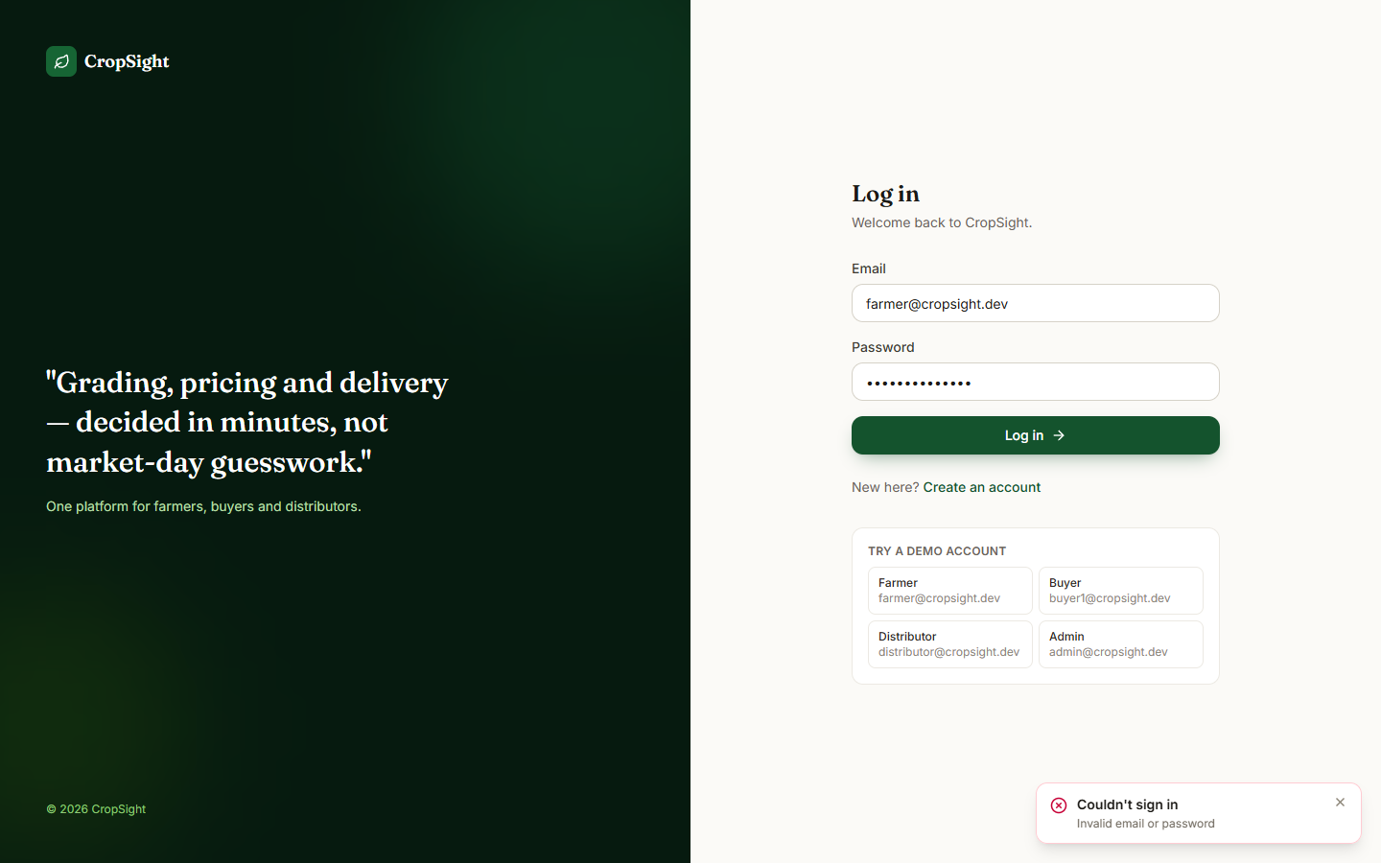  Fig. 8.2: Failure case: wrong password

Landing page. The public home page: the headline "Move every harvest with certainty, not guesswork", the line that CropSight grades quality from a photo, forecasts the price and says who to sell to and when, and the buttons Get started and Log in.
Failure case: wrong password. The log-in page after the farmer's e-mail was entered with a wrong password. The API answered HTTP 401 and the page shows the red message "Couldn't sign in - Invalid email or password".
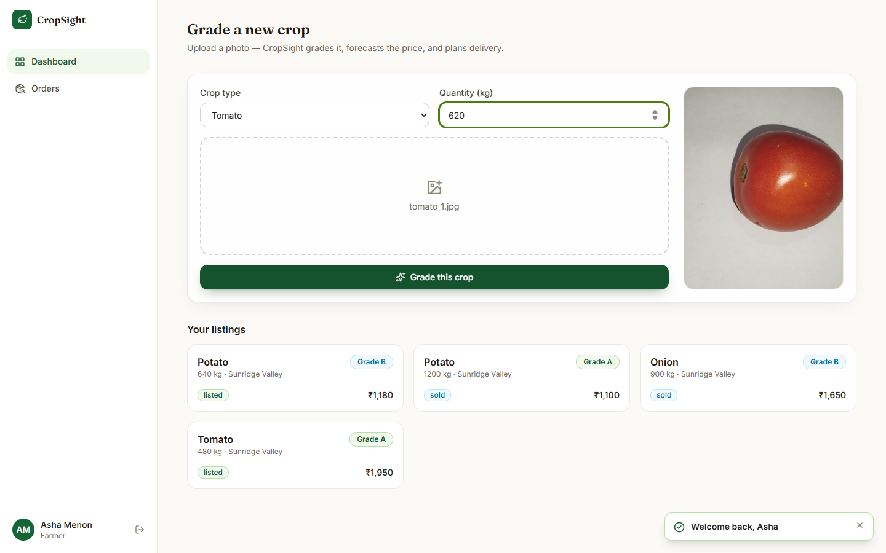
Fig. 8.3: Farmer dashboard with a real photograph selected

Farmer dashboard with a real photograph selected. The farmer chose the crop Tomato, a quantity of 620 kg and the real photograph tomato_1.jpg (from the public vegetable dataset); the photograph appears in the preview panel on the right.
Fig. 8.4: Grading result
Right after the upload the app opened the listing workspace: Tomato, 620 kg, Sunridge Valley, Grade B with 70.1% confidence. The radar chart summarises colour, texture, size, surface, blemish (inverted) and vibrancy; the bar chart "What drove this grade" shows the six largest SHAP contributions (colour uniformity, blemish ratio, texture homogeneity, edge density, saturation spread, mean value). The toast says "Crop graded - Grade B, 70% confidence".
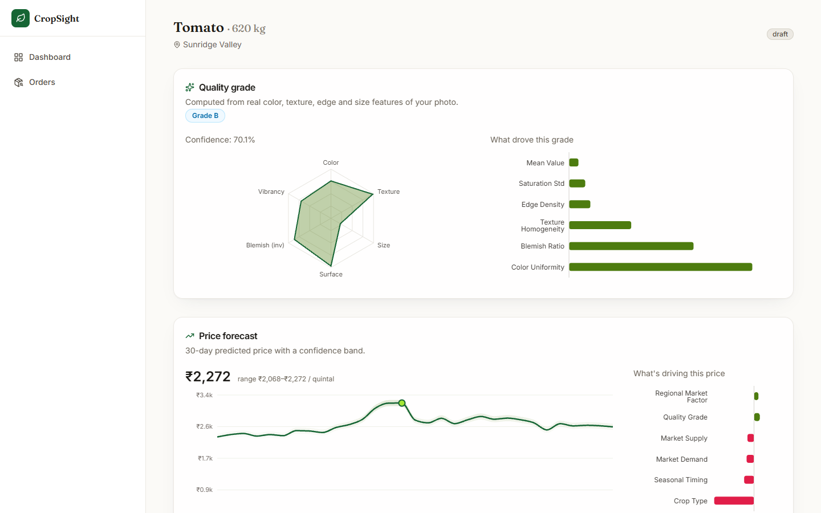
Fig. 8.5: Price forecast
After pressing Forecast price: the current price INR 2,272 per quintal with the range INR 2,068 to 2,272, the 30-day curve with its confidence band (peak near 9 November) and the SHAP bars "What's driving this price" - crop type is the largest (negative) contributor, quality grade and regional factor push up. The range ends exactly at the current price, because the displayed band is clamped to include the point estimate.
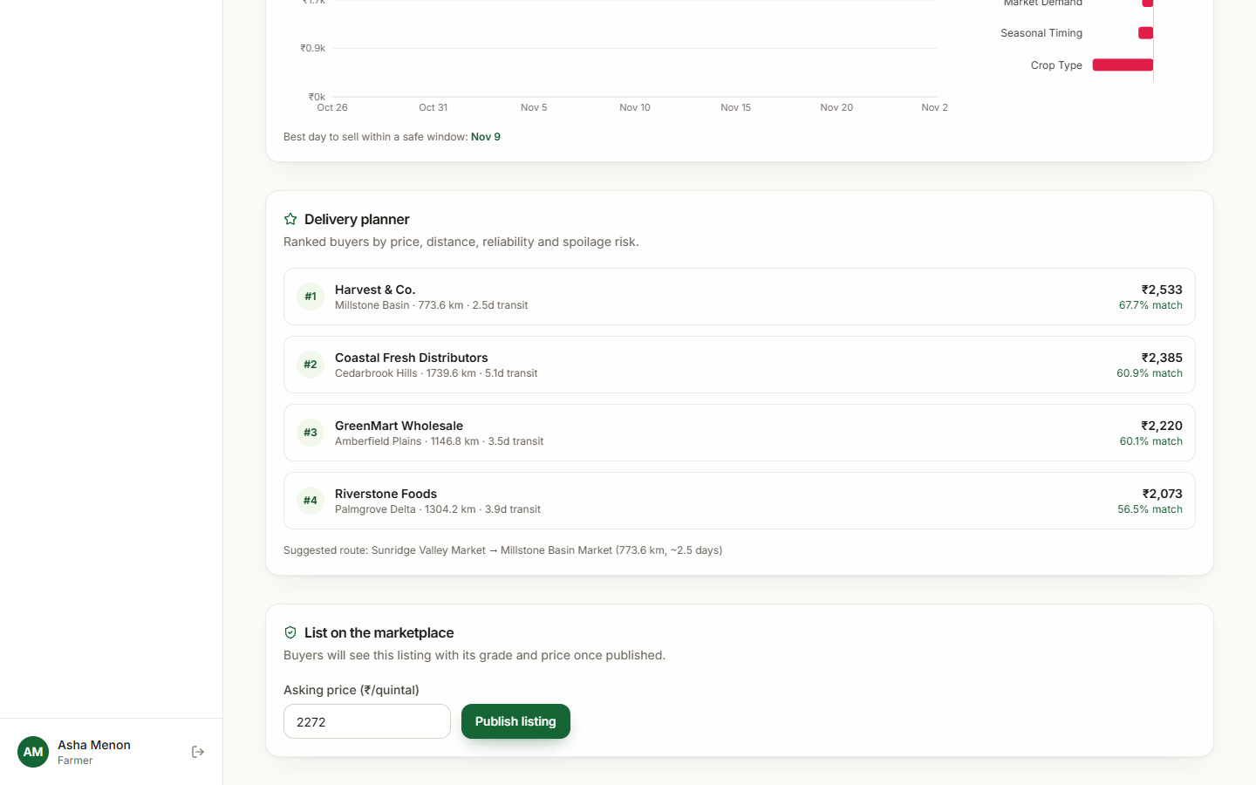
Fig. 8.6: Delivery planner
After Plan delivery: four buyers ranked by match score - Harvest & Co. (Millstone Basin, 773.6 km, 2.5 days, INR 2,533, 67.7% match), Coastal Fresh Distributors (60.9%), GreenMart Wholesale (60.1%) and Riverstone Foods (56.5%) - and the suggested route Sunridge Valley Market to Millstone Basin Market. The best sell day for the listing is 9 November. The buyer offers are simulated from a hash of the buyer and crop.
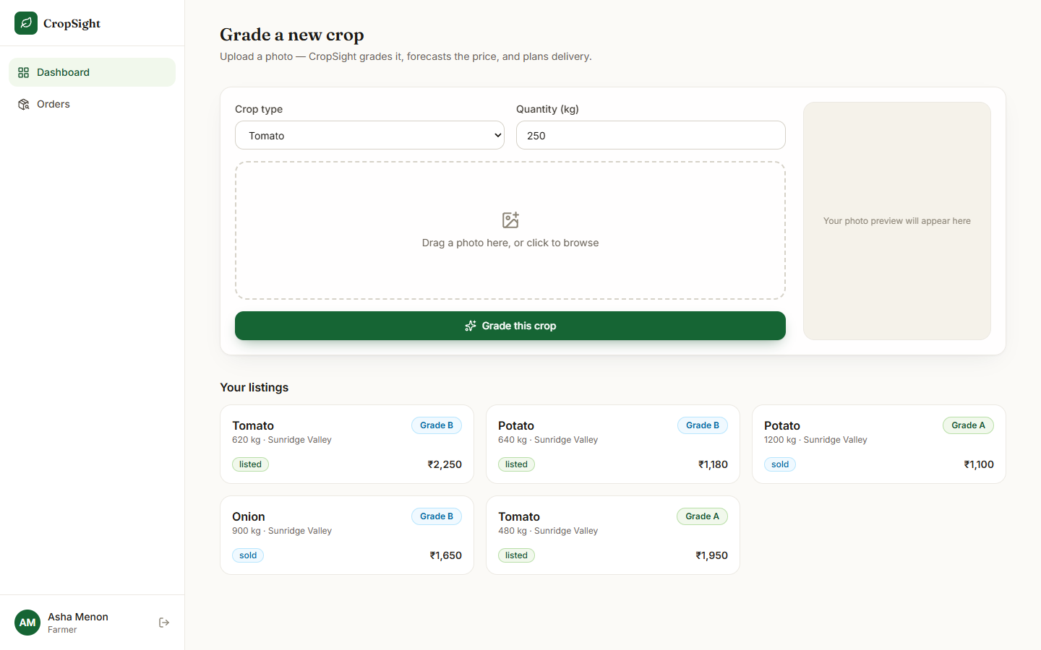  Fig. 8.7: Listings after publishing | Fig. 8.8: Buyer marketplace

Listings after publishing. The farmer's dashboard after the tomato lot was published at INR 2,250: Tomato 620 kg (Grade B, listed), Potato 640 kg (Grade B, listed), Potato 1,200 kg (Grade A, sold), Onion 900 kg (Grade B, sold) and the seeded Tomato 480 kg (Grade A, listed).
Buyer marketplace. The buyer (Riverstone Foods) sees the three listings that are still for sale with their photographs, grade badges, quantity and asking price: Tomato 620 kg at INR 2,250 (Grade B), Potato 640 kg at INR 1,180 (Grade B) and the seeded Tomato 480 kg at INR 1,950 (Grade A, no image).
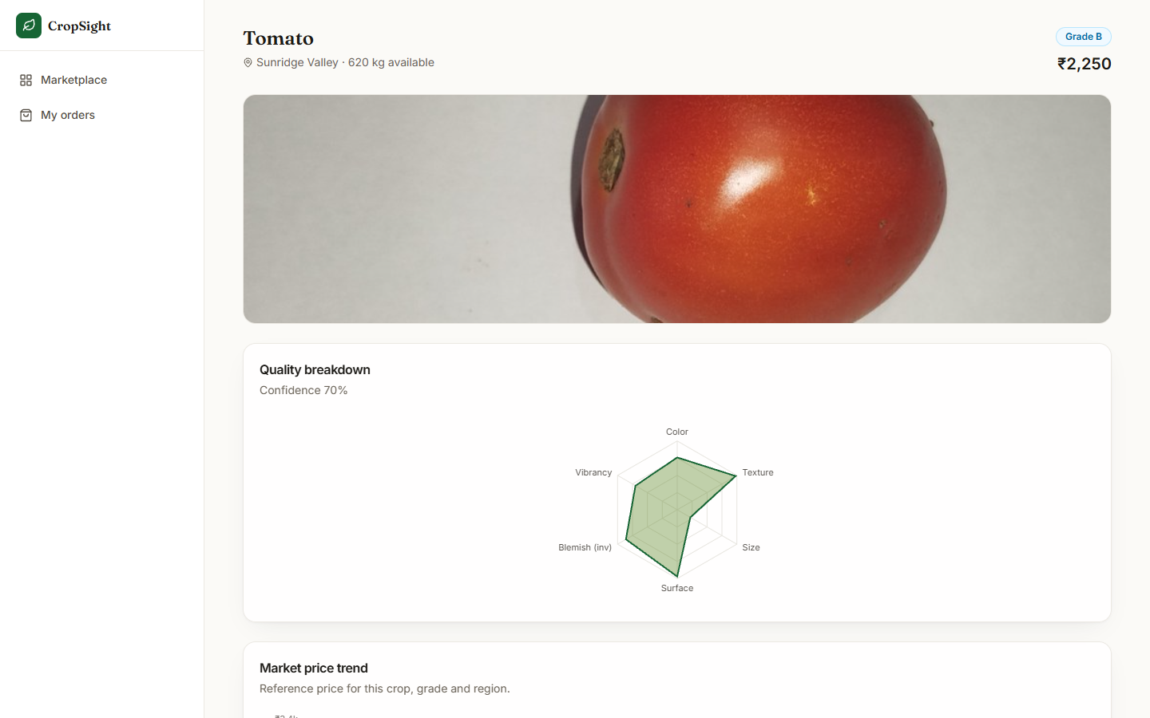  Fig. 8.9: Listing detail | 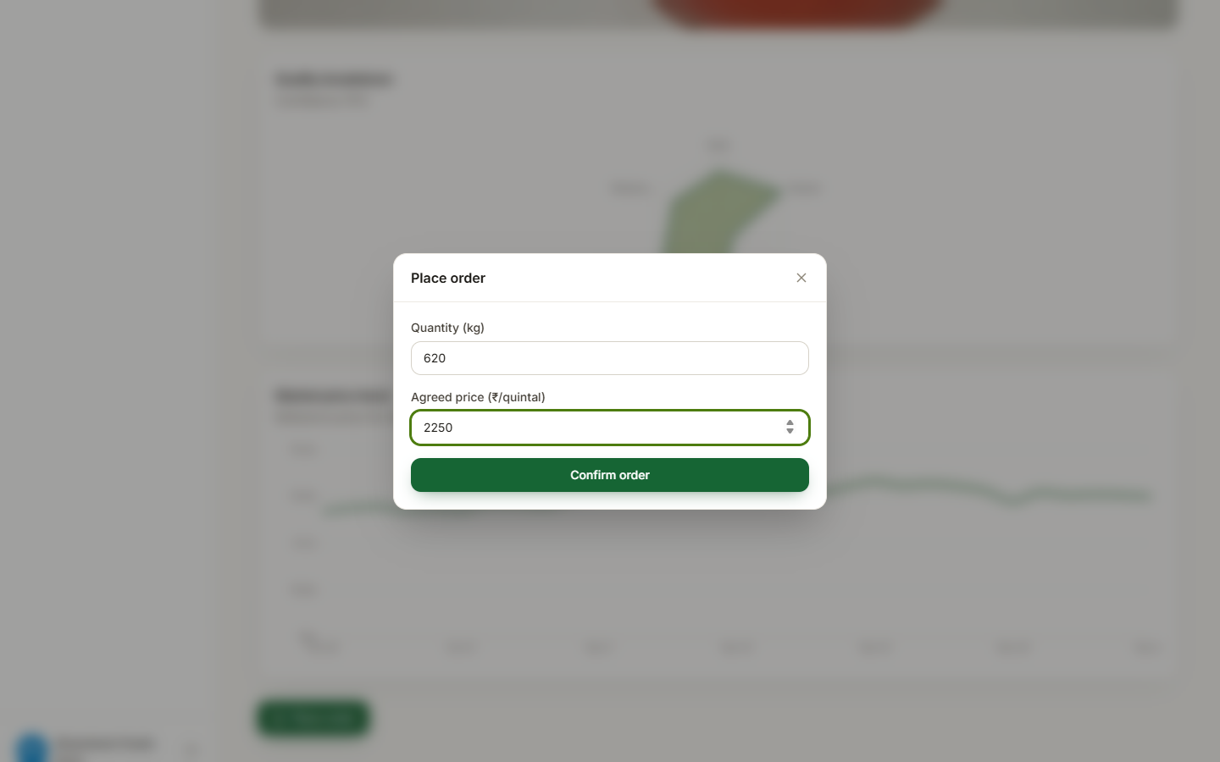  Fig. 8.10: Place-order dialog

Listing detail. The buyer's view of the tomato lot: photograph, Grade B, INR 2,250, 620 kg available, the quality breakdown radar with "Confidence 70%" and, below it, the market price trend (reference price for this crop, grade and region).
Place-order dialog. The Place order dialog over the blurred listing: quantity 620 kg and agreed price INR 2,250 per quintal entered by the buyer, and the Confirm order button.
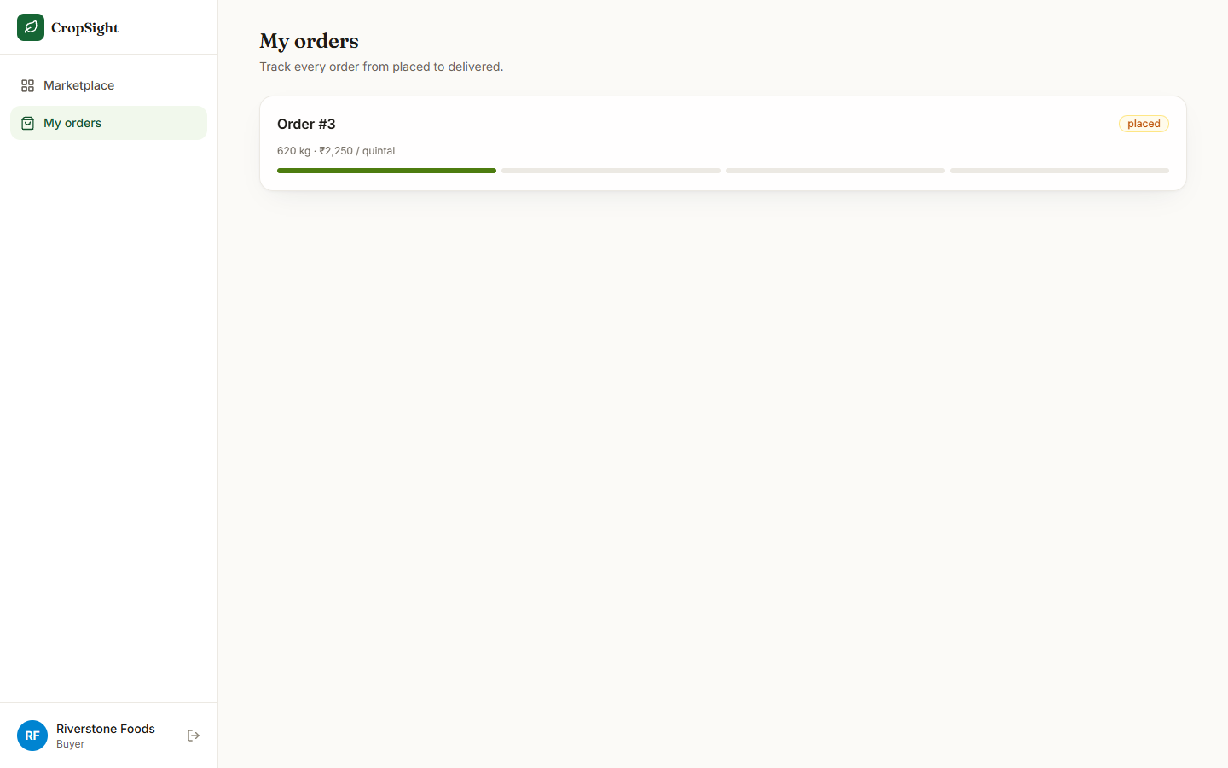  Fig. 8.11: Buyer orders | 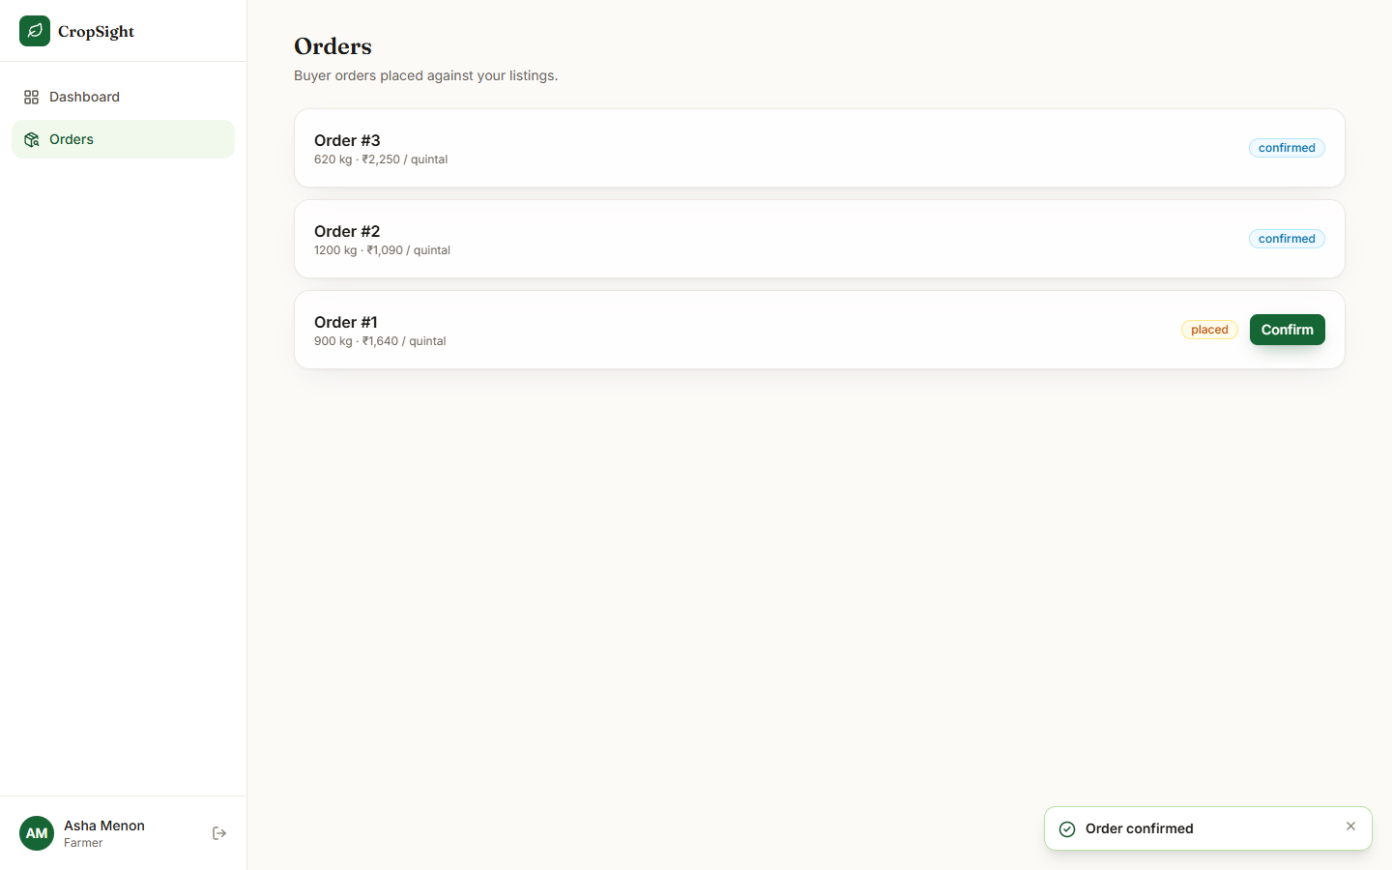  Fig. 8.12: Farmer confirms an order

Buyer orders. My orders for the buyer: Order #3, 620 kg at INR 2,250 per quintal, state placed, with a four-segment progress bar of which the first segment (placed) is filled.
Farmer confirms an order. The farmer's Orders page after pressing Confirm: Order #3 (620 kg, INR 2,250) and Order #2 (1,200 kg, INR 1,090) are confirmed, Order #1 (900 kg, INR 1,640) is still placed with its Confirm button; the toast reads "Order confirmed".
Fig. 8.13: Distributor: orders ready to ship | 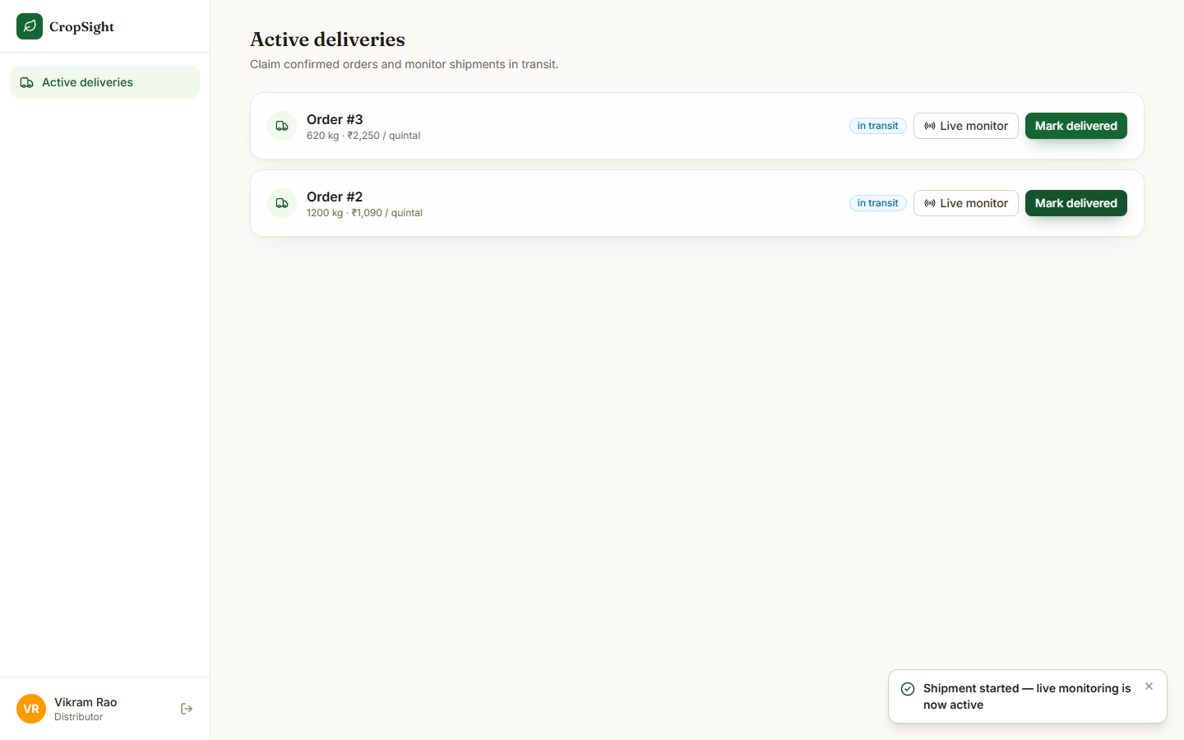  Fig. 8.14: Distributor: shipments in transit

Distributor: orders ready to ship. Active deliveries for the distributor (Vikram Rao): the two confirmed orders, #3 and #2, each with a Start transit button.
Distributor: shipments in transit. After Start transit on both orders: each row shows the badge "in transit", Live monitor and Mark delivered; the toast says "Shipment started - live monitoring is now active".
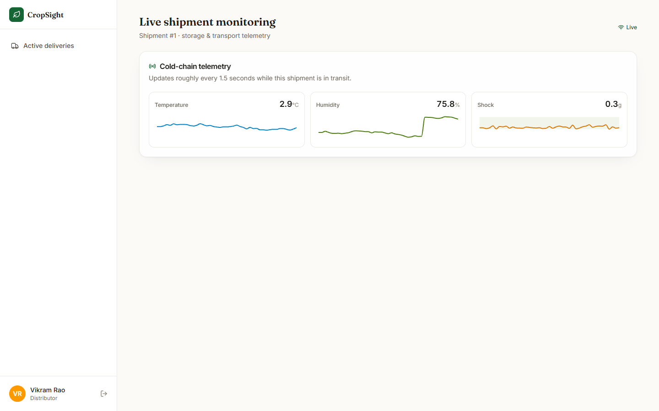  Fig. 8.15: Live shipment monitoring | 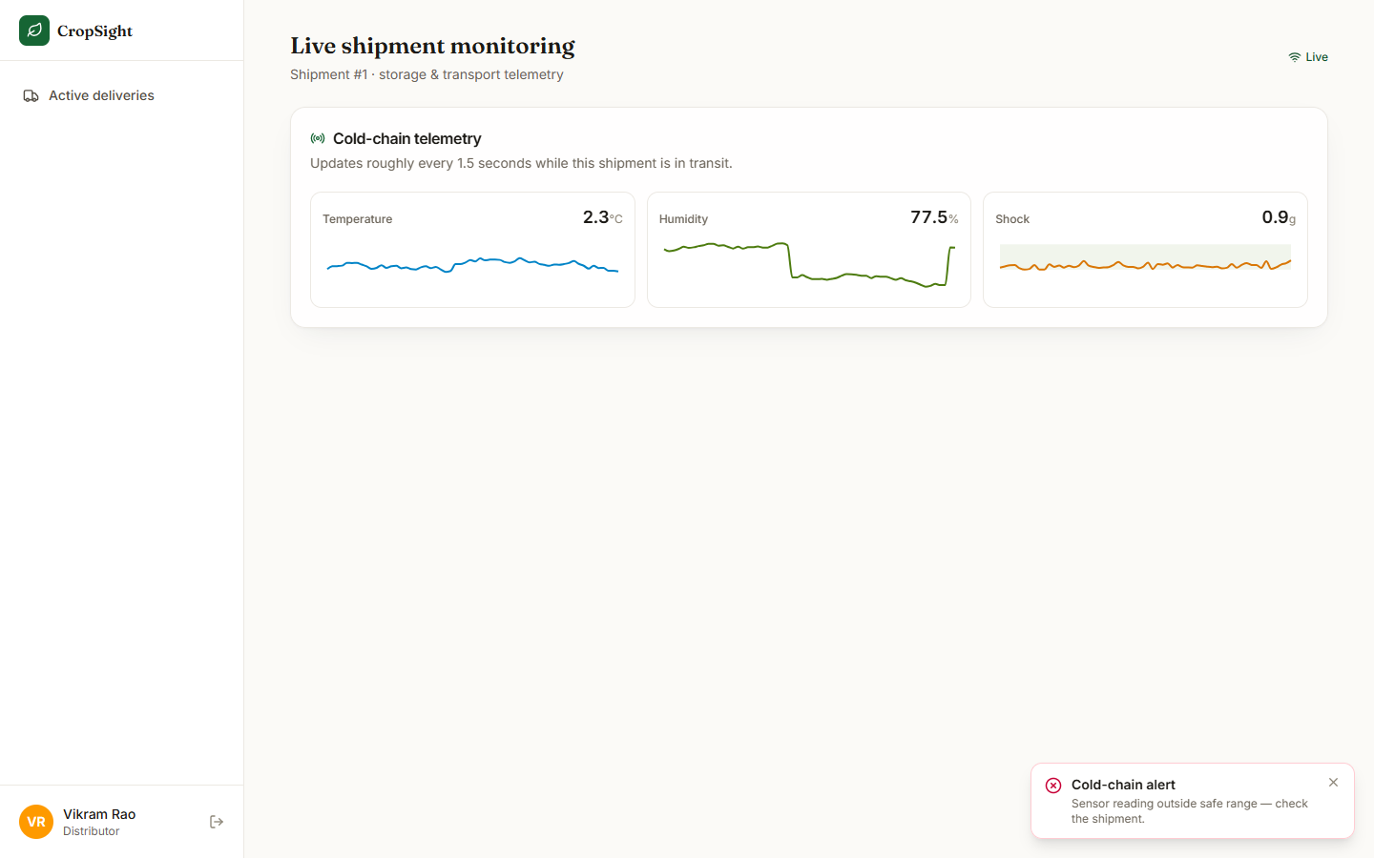  Fig. 8.16: Cold-chain alert toast

Live shipment monitoring. Shipment #1 about one minute after the page was opened: the Live indicator, and three trace panels for temperature (2.9 C), humidity (75.8%, after a step upwards) and shock (0.3 g).
Cold-chain alert toast. 44 seconds after the page was opened the simulator's first injected event arrived and the red toast "Cold-chain alert - Sensor reading outside safe range" appeared while the traces were still near normal (temperature 2.3 C, humidity 77.5%, shock 0.9 g).
Fig. 8.17: Alert banner after drift
215 seconds after opening the page the red banner "Sensor readings are currently outside the safe range for this shipment" is on: temperature 9.5 C and humidity 93.7% are highlighted in red. The temperature and humidity random walks had drifted out of the alarm band without any new event.
Fig. 8.18: Admin overview | Fig. 8.19: Model insights: quality model

Admin overview. Platform overview: 5 listings (2 live, 3 sold), 3 orders, 1 farmer, 4 buyers, 1 distributor, 1 admin, and a gross transaction volume of INR 41,79,000.
Model insights: quality model. The admin's transparency page: Random Forest classifier, the badge "92.3% test accuracy", the impurity importance of the 11 features (blemish ratio and colour uniformity largest, mean hue smallest) and the disclosure that the training data were synthetically generated and no real labelled image set was used.

8.2 Model Performance
CropSight contains two trained models, a Random Forest that grades a crop photograph and a Gradient Boosting model that prices it, and two rule-based parts, the delivery score and the sensor simulator. No real labelled crop-image set and no real market-price series were available to the project, so both models were trained on synthetic data generated by the project's own code. The admin screen says so. This has a consequence for how every figure in this section must be read: a score on a synthetic test set measures how well a model recovers the generator that produced its training data, not how it performs on a farm or in a market. To go beyond that, the grader was also run on 3,200 real photographs (see the subsection on real photographs below). All figures come from experiments/*/metrics.json and were produced on an Intel Core i5-12500 with 15.7 GB RAM and no GPU.
Table 8.1: Headline results
Measure | Result | Data
Quality grader accuracy (shipped split, 1,200 rows) | 92.3%, macro F1 0.924 | synthetic
Quality grader accuracy, five seeds | 92.9% +- 0.3 | synthetic
Quality grader on real fruit photographs (fresh vs rotten) | 50.4% (chance 50%), AUC 0.571 | 3,200 real photos
Same 11 features retrained on real labels, 5-fold CV | 90.6%, AUC 0.970 | 3,200 real photos
Price model MAE / RMSE (INR per quintal) | 164.6 / 252.2 | synthetic
Price model R2 / MAPE | 0.9916 / 5.1% (noise floor 2.8%) | synthetic
15-85% price band coverage (nominal 70%) | 69.3% | synthetic
Delivery ranking: top buyer unchanged under weight changes | 97.7% | 256 cases, 4 buyers
Automated tests | 36 passed, 3 expected failures | pytest
Upload-and-grade response time (median / 95th percentile) | 174 ms / 207 ms | live API

8.2.1 Quality grader on its synthetic test set
Table 8.2: Per-grade results of the Random Forest (1,200 synthetic test rows)
Grade | Precision | Recall | F1 | Support
A | 0.928 | 0.964 | 0.946 | 280
B | 0.924 | 0.862 | 0.892 | 325
C | 0.909 | 0.894 | 0.901 | 312
Reject | 0.933 | 0.986 | 0.959 | 283

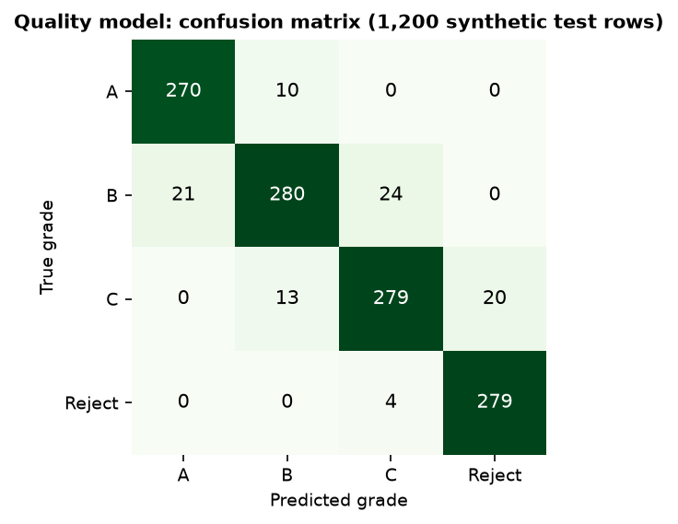
Fig. 8.20: Confusion matrix of the quality grader on the synthetic test set
Accuracy is 92.3% and macro F1 0.924 (train accuracy 93.9%). Of the 92 errors, all are between neighbouring grades: none confuses A with C or Reject, or B with Reject. The model is a little less confident when it is wrong (mean top probability 0.79 against 0.87 when right). Over five different splits and forest seeds the accuracy is 92.9% with a standard deviation of 0.3 points (range 92.5% to 93.2%).
What the number means. The training data contain 6% label noise (360 of 6,000 labels moved to a neighbouring grade), so the best a model can do on the noisy test labels is about 94.1%. Scored against the clean labels of the same test rows the forest reaches 98.1%, and trained and tested on clean labels 98.0%. The grader has therefore learned the generator's grade profiles almost completely; that is the ceiling of this experiment.
Table 8.3: Baselines on the same synthetic split
Model (same split) | Accuracy | Macro F1
Majority class | 0.271 | 0.107
Decision tree (depth 9) | 0.885 | 0.887
Histogram gradient boosting | 0.922 | 0.923
Random Forest (shipped) | 0.923 | 0.924
k-nearest neighbours (k = 15) | 0.930 | 0.931
Logistic regression | 0.931 | 0.932

A linear model (0.931) and k-nearest neighbours (0.930) match the forest (0.923): the synthetic grade classes are close to linearly separable, so the choice of forest over a simpler model is not justified by accuracy on this data. It is justified by the tree-based SHAP explanations and by the expectation that real data will not be separable linearly.
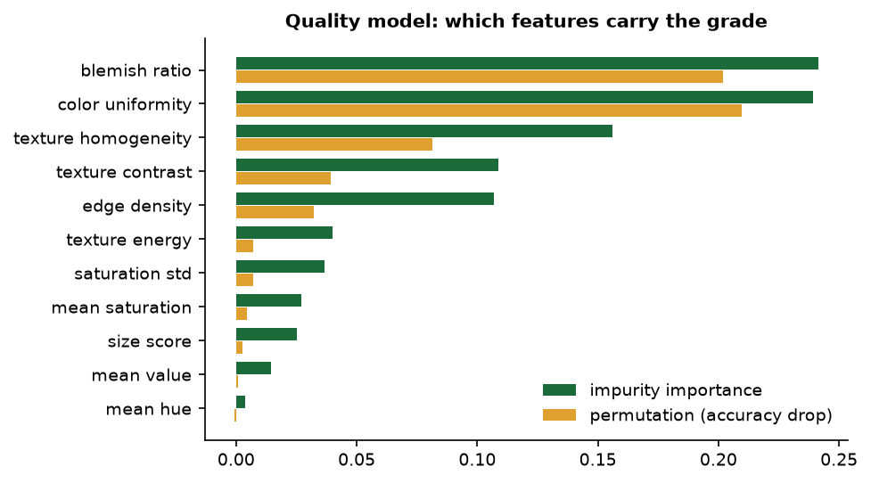  Fig. 8.21: Impurity and permutation importance of the 11 features | 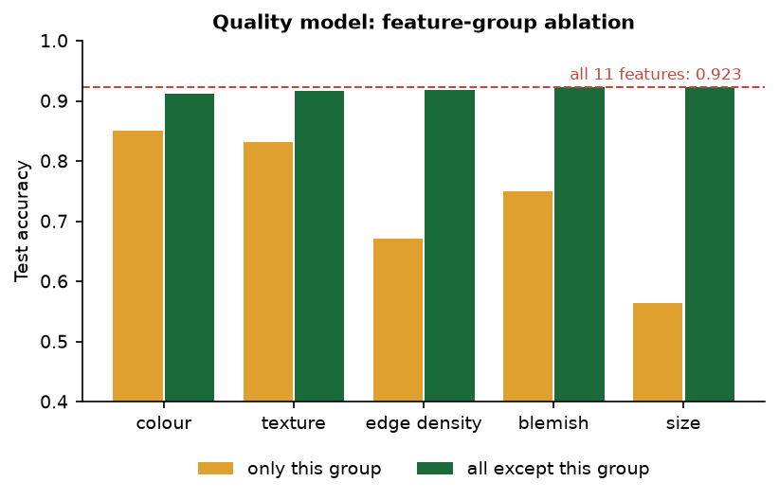  Fig. 8.22: Feature-group ablation: one group alone against all but one group

Blemish ratio (impurity importance 0.241) and colour uniformity (0.239) matter most; mean hue matters least (0.004). Removing any single group costs at most 1.2 points because the groups carry overlapping information; each group alone gives 56% (size score) to 85% (colour).

8.2.2 Quality grader on real photographs
To test the grader outside its own generator, the real feature extractor and the shipped model were run on all 3,200 images of the Fresh and Rotten Fruits dataset [8] (CC BY 4.0): 1,600 fresh and 1,600 rotten photographs of eight fruits, 200 of each state per fruit. The dataset labels are fresh or rotten, not A, B, C or Reject, so the check maps fresh to {A, B} and rotten to {C, Reject}; this mapping is an assumption of the check, and the fruits are not CropSight's crops, but a grader that sees quality in a photograph should still rank a rotten fruit below a fresh one.
Table 8.4: Grades predicted by the shipped model for 3,200 real fruit photographs
True state | Grade A | Grade B | Grade C | Reject
Fresh | 0.12% | 99.81% | 0.06% | 0.00%
Rotten | 0.06% | 99.12% | 0.81% | 0.00%

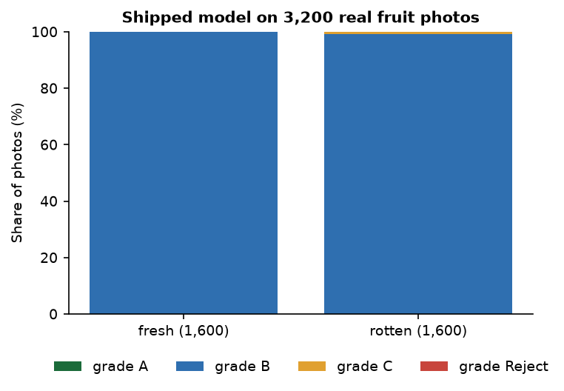
Fig. 8.23: Predicted grade share for fresh and rotten photographs
The shipped grader does not transfer. It calls 99.8% of the fresh and 99.1% of the rotten photographs grade B; the mapped fresh-or-rotten accuracy is 50.4% (chance is 50%) and the area under the ROC curve of P(A)+P(B) is 0.571. Per fruit the AUC ranges from 0.19 (jujube, i.e. inverted) to 0.81 (strawberry). 99.8% of the real images lie outside the three-standard-deviation envelope of every synthetic grade profile.
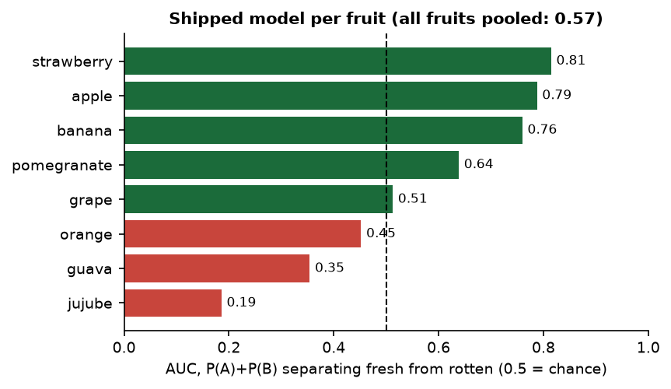
Fig. 8.24: Fresh-versus-rotten AUC of the shipped model for each fruit
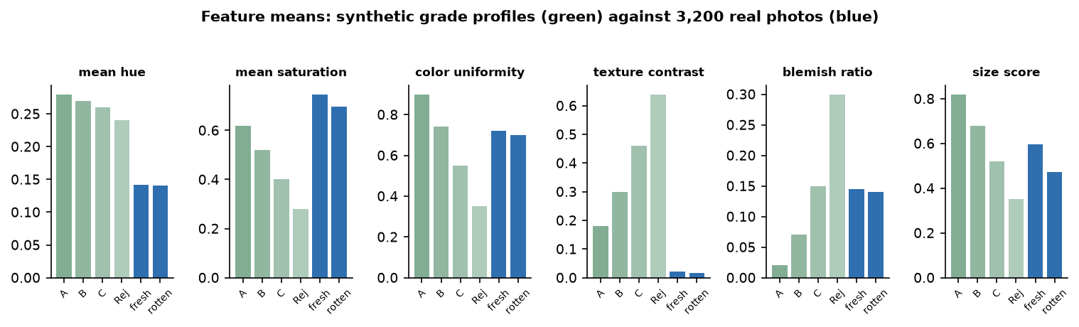
Fig. 8.25: Mean feature values of the synthetic grade profiles and of the real photographs
The reason is visible in the feature means: real photographs have mean hue 0.14 (synthetic grades 0.24-0.28), texture contrast 0.02 (synthetic 0.18-0.64), blemish ratio 0.14 for both fresh and rotten fruit and colour uniformity 0.70-0.72. The synthetic profiles were written by hand around plausible values, and real images fall in none of them; the classifier maps all of them to the middle grade.
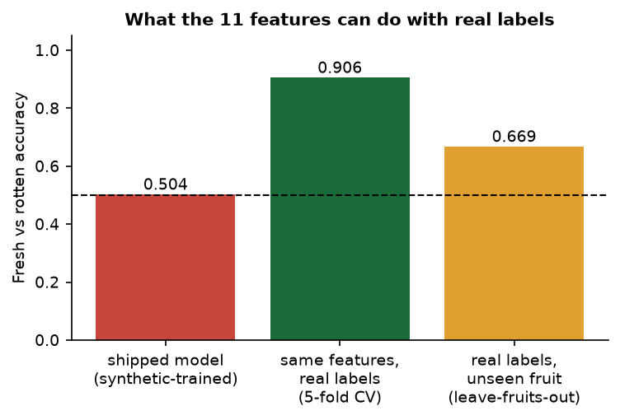
Fig. 8.26: Fresh-versus-rotten accuracy: shipped model, retrained on real labels, and retrained on unseen fruits
The extractor itself is not the problem. The same 11 features, with a Random Forest of the same size trained on the real labels, reach 90.6% accuracy (AUC 0.970) in five-fold cross-validation. When whole fruit types are held out the accuracy falls to 66.9% (AUC 0.748), so the features are fruit-specific. The most important real-label features are mean hue (0.29) and mean saturation (0.12), the opposite order to the synthetic model. The practical conclusion is that the grader must be retrained on real labelled images of the crops it is meant to grade before its grades can be trusted.

8.2.3 Price model
Table 8.5: Price model results on the synthetic series
Measure | Value
Test MAE / RMSE (3,504 rows, INR per quintal) | 164.6 / 252.2
R2 / MAPE | 0.9916 / 5.08%
Noise floor (noise-free generating formula against the observed price) | MAE 105.5, MAPE 2.80%
Model against the noise-free formula | MAE 120.5, MAPE 3.99%
Five seeds, MAE / R2 | 162.8 +- 5.5 / 0.9919 +- 0.0006
Time hold-out (train 2022-23, test 2024), MAE / R2 / MAPE | 191.8 / 0.988 / 5.1%
15-85% band: empirical coverage, mean width | 69.3% (nominal 70%), 23.1% of the price
Test rows where the lower quantile model exceeds the upper one | 119 of 3,504

Table 8.6: Price baselines on the same split
Model | MAE | R2 | MAPE
Crop mean | 990 | 0.719 | 32.8%
Crop x grade mean | 714 | 0.858 | 20.2%
Linear regression | 528 | 0.908 | 20.6%
Random Forest (200 trees) | 245 | 0.983 | 7.2%
Gradient boosting (shipped) | 165 | 0.992 | 5.1%

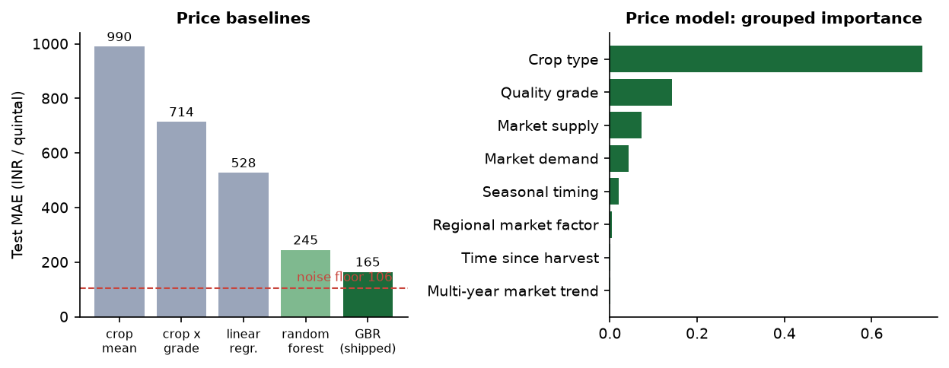  Fig. 8.27: Price baselines and grouped feature importance | 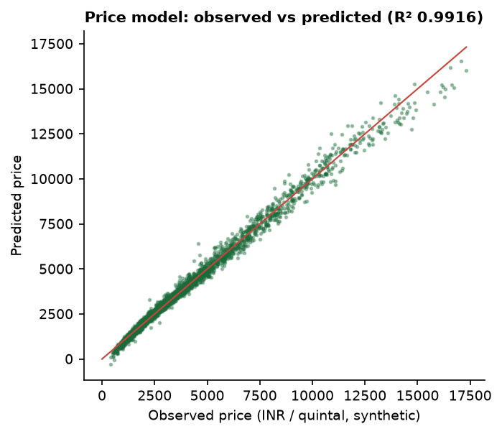  Fig. 8.28: Observed against predicted price on the synthetic test set

The boosted model clearly beats every baseline and sits close to the noise floor of its data (MAPE 5.1% against 2.8%). The 2024 hold-out is only slightly worse (R2 0.988) even though the trend feature leaves its training range. The error is largest for the Reject grade (MAPE 11.4%, against 4.2% for grades A and B) and for the dearest crop, cotton (MAE 383). The 70% band covers 69.3% of the observed prices, so it is well calibrated on this data.
What the model learned. Crop type carries 72% of the importance, quality grade 14%, market supply 7% and demand 4%; rainfall and average temperature are almost zero (0.00009 and 0.00005). The generator uses temperature not at all and rainfall only above 150 mm, which almost never occurs, so a model that ignores weather is correct for this data - and a reminder that weather, one of the inputs the project set out to use, plays no real role here.
Behaviour of the served forecast. The forecast shown to the farmer evaluates the point model on 31 successive daily market contexts that are generated from a hash of crop, region and date (not from a weather or demand feed). Over all 256 crop, region and grade combinations the recommended best day is today in 24.2% of cases, on average day 6.2, and waiting for it would raise the price by 14.6% on average (median 8.4%, largest 136%); the mean spread between the highest and lowest price over 30 days is 33.5% of the mean. These swings come from the hashed daily noise in demand and supply, so the sell-day advice is an illustration of the interface, not market information. The price order A > B > C > Reject holds for all 64 crop-region pairs.
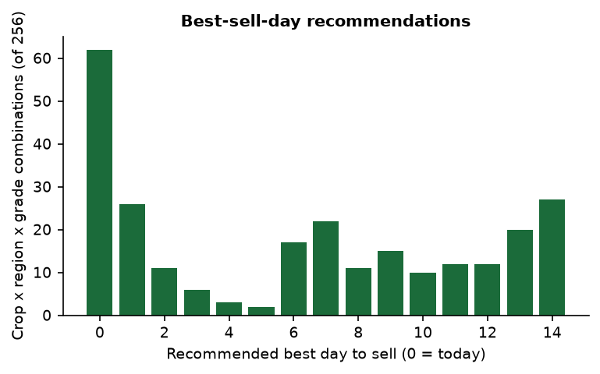
Fig. 8.29: Distribution of the recommended best sell day over 256 combinations

8.2.4 Delivery recommendation
The delivery engine is a weighted score, not a trained model: 0.38 price, 0.22 distance, 0.18 quality fit, 0.14 reliability and 0.08 low spoilage risk (the weights sum to 1.00). For all 256 crop, region and grade combinations an independent re-computation reproduced the served top buyer in 256/256 cases. When every weight was multiplied by a random factor between 0.5 and 1.5 (100 trials per case) the top buyer stayed the same 97.7% of the time (worst case 74%) and the full ranking correlated at 0.95 with the original, so the ranking is stable. Across the four buyers distance separates them most, then price; quality fit does not differ between buyers at all, because it is a property of the lot. The offered prices are the model price times a hash-derived factor between 0.90 and 1.18, so they are simulated, not quotes.

8.2.5 Sensor stream and alerts
The sensor stream is simulated (no hardware exists). Over 50 simulated shipments of 1,200 steps the first alert came after a median of 26 steps (0.6 minutes at 1.4 s per step). The temperature and humidity are random walks without a pull back to normal, so shipments drift out of the alarm band: 28% were in alarm by step 50, 58% by step 100 and all 50 by step 400, and 97.3% of all flagged steps were persistent drift rather than injected events. The median longest uninterrupted alarm lasted 1102 of the 1,200 steps. The live run reproduced this: the first alert after 44 s and a persistent banner at 215 s.
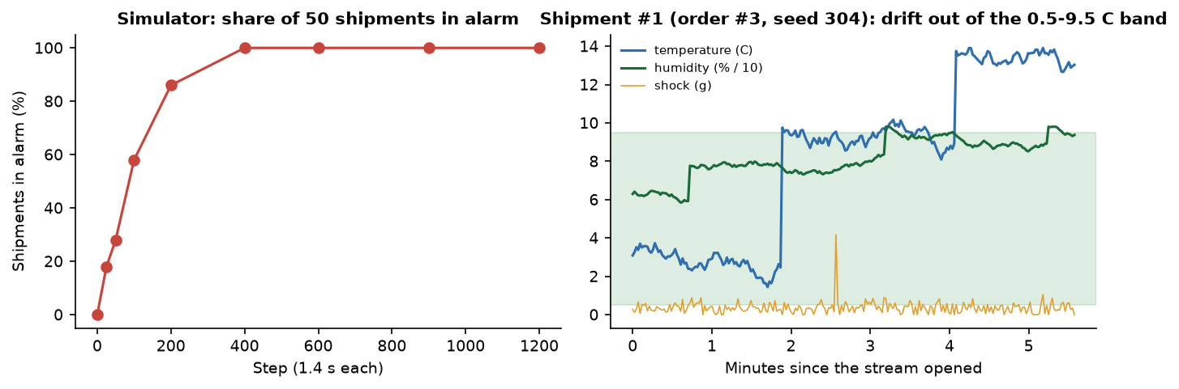
Fig. 8.30: Share of simulated shipments in alarm (left) and one simulated trajectory, the demo shipment of order 3, seed 304 (right)

8.2.6 Response time
Table 8.7: API response times (live server on 127.0.0.1, same machine, other jobs running)
Endpoint | n | Median (ms) | 95th percentile (ms)
Log in (bcrypt) | 30 | 325.3 | 349.0
Health check | 30 | 1.6 | 4.7
Upload and grade a 900 x 675 photograph | 20 | 173.9 | 207.3
Price forecast with SHAP | 30 | 54.9 | 119.4
Delivery recommendation | 30 | 99.8 | 147.9
Marketplace listings | 30 | 17.7 | 36.5
Admin overview | 30 | 22.8 | 46.0
Admin model insights | 30 | 112.9 | 149.5

Grading a photograph, including feature extraction, the forest, SHAP and the database write, takes about 0.17 s; the slowest call is the bcrypt log-in at about 0.33 s, which is intended. No load test with many concurrent users was run.

8.3 Software Verification Results
The backend has a pytest suite (backend/tests) that uses a throw-away SQLite database. 36 tests pass and 3 are expected failures (about 30 s). The three expected failures are tests that assert the behaviour a hardened system should have and fail on the shipped code; they are kept visible rather than deleted.
Table 8.8: Automated test results
Group | Tests | What is checked
Health and authentication | 8 | sign-up and log-in round trip, duplicate e-mail, no admin self-sign-up, validation errors, wrong password, token required, tampered token rejected
Role guards | 1 | a buyer cannot upload, a farmer cannot order, non-admins cannot read admin routes, a distributor cannot ask for a delivery plan
Listings, grading and CV features | 12 | grade, probabilities and 11 features returned; blemished photo not graded above a clean one; non-image and oversize uploads rejected; feature vector contract; deterministic grading; foreign listings are 404
Price intelligence | 5 | response shape (31 days, band contains the price, best day 0-14), A > B > C > Reject, listing grade is used
Delivery | 3 | top five sorted by score within 0-100, weights sum to 1, foreign listing is 404
Marketplace and orders | 5 | browse and filter, full lifecycle placed to delivered with every guard, unlisted listing cannot be ordered, role-scoped order lists
IoT and simulator | 4 | WebSocket delivers three readings, history stored, unknown shipment 404, simulator deterministic per seed and bounded
Admin | 1 | overview counts, both models' transparency cards
Expected failures | 3 | corrupt image returns HTTP 500 and leaves a gradeless draft listing; unknown crop is accepted; non-positive order quantity is accepted

The end-to-end flow was also executed in the browser: a farmer graded, forecast, planned and published a tomato lot; a buyer ordered it; the farmer confirmed; a distributor started transit, watched the live stream and could mark the order delivered. Every state change was refused when attempted by the wrong role or out of order (tested in the suite).

8.4 Comparison with the Base Paper
The base paper [1] builds an AI-driven smart-agriculture system for the pre-harvest stage: IoT soil sensors and a weather API feed deep tabular models for irrigation advice (Transformer-based tabular learning, accuracy 99.13%), soil analysis (TabNet regressor, RMSE 1.51, R2 98.7%), crop recommendation (SwiFT, 98.75%) and fertiliser recommendation (TabNet classifier, 99.3%), with explainable-AI techniques (LIME [21] and TabNet [22] among them) and a chatbot. CropSight takes the same idea of IoT, learning and explanation into the post-harvest stage. The two works differ in task, data, model family and metric, and CropSight's data are synthetic, so the figures cannot be compared and no head-to-head claim is made. What can be compared is capability.
Table 8.9: CropSight and the base paper
Aspect | Base paper [1] | CropSight
Stage of the farm cycle | Before harvest: soil, irrigation, crop and fertiliser choice | After harvest: quality grading, price, delivery, marketplace
Input data | Tabular soil, weather and crop records; IoT sensor readings | Crop photographs; synthetic market series; simulated sensor stream
Models | Transformer-based tabular learning, TabNet, SwiFT (deep) | Random Forest, Gradient Boosting with quantile bands (classical), weighted scoring
Explainability | XAI techniques applied to TabNet predictions | SHAP for both models, shown to the farmer; feature importance for the admin
IoT | Soil sensors for real-time analysis | Simulated cold-chain stream over WebSocket with alerts; no hardware
Reported results | 99.13% (irrigation), RMSE 1.51 / R2 98.7% (soil), 98.75% (crop), 99.3% (fertiliser) | 92.3% grading and R2 0.992 pricing on synthetic data; chance level on real photographs
Marketplace and delivery | Not part of the system | Farmer, buyer and distributor marketplace with order states; delivery ranking
User interface | Chatbot interface for farmers | React web app with four role dashboards

The batch literature survey also lists [3] (image-based quality inspection and e-commerce grading), [4] and [5] (crop price prediction with machine learning). These three could not be retrieved, so no result from them is used here.
Two other works that were read support the direction. The foundation-model study [6] shows on real USDA price data that modern time-series models beat classical, machine-learning and deep-learning forecasters; CropSight's price model uses none of that and is trained on synthetic data, so it is the first thing to replace. The crop-image recognition study [7] reports an accuracy of 0.982 for a ConvLSTM-based model on real crop images; again a different task and data.

8.5 Sample Inputs and Outputs
Table 8.10: Real sample photographs and the grades the shipped model gave them
Photograph | Crop | Photos scanned | Grade | Confidence
tomato_1.jpg | Tomato | 40 (A 0, B 40, C 0, Reject 0) | B | 0.701
onion_1.jpg | Onion | 40 (A 0, B 40, C 0, Reject 0) | B | 0.742
potato_1.jpg | Potato | 40 (A 1, B 39, C 0, Reject 0) | B | 0.662
potato_2.jpg | Potato | 40 (A 1, B 39, C 0, Reject 0) | A | 0.834

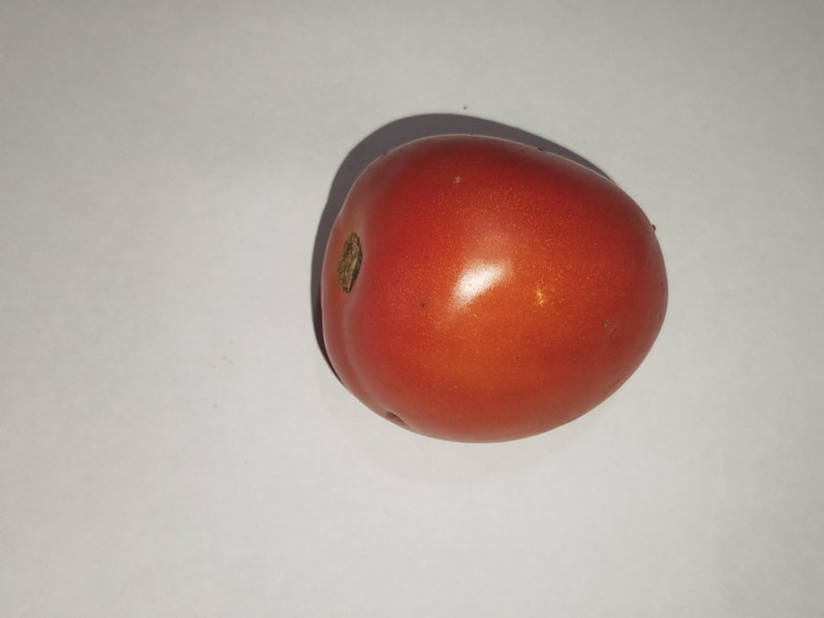  Fig. 8.31: tomato_1.jpg, graded B (0.701) | 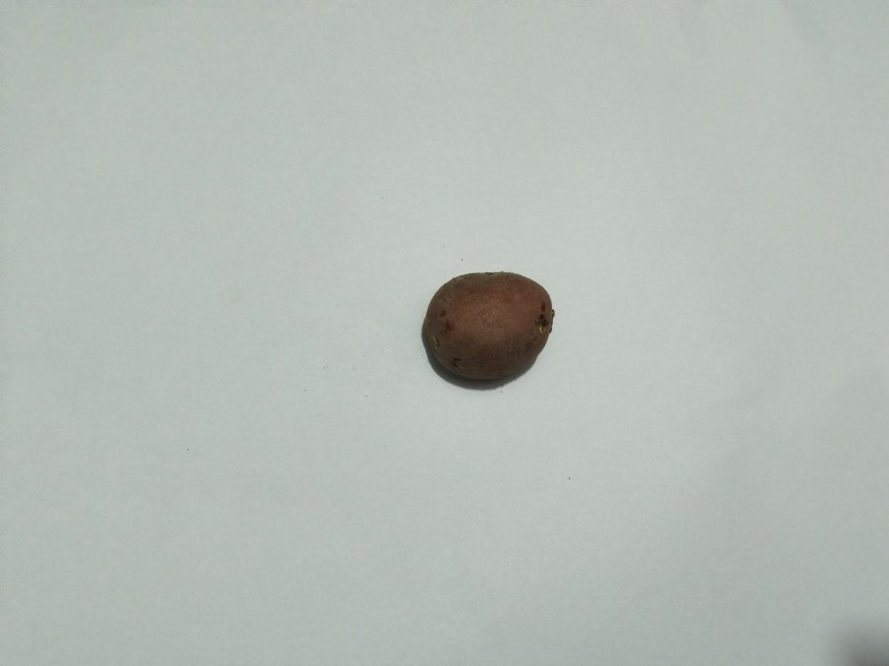  Fig. 8.32: potato_2.jpg, graded A (0.834)

The photographs come from the public vegetable dataset [9]. Forty photographs of each crop were graded and the examples were chosen so that the screens show more than one grade; this selection is not a test. All 40 tomatoes and all 40 onions were graded B and 39 of 40 potatoes were graded B, which is consistent with the real-photograph finding that the grader gives B to almost everything.
Table 8.11: Sample inputs and outputs (live run, 26 October 2026)
Input | Output
Photograph tomato_1.jpg, Tomato, 620 kg, Sunridge Valley (farmer) | Grade B, confidence 70.1%; top SHAP features colour uniformity, blemish ratio, texture homogeneity; stored as a draft listing
Forecast for the graded lot | Current price INR 2,272 per quintal, range 2,068 to 2,272, 30-day curve, best day to sell 9 November
Delivery plan for the lot | 1 Harvest & Co. 67.7% (INR 2,533, 773.6 km, 2.5 days); 2 Coastal Fresh Distributors 60.9%; 3 GreenMart Wholesale 60.1%; 4 Riverstone Foods 56.5%
Publish at INR 2,250; buyer orders 620 kg at INR 2,250 | Listing becomes sold; Order #3 placed; farmer confirms; distributor starts transit; shipment #1 opens the live stream
Wrong password for the farmer account | HTTP 401, message "Invalid email or password"
Admin overview after the demo | 5 listings (2 live, 3 sold), 3 orders, 7 users (1 farmer, 4 buyers, 1 distributor, 1 admin); displayed volume INR 41,79,000

8.6 Success and Failure Analysis

8.6.1 Where it works
- The complete marketplace flow works end to end with four roles, JWT authentication and an order state machine that refuses wrong-role and out-of-order changes (36 passing tests).
- Grading, SHAP explanation, price forecast with a band, delivery ranking and the live sensor stream all respond quickly: 0.17 s to upload and grade, 55 ms median for a price forecast, 100 ms for a delivery plan.
- On its own generated data the grader reaches 92.3% and the price model R2 0.992, with errors only between neighbouring grades and a band that covers 69.3% against 70% nominal.
- The weighted delivery ranking is stable: the top buyer survives 97.7% of random weight changes.
- The admin transparency page discloses honestly that both models are trained on synthetic data.

8.6.2 Where it fails or is weak
Table 8.12: Failure and weakness analysis
Observation | Cause | Effect / handling
Grader gives grade B to 99% of 3,200 real photographs and is at chance for fresh versus rotten (50.4%, AUC 0.57) | Trained only on synthetic feature profiles that real images do not resemble | Grades on real photographs are not trustworthy; retrain on real labelled images (future scope)
A corrupt file sent as an image gives HTTP 500 and leaves a gradeless draft listing | The listing row is saved before grading and grading is not guarded | Expected-failure test; wrap grading and roll back the listing
Admin gross volume INR 41,79,000 for three small orders | Price per quintal multiplied by quantity in kilograms (100 times too large) | Divide by 100; the correct figure for the demo orders is INR 41,790
Sensor alarm drifts into permanent alarm; each connection restarts the stream from its seed | Random walks without mean reversion; simulator state lives in the connection | Add return-to-normal behaviour and hysteresis; keep state per shipment
Order accepts zero, negative or larger-than-listing quantities | No validation of quantity or price | Expected-failure test; add schema constraints and a stock check
Unknown crop or region is priced instead of rejected | No catalogue check; unknown crop uses an all-zero one-hot | Expected-failure test; validate against the catalogue
Displayed price range ends exactly at the current price | The band is clamped to include the point estimate | Report the unclamped quantile band or recalibrate
Landing page shows 38,400+ crops graded, +17% price uplift, 92% accuracy, 2,400+ farmers | Fixed marketing numbers in the page source | Remove or replace with real statistics
"Best day to sell" suggests large gains (mean +14.6%) | Hash-generated daily demand and supply noise, not a real forecast | Treat as an illustration; replace with a real time-series model

8.7 Limits of the Results
- Synthetic data. The accuracy of 92.3%, the R2 of 0.992 and the 70% band all describe recovery of the project's own generators. They say nothing about real farms or markets; the only real-image evidence is the negative result above.
- Mapped labels. The real-photograph check maps fresh and rotten to grades and uses fruits instead of the app's crops; it shows non-transfer clearly but cannot measure the accuracy of A, B, C and Reject grading.
- Simulated sensors and offers. The sensor stream, the buyer offers and the daily market context are generated, so the alert behaviour, the ranking and the sell-day advice illustrate the interface only.
- Small, single-machine measurements. Timings come from one desktop with other jobs running, 20 to 30 calls per endpoint, no concurrent load and no memory profile; no user study was carried out.
- Chosen photographs. The sample photographs on the output screens were picked from 40 scanned per crop to show more than one grade.
- No numeric comparison with the base paper is possible, as explained in the section Comparison with the Base Paper.

8.8 Objectives Against Outcomes
Table 8.13: Objectives against outcomes
Objective | Outcome | Evidence
1. Grade crop quality automatically from images | Partly achieved | Implemented as classical machine learning on 11 hand-crafted features, not a deep network; 92.3% on synthetic data; at chance on 3,200 real photographs; retraining on real labels reaches 90.6%
2. Forecast crop prices from market, weather and demand data | Partly achieved | Boosted model with a 70% band, R2 0.992 on synthetic data; weather has almost no effect; the 30-day forecast uses generated context; no real price feed
3. Monitor storage and transport with IoT sensors | Demonstrated with simulation only | WebSocket stream, stored readings and alert banner work end to end; no hardware, and the alarm drifts into permanent alarm
4. Explain grading and pricing decisions with XAI | Achieved | SHAP top-six contributions for every grade and price, shown in the app; importance charts for the admin
5. Recommend buyers, routes and the best time to sell | Achieved as a heuristic | Weighted ranking stable under weight changes (97.7%); route is the top buyer's town; offers and sell-day advice are simulated
6. Connect farmers, distributors and buyers through a marketplace | Achieved | Four roles, listings, orders, state machine, shipments; 36 tests pass; 3 validation gaps documented

CHAPTER 9
CONCLUSION

9.1 Summary of the Work
This project built CropSight, a full-stack platform for the stage after harvest. A farmer uploads a photograph of a crop; computer-vision features are extracted from its pixels (colour, texture, edges, blemishes, relative size) and a Random Forest assigns the grade A, B, C or Reject, explained with SHAP. A Gradient Boosting model with quantile bands gives the current price, a 30-day forecast and a best day to sell, again explained with SHAP. A transparent weighted score ranks buyers, a route and the spoilage risk. Farmers, buyers, distributors and an admin work through a marketplace with a checked order lifecycle, and a distributor can follow a shipment's temperature, humidity and shock on a live stream with alerts. The system has 21 interfaces (20 REST and one WebSocket), nine database tables, a React web application with four role dashboards and a pytest suite.
Because no real labelled crop images or market prices were available, both models were trained on synthetic data generated by the project's code, and the sensor stream and buyer offers are simulated. On its own synthetic test set the grader reaches 92.3% accuracy and the price model R2 0.992 with MAPE 5.1%. A check on 3,200 real fruit photographs showed that the grader does not transfer (fresh versus rotten accuracy 50.4%), while the same features retrained on real labels reach 90.6%. Thirty-six automated tests pass, three more document known gaps, and a photograph is graded in about 0.17 s.

9.2 Objectives Achieved
Of the six objectives, three are achieved as stated and three only in part. Explaining grading and pricing with explainable AI (objective 4), connecting farmers, distributors and buyers through a marketplace (objective 6) and recommending buyers, routes and the best time to sell (objective 5, as a transparent heuristic with simulated offers) are in place and tested. Grading quality from images (objective 1) is implemented with classical machine learning rather than deep learning and works only on synthetic data; forecasting prices (objective 2) is implemented but trained and evaluated on synthetic data; and monitoring storage and transport (objective 3) is demonstrated with a simulated sensor stream. Chapter 8 gives the evidence for each.

9.3 Key Findings
1. A high score on synthetic data is not evidence of quality. The grader scores 92.3% on its own generator and 50.4% (chance) on 3,200 real photographs; it grades 99.1% of rotten fruit as grade B.
2. The features are sound; the training data are not. The same 11 features retrained on real fresh and rotten labels give 90.6% (AUC 0.97), but only 66.9% for unseen fruits, so grading must be trained per crop on real labels.
3. The price model recovers its generator almost exactly. MAPE 5.1% against a data noise floor of 2.8%, and R2 0.988 on a 2024 hold-out; crop type explains 72% of its importance and weather essentially none.
4. The "best day to sell" is an artefact. Waiting is recommended in 76% of cases with a mean gain of 14.6%, produced by hash-generated daily noise; a real forecast needs real price series, for which time-series foundation models [6] are a promising baseline.
5. The delivery ranking is robust but its inputs are simulated. The top buyer survives 97.7% of random weight changes; offers are a hash of the buyer and crop.
6. The sensor simulator needs a return to normal. 97.3% of its alarm steps are persistent drift, so by step 400 every one of the 50 simulated shipments was in alarm.
7. Software defects were found by testing: a 100-fold overstatement of the admin transaction volume (unit mix of quintal and kilogram), a server error and orphan record on a corrupt image, and unvalidated crop, region and order values.
8. Disclosure works. Because the admin page and this report state the synthetic origin of the models, the limits above are visible rather than hidden.

9.4 Practical Applications
In its present form CropSight is a working prototype and a teaching and demonstration platform for a post-harvest marketplace; it should not be used to set real prices or grades. With real labelled images of the crops it targets, a real price series from mandi or exchange feeds, real cold-chain sensors and the security fixes listed in Chapter 10, the same structure could support four uses: a photograph-based first grade that a buyer can inspect and challenge; price and timing guidance for smallholders with an honest uncertainty band; matching of lots to nearby buyers; and cold-chain alerts during transport.

9.5 Known Limitations
- Both models are trained on synthetic data; the grader fails on real photographs and the price forecast uses generated market context.
- The grader is classical machine learning on 11 hand-crafted features, not a deep network, and was never evaluated on A, B, C and Reject labels given by real graders.
- The sensor stream, the buyer offers and the buyer reliability scores are simulated or seeded; the alarm rarely returns to normal once the readings have drifted.
- Input validation, authorisation and the WebSocket are not hardened; the default signing key is in the source; the admin volume figure is wrong by a factor of 100.
- Single-process SQLite on one machine, no load test, no payment, no user study.
- The landing page shows fixed marketing counters that are not measurements.

CHAPTER 10
FUTURE SCOPE

10.1 Improvements
- Retrain the grader on real labelled images of each crop, starting with the Fresh and Rotten Fruits set [8] and the bruised-vegetable set of the same collection, with grades assigned by trained graders; report per-grade accuracy on held-out farms.
- Replace the synthetic price series with real mandi or exchange prices and compare the boosted model with a seasonal baseline and a time-series foundation model, as in [6], using a rolling-origin evaluation.
- Calibrate the price band so that it is not clamped to the point estimate, and report its coverage on real data.
- Fix the known defects: the admin volume units, a transactional upload that does not leave an orphan listing, and a return-to-normal rule with hysteresis for the sensor alarm.
- Validate inputs and authorisation: catalogue checks for crop and region, positive quantities limited to the lot, ownership checks on listing and order detail, and an authenticated WebSocket.

10.2 Additional Features
- Regional-language interface and voice input for farmers; photographs taken in the app with a guide for background and light.
- Multiple photographs per lot and a size reference object, so that size and surface are measured rather than inferred from the mask.
- Buyer bids and counter-offers instead of a single agreed price, delivery-partner assignment and proof of delivery.
- Disease and pest recognition for leaves, in the direction of [2], and storage-life estimates from the sensor history.
- Notifications by SMS or messaging application for orders and cold-chain alerts.

10.3 Scalability and Deployment
The next step is a hosted deployment: a managed database in place of SQLite, object storage for photographs, HTTPS, a strong secret key from the environment, rate limiting, a background worker for grading, and a process manager. The model artefacts should be versioned and monitored (grade distribution, confidence, drift of the feature means against training). A load test with concurrent users, a measured memory profile and a continuous-integration run of the 39 tests would turn the single-machine timings of this report into capacity figures.

10.4 Further Research
- How far hand-crafted features go against a small convolutional network or a vision transformer fine-tuned on a few thousand real photographs per crop, and how much SHAP-style explanations lose or gain.
- Domain shift in produce photography: backgrounds, lighting and cameras, and how much augmentation or colour calibration closes the gap seen in Chapter 8.
- Uncertainty for farmers: conformal intervals for price and a calibrated confidence for grades, so that low-confidence grades are sent for human inspection.
- Joint optimisation of timing, buyer and route under spoilage, with the price forecast and the cold-chain state as inputs rather than a fixed weighted score.
- A user study with smallholders and buyers to learn whether explanations change trust and decisions.

REFERENCES
[1] A. Khaliq, A. Khan, S. Jan, M. Umair, A. Gulshair, A. Ali, and U. A. Shah, "AI-driven smart agriculture: An integrated approach for soil analysis, irrigation, and crop-fertilizer recommendations," IEEE Access, vol. 13, pp. 141124-141138, 2025, doi: 10.1109/ACCESS.2025.3594162.
[2] "Cross-task consistent multi-task learning for fine-grained crop leaf disease diagnosis and severity grading," in Proc. 2026 7th Int. Conf. Computer Vision, Image and Deep Learning (CVIDL), 2026 (listed in the batch literature survey; not independently retrieved).
[3] "Design of agricultural product quality inspection and e-commerce grading system based on image recognition," in Proc. 2nd Int. Conf. Artificial Intelligence, Deep Learning, and Neural Networks (AIDLNN 2025), 2026 (listed in the batch literature survey; not independently retrieved).
[4] "Crop and market price prediction system using machine learning," Int. Research J. Modernization in Engineering Technology and Science (IRJMETS), 2023 (listed in the batch literature survey; not independently retrieved).
[5] "Crop price prediction using machine learning," J. Electrical Systems, 2024 (listed in the batch literature survey; not independently retrieved).
[6] L. Wang and B. Zhang, "The promise of time-series foundation models for agricultural forecasting: Evidence from commodity prices," arXiv:2601.06371, Jan. 2026.
[7] L. Feng and S. Zong, "Large-scale crop image recognition based on ConvLSTM spatiotemporal feature extraction and LCMST-Net model," IEEE Access, vol. 14, pp. 10719-10734, 2026, doi: 10.1109/ACCESS.2026.3653414.
[8] N. Sultana, M. Jahan, and M. S. Uddin, "An extensive dataset for successful recognition of fresh and rotten fruits," Data in Brief, vol. 44, Art. no. 108552, 2022, doi: 10.1016/j.dib.2022.108552.
[9] Project-AgML, "Vegetable classification (Bangladesh)," Hugging Face dataset repository, CC BY 4.0. [Online]. Available: https://huggingface.co/datasets/Project-AgML/vegetable_classification_bangladesh
[10] L. Breiman, "Random forests," Machine Learning, vol. 45, no. 1, pp. 5-32, 2001.
[11] J. H. Friedman, "Greedy function approximation: A gradient boosting machine," Annals of Statistics, vol. 29, no. 5, pp. 1189-1232, 2001.
[12] R. Koenker and G. Bassett, "Regression quantiles," Econometrica, vol. 46, no. 1, pp. 33-50, 1978.
[13] S. M. Lundberg and S.-I. Lee, "A unified approach to interpreting model predictions," in Advances in Neural Information Processing Systems (NeurIPS), vol. 30, 2017, pp. 4765-4774.
[14] S. M. Lundberg et al., "From local explanations to global understanding with explainable AI for trees," Nature Machine Intelligence, vol. 2, no. 1, pp. 56-67, 2020.
[15] R. M. Haralick, K. Shanmugam, and I. Dinstein, "Textural features for image classification," IEEE Trans. Systems, Man, and Cybernetics, vol. SMC-3, no. 6, pp. 610-621, 1973.
[16] J. Canny, "A computational approach to edge detection," IEEE Trans. Pattern Analysis and Machine Intelligence, vol. PAMI-8, no. 6, pp. 679-698, 1986.
[17] N. Otsu, "A threshold selection method from gray-level histograms," IEEE Trans. Systems, Man, and Cybernetics, vol. SMC-9, no. 1, pp. 62-66, 1979.
[18] F. Pedregosa et al., "Scikit-learn: Machine learning in Python," J. Machine Learning Research, vol. 12, pp. 2825-2830, 2011.
[19] S. van der Walt et al., "scikit-image: Image processing in Python," PeerJ, vol. 2, Art. no. e453, 2014.
[20] G. Bradski, "The OpenCV library," Dr. Dobb's Journal of Software Tools, 2000.
[21] M. T. Ribeiro, S. Singh, and C. Guestrin, "'Why should I trust you?': Explaining the predictions of any classifier," in Proc. 22nd ACM SIGKDD Int. Conf. Knowledge Discovery and Data Mining, 2016, pp. 1135-1144.
[22] S. O. Arik and T. Pfister, "TabNet: Attentive interpretable tabular learning," in Proc. AAAI Conf. Artificial Intelligence, vol. 35, no. 8, 2021, pp. 6679-6687.
[23] M. Jones, J. Bradley, and N. Sakimura, "JSON Web Token (JWT)," RFC 7519, Internet Engineering Task Force, May 2015.

APPENDIX A
IMPORTANT CODE
The listings below are extracted from the source files when this report is built, so they match the code that produced the results.

A.1 Foreground Mask and Blemish Features
Listing: _foreground_mask() and the edge and blemish features in ml/quality/feature_extraction.py
def _foreground_mask(bgr: np.ndarray) -> np.ndarray:
hsv = cv2.cvtColor(bgr, cv2.COLOR_BGR2HSV)
sat = hsv[:, :, 1]
val = hsv[:, :, 2]
# background heuristic: low-saturation, bright/near-uniform surface
_, mask = cv2.threshold(sat, 0, 255, cv2.THRESH_BINARY + cv2.THRESH_OTSU)
bright_bg = (val > 235) & (sat < 25)
mask[bright_bg] = 0
kernel = np.ones((5, 5), np.uint8)
mask = cv2.morphologyEx(mask, cv2.MORPH_OPEN, kernel)
mask = cv2.morphologyEx(mask, cv2.MORPH_CLOSE, kernel)
coverage = mask.mean() / 255.0
if coverage < 0.03 or coverage > 0.98:
mask = np.full(bgr.shape[:2], 255, dtype=np.uint8)
return mask
...
edges = cv2.Canny(gray, 60, 150)
edge_density = float((edges[mask_bool] > 0).mean()) if mask_bool.any() else 0.0

value_pixels = v[mask_bool]
if value_pixels.size:
thresh = value_pixels.mean() - 1.15 * value_pixels.std()
blemish_pixels = ((v < thresh) & mask_bool).sum()
blemish_ratio = float(blemish_pixels / value_pixels.size)
else:
blemish_ratio = 0.0

A.2 Random Forest Training
Listing: Training of the quality grader in ml/quality/train_model.py
X = df[FEATURE_NAMES].values
y = df["grade"].values

X_train, X_test, y_train, y_test = train_test_split(X, y, test_size=0.2, random_state=42, stratify=y)

model = RandomForestClassifier(
n_estimators=250,
max_depth=9,
min_samples_leaf=4,
random_state=42,
n_jobs=-1,
)
model.fit(X_train, y_train)

preds = model.predict(X_test)
acc = accuracy_score(y_test, preds)
report = classification_report(y_test, preds, output_dict=True)

artifact = {
"model": model,
"feature_names": FEATURE_NAMES,
"classes": list(model.classes_),

The listings of the price forecast walk, the delivery score, the order state machine, the role guard and the sensor simulator step are given in section 6.8 and are not repeated here.

APPENDIX B
INSTALLATION AND USER GUIDE

B.1 Installation Guide
CropSight runs on Windows, macOS or Linux with Python 3.11 and Node.js. The commands below are those of the project README; the port numbers are fixed in the code.
1. Backend: cd backend, python -m venv venv, activate it (venv\Scripts\activate on Windows) and run pip install -r requirements.txt.
2. Train both models (about 20 s on the machine of this report): python -m app.ml.quality.train_model and python -m app.ml.price.train_model. They write .joblib artefacts and CSV datasets to backend/app/data/.
3. Seed the demo accounts, eight towns and one sample listing: python scripts/seed_db.py.
4. Start the API on port 8000: python -m uvicorn app.main:app --port 8000 (do not use --reload on Windows in this setup). Interactive documentation is at /docs.
5. Frontend: cd frontend, npm install, npm run dev. The web app is served at http://127.0.0.1:5190 and proxies /api, /uploads and /ws to port 8000.
6. Tests (optional): pip install pytest httpx, then cd backend and python -m pytest tests -q; the suite uses its own temporary database.
Table B.1: Demo accounts created by the seed script
Role | E-mail | Password
Farmer | farmer@cropsight.dev | cropsight123
Buyer | buyer1@cropsight.dev (also buyer2, buyer3, buyer4) | cropsight123
Distributor | distributor@cropsight.dev | cropsight123
Admin | admin@cropsight.dev | cropsight123

B.2 User Guide
Table B.2: User guide
Task | How
Grade a crop (farmer) | Dashboard, choose the crop and quantity, drop or select a JPEG, PNG or WEBP photograph of at most 8 MB, press Grade this crop; the workspace opens with grade, confidence and the explanation
Forecast the price (farmer) | In the workspace press Forecast price: current price, 30-day curve with band, best day to sell and the drivers
Plan delivery (farmer) | Press Plan delivery: the top buyers with offer, distance, transit time and match score, and the suggested route
Publish a listing (farmer) | Enter the asking price per quintal and press Publish listing; the lot appears in the marketplace
Confirm an order (farmer) | Orders, press Confirm on a placed order
Buy (buyer) | Marketplace, filter by crop, region and grade, open a listing, Place order, enter quantity and agreed price; My orders shows the progress
Ship (distributor) | Active deliveries, Start transit on a confirmed order, Live monitor for the sensor stream, Mark delivered at the end
Review the platform (admin) | Overview for users, listings, orders and volume; Model insights for the algorithms, accuracy and training-data notes

CropSight is a prototype: grades, prices and alerts shown by the application are produced by models trained on synthetic data and by simulators, and must not be used for real transactions.

APPENDIX C
ADDITIONAL SCREENS
Additional captures of the running application (26 October 2026, 1440 by 900 pixels).
Fig. C.1: Log-in page | 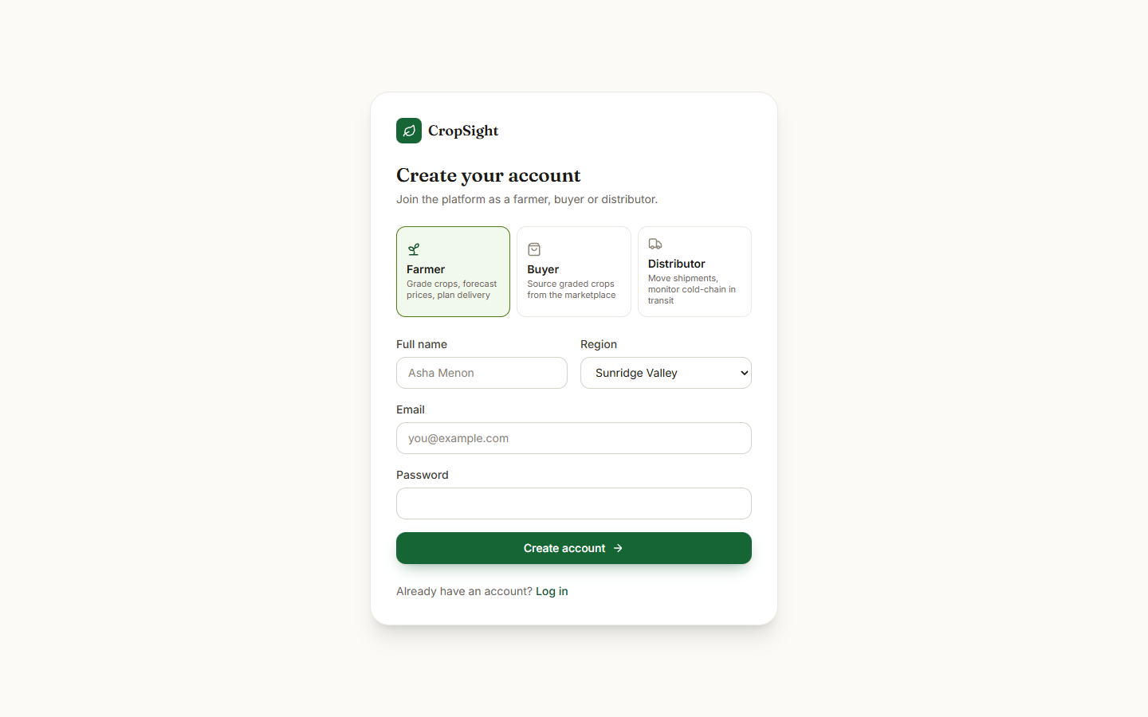  Fig. C.2: Sign-up page

Log-in page. The log-in form with the e-mail and password fields and the four demo-account shortcuts (farmer, buyer, distributor, admin).
Sign-up page. The registration form with name, e-mail, password (minimum six characters), role (farmer, buyer or distributor), region and phone.
Fig. C.3: Farmer dashboard before an upload | 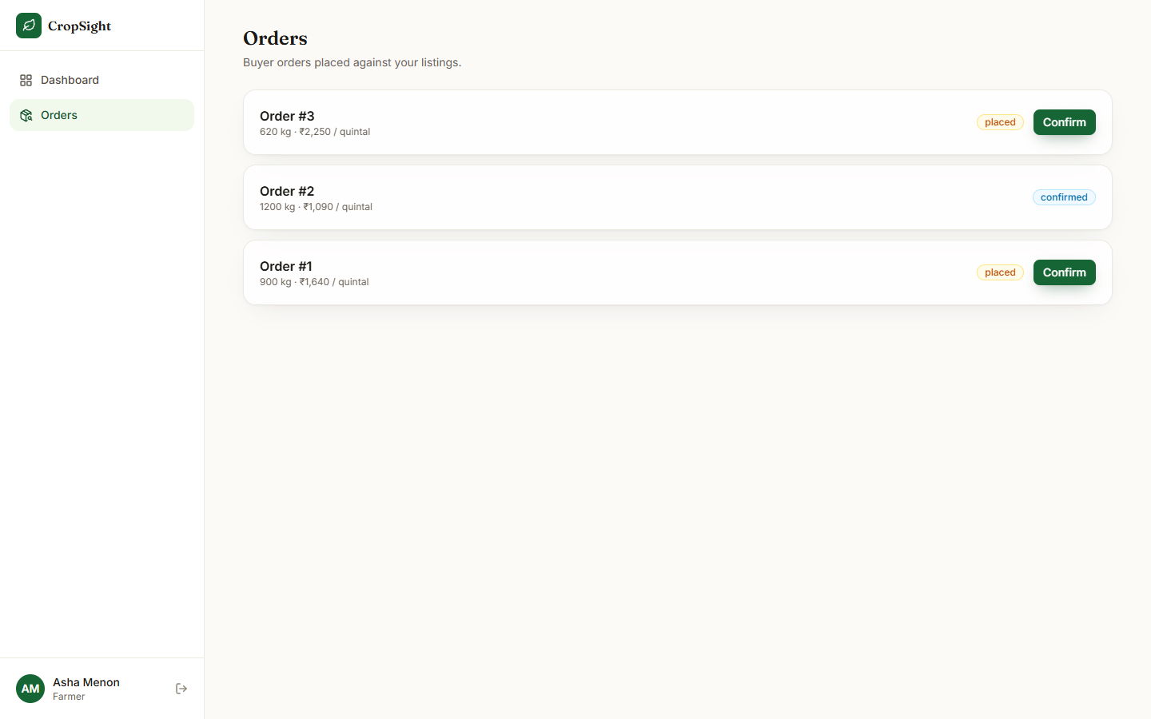  Fig. C.4: Farmer orders before confirming

Farmer dashboard before an upload. The Grade a new crop form with the default crop and quantity, the empty drop zone and photo preview, and the farmer's existing listings.
Farmer orders before confirming. Orders #3 and #1 are placed and show Confirm buttons; Order #2 is already confirmed.
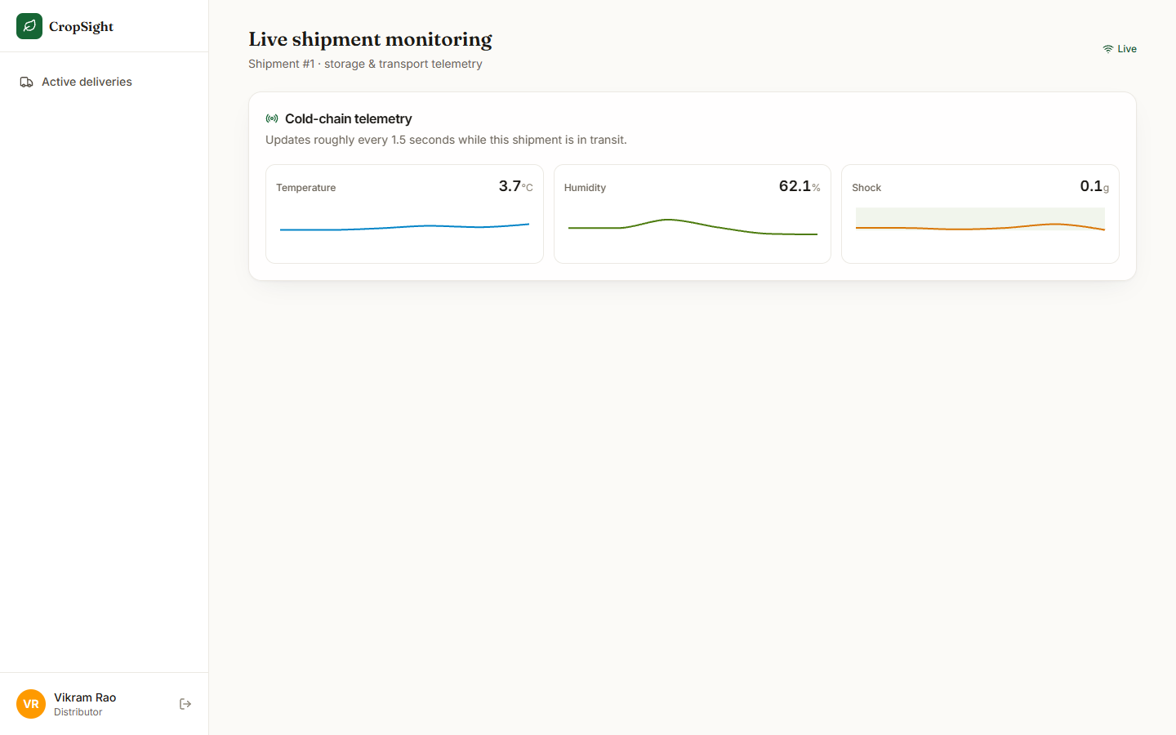  Fig. C.5: Live monitoring right after opening | 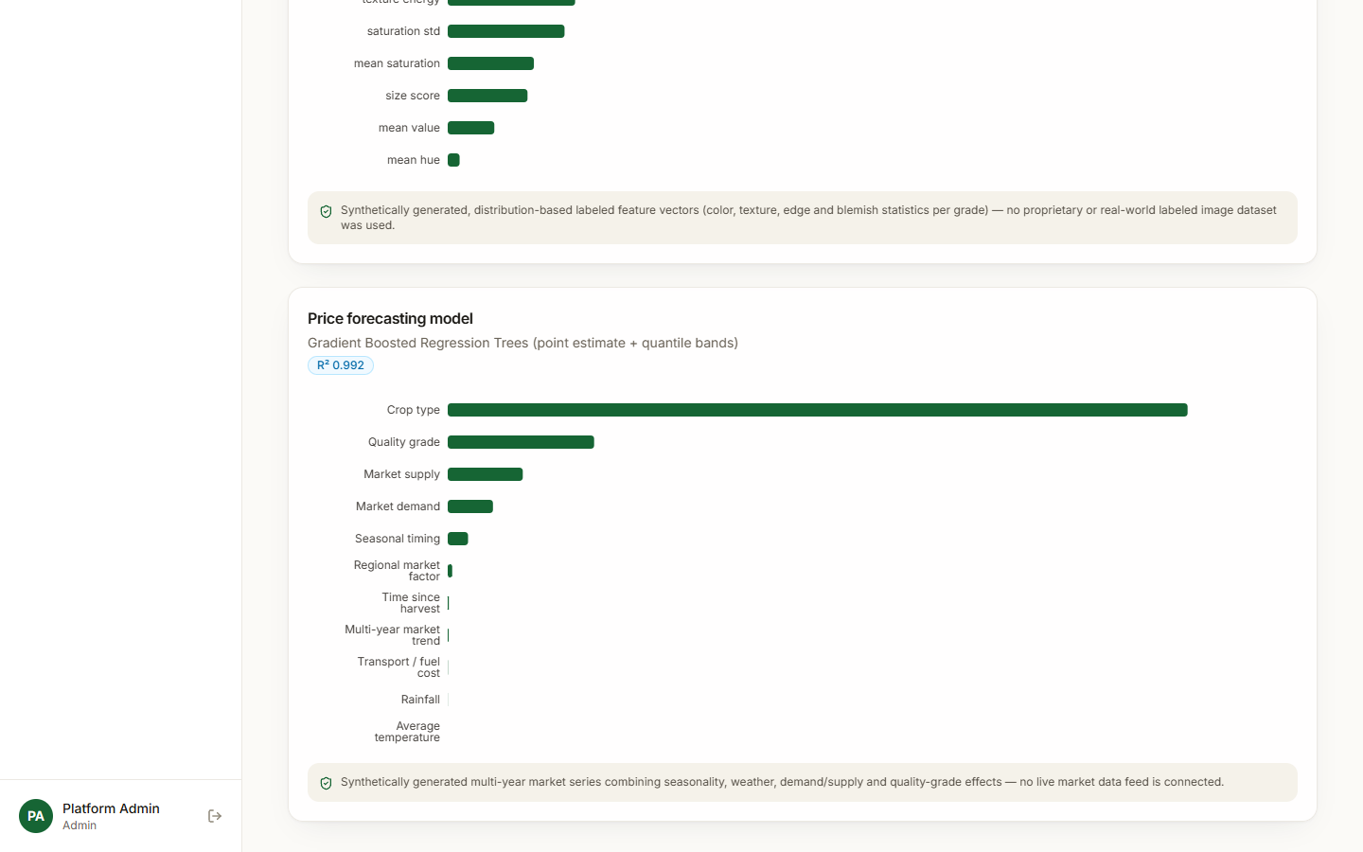  Fig. C.6: Model insights: price model

Live monitoring right after opening. The page a few seconds after the WebSocket connected: the Live indicator and the three telemetry panels begin to fill.
Model insights: price model. The price model card: Gradient Boosted Regression Trees with point estimate and quantile bands, the badge "R2 0.992", grouped importances (crop type largest; rainfall and average temperature almost zero) and the disclosure of synthetic training data.

